**CHAPTER 1**

**INTRODUCTION**

It has been known that a hospital is a health institution developed by the society intended to meet the complex health needs of its members who are sick or injured. Hospitals are equipped with medical instruments for their use in treating people who are sick or badly hurt. Professionally & technically skilled people apply their knowledge and skill with the help of complicated equipment and appliances to provide quality care for the patient. In a healthcare system, its workers play an integral role in serving a full care to patients, such as personnel who are in charge of lifting and transferring of patients (i.e. Hospital porters). In the Philippines IWD or Hospital porters are one of the healthcare workers who move patients, equipment and numerous other medical paraphernalia between the various areas of a hospital. Hospital porters are essential in maintaining the smooth running of a hospital, a significant aspect of the job is patient care. They transfer patients to and from various locations, such as from ward to any department. Like hospital porters, nurses also play a big role on patient handling care, they also transfer, reposition and lift patients. They mainly focus on **helping patients** and meets their needs including emotional, social, physical, cognitive & spiritual. Nurses facilitate patient optimal wellness, health and functioning in the care of communities, individuals and families.

# With such complicated physical job, they experience work-related issues on handling patients, majority of them experience back pains and musculoskeletal disorders. Healthcare workers are at risk for musculoskeletal disorders because of the numerous ergonomic hazards present in the workplace. Ergonomic hazards are defined as a physical factor within the environment that may cause harm to the musculoskeletal system such as repetitive movements and manual patient handling (AMN Healthcare Education Services 2017).

Understanding ergonomics is important for health workers as a large portion of patient care activities involves lifting, repositioning, moving and transferring of patients. This places health workers at high risk for physical injury**.** Upon further study on the said problem, the researcher came up with the idea on designing an ergonomically designed hospital bed with attachable – detachable stretchair that will benefit the healthcare workers in terms of reducing musculoskeletal disorders from lifting and transferring patients from hospital bed to wheelchair and to stretcher, since this process involves patient handling activities.

**Background of the study**

# In the Philippines, healthcare workers like nurses, nursing assistants and hospital porters are involved on patient handling activities like lifting and transferring of patients. In 2007, according to Occupational Health and safety Issues among Nurses in the Philippines, work-related problems among a sample of nurses in the Philippines are described. A survey was collected during Philippine Nurses Association 2007 convention and measures included four categories: work-related demographics, occupational injury/illness, reporting behavior, and safety concerns. Approximately Forty percent (40%) of nurses had experienced at least one injury or illness in the past year, and Eighty percent (80%) had experienced back pain. Filipino nurses encounter considerable health and safety concerns that are similar to those encountered by nurses in other countries.

In addition to this issue, the researchers conducted a study among the healthcare workers of M.V Santiago Medical and Diagnostic Center located in Poblacion 3, Indang, Cavite which is specialized in medical consultation, fast and accurate diagnostic service, wellness services and emergency services. In this study, the researchers were able to gathered data through interviews, observations and survey questionnaire. The researchers considered twenty – five (25) respondents healthcare workerswho are involved in the process of lifting and transferring patient from hospital bed going to wheelchair and stretcher and they are Institutional Worker Department (IWD) and nurses. It was found out from the collected survey questionnaires that 100%of those healthcare workers revealed that theprocess and technique used in transferring patient from bed to stretcher and wheelchair are both manually**,** and does not use any lifting equipment**.** It was determined that this process contributes a big factor on having body pains from lifting and transferring of patient from bed to stretcher or wheelchair, since the survey results tells that 100% of the those healthcare workers who are involved in the said process experiencing pain on different parts of their body. By using Rapid Entire Body Assessment (REBA), Musculoskeletal Disorder factor was described on both process, with a risk score of twelve (12) which means very high risk and need to implement change.

Thus, the researchers came up with the idea of designing an ergonomically smart hospital bed with attachable – detachable “Stretchair”. The term “Stretchair” is the combination of stretcher and wheelchair, and the stretcher which is the detachable part of the hospital bed can be assembled and transformed into a wheelchair. The equipment will help lessen the risk of Musculoskeletal Disorder (MSD) and provide a safer and comfortable process of transferring patient without putting the healthcare worker’s health at risk.

**Objective of the study**

This study aims to design an ergonomically smart hospital bed with attachable – detachable stretchair, that will help the healthcare workers from manual lifting and transferring of patients from hospital bed going to stretcher or wheelchair and vice versa.

**Specifically, the study aims to:**

* Fabricate the Ergonomically Designed Smart Hospital Bed with Attachable – detachable stretchair.
* Create Radio – Frequency Identification (RFID) access for assigned healthcare worker for transferring patients to avoid accident, technical problems (damage) from mishandling the proposed hospital bed.
* Reduce musculoskeletal disorder that has very high-risk Rapid Entire Body Assessment (REBA) score of Twelve (12) among healthcare workers in the process of transferring a patient from hospital bed going to stretcher or wheelchair and vice versa.
* Test and evaluate the user-friendliness and functionality of the proposed hospital bed using survey questionnaire.
* Test and evaluate the effectiveness from reducing the risk of musculoskeletal disorder using survey questionnaire and REBA.

**Operational Framework**

Ergonomically Designed Smart Hospital Bed with Attachable – Detachable stretchair

Hardware Development:

* Design
* Electronic Configuration
* Assembly
* Finalization

Software Development:

* Programming
* Troubleshooting

Testing

Evaluation

Validation

Hardware Requirements:

* DC Motor
* Power Supply
* Sensors
* RFID
* Arduino Uno
* Android Tablet
* Switch/Locks
* Hospital Bed
* Servo Motor
* Stainless Steel
* Leather foam

Software Requirements:

* Arduino IDE
* Android Studio
* MySQL

.

*Figure 1* Operational Framework

The figure above shows the hardware and software requirements in order to accomplish the proposed design of Hospital bed. Through data gathering like interviews, observation and survey questionnaires, the researcher was able to analyze the requirement and whole process of making the proposed hospital bed and what will be the type of design that will serve as a solution to the problem stated in this study.

**Significance of the study**

The researchers believe that the study would be beneficial to the following:

***Healthcare workers.*** They are involved in the process of transferring patients are the main beneficiaries of this study for it will help reduce the risk of Musculoskeletal disorder (MSD), it reduces the process of manual lifting and transferring of patient from hospital bed to stretcher or wheelchair that will result in lesser fatigue and exhaustion of healthcare worker on long working hours. This will significantly boost the healthcare worker’s efficiency and productivity for the whole working shift.

***Patient****.* This study provides a safer transferring method for patients that are ill or badly hurt from bed going to stretcher and wheelchair or vice versa. Thus, they will feel at ease in terms of comfort and secured during the process than before. The proposed design will significantly increase the safety and comfortability of the patients particularly to those who are ill or badly hurt.

***Hospital.*** Through the use of ergonomically designed smart hospital bed with attachable

and detachable stretchair, the hospital may increase the rate of patients and employees satisfaction because of the comfortability and safer use of the proposed Hospital bed that will result to positive feedback from patients and employees.

***Future Researchers.*** This study will serve as a pattern and guide for future researchers who want to develop an ergonomically designed equipment. This will also help future researchers by giving inspiration and motivations to come up with better ideas for new innovations.

**Scope and limitations**

The researchers focused on designing an Ergonomically designed Smart Hospital bed with attachable – detachable stretchair to reduce the risk of musculoskeletal disorders of the healthcare workers. The area of concern for this study was from the healthcare workers who are involve in nursing assistance specifically in the said process and for the patients that need to be transferred with exertion from hospital bed going to stretcher or wheelchair. For design and technicalities, the “Stretchair” is a semi – automated equipment and is the combination of a stretcher and a wheelchair design and functionalities. The “Stretchair” can be attached or detached to the hospital bed by a locking mechanism using RFID Technology. The “Stretchair” will only have the function of adjusting the slope of its backrest and foot part of the Hospital bed when it is already detached from the hospital bed, this was done by providing a battery that is connected to the motor.

For Electronics configuration, the authority who can only access to detach – attach (unlock or lock) the smart hospital bed are the assigned nursing assistants. The hospital bed has a preset values slope and can be adjusted from 0° to 45°, 88°, and vice versa.

This study is limited only to hospitals in the Philippines and to the healthcare workers who are involved on transferring patient from bed to stretcher or wheelchair. Healthcare workers who are pregnant and elderlies aged Sixty (60) and above will not be allowed on using the proposed equipment since the proposed equipment aims only to reduce the risk of musculoskeletal disorder and not to totally eliminate it which mean it is still needed to put an extra effort when using the proposed equipment especially on pulling and pushing part when using of the proposed equipment.

**Definition of terms**

**Ergonomics.** A branch of science that aims to learn about human abilities and limitations, and then apply this learning to improve people’s interaction with products, systems and environments. Also aims to create safe, comfortable and productive workspaces by bringing human abilities and limitations into the design of a workspace, including the individual’s body size, strength, skill, speed, sensory abilities(vision, hearing), and even attitudes (Dorman Consulting, 2014)

**Healthcare Workers.** Someone who works in a hospital or health center (Collins, 2019).

**Hospital porters.** They move patients, equipment and numerous other medical paraphernalia between the various areas of a hospital. They transfer patients to and from various locations, such as from the ward to the x-ray department (Fubra Limited, 2019).

**Microcontroller.** Is basically cheap and small computer on a single chip that comprises a

Processor, a small memory, and programmable input-output peripherals. They are

Meant to be used in automatically controlled products and devices to perform predefined and pre-programmed tasks (Circuit Digest, 2019).

**Musculoskeletal Disorders (MSD). Are injuries and disorders that affect the human body’s movement or musculoskeletal system** (i.e. muscles, tendons, ligaments, nerves, discs, blood vessels, etc.) (ErgoPlus, 2019).

**Nursing Assistants.** They help physicians and nurses care for patients by feeding, cleaning and transporting patients (Hearst Newspaper, 2019).

**RFID Module.** Radiofrequency Identification is the use of radio waves to read and capture information stored on a tag attached to an object (Barcode graphics Inc., 2019).

**Stretcher.** A device for transporting the ill, wounded, or dead, consisting of a frame

Covered by canvas or other material (Dictionary of the English Languange, 2016).

**Wheelchair**. Is a manually operated or power-driven device designed primarily for use by an individual with a mobility disability for the main purpose of indoor, or of both indoor and outdoor, locomotion (National network, 2019).

**Stretchair.** The term “Stretchair” is the combination of stretcher and wheelchair, and the stretcher which is the detachable part of the hospital bed can be assembled and transform into a wheelchair.

**IWD.** Institutional Worker Department. They are part of nursing assistance and essential in maintaining the smooth running of a hospital, a significant aspect of the job is patient care. They transfer patients to and from various locations, such as from ward to any department

**CHAPTER II**

**REVIEW OF RELATED LITERATURE & STUDIES**

This chapter includes previous literature and studies that can contribute in the accomplishment of the objectives of this study. The problem of the study and technical requirements related to the study are examined and collected to establish its foundation.

**Conceptual Literature**

The proponents started with this study with the assistance of multiple relevant studies and literature to construct a solid concept, gathered from the past publications and ideas the past researchers had collected.

**MSDs from Patient handling in healthcare**

According to *European Agency for safety and health* at work, work related musculoskeletal disorders (MSDs) are serious problem among hospital personnel, and nursing staff. Primary concern are back injuries and shoulder strain which can both, be severely debilitating. The nursing profession has been shown to be the most at risk occupation for low back pain. The primary cause for MSDs is patient handling task such as lifting, transferring, and repositioning of patients.

# Occupational Health and Safety Issues among Nurses in the Philippines

# Nursing is a hazardous occupation in the United States, but little is known about workplace health and safety issues facing the nursing work force in the Philippines. In this article, work-related problems among a sample of nurses in the Philippines are described. Cross-sectional data were collected through a self-administered survey during the Philippine Nurses Association 2007 convention. Measures included four categories: work-related demographics, occupational injury/illness, reporting behavior, and safety concerns. Approximately forty percent (40%) of nurses had experienced at least one injury or illness in the past year, and eighty (80%) had experienced back pain. Most who had an injury did not report it. The top-ranking concerns were stress and overwork. Filipino nurses encounter considerable health and safety concerns that are like those encountered by nurses in other countries. Future research should examine the work organization factors that contribute to these concerns and strengthen policies to promote health and safety.

# Analysis of trends of Occupational Injury in the Philippines: Implication for policy

# The sector, which includes the nursing profession, encounters occupation related injuries that are different from the injuries in the agricultural and manufacturing industries. In a study among Filipino nurses, forty percent (40%) of 4,800 nurses all over the Philippines had experienced at least one injury (e.g., back injury and needle stick injuries) in 2008. Most of those who were injured did not reported injury. They considered the injury either insignificant or a routine part of their job (Lu et al., 2008). Nursing Assistants ranks one of the highest rate of MSDs cases According to surveys from by the Department of Labor’s Bureau of Labor Statistics (BLS), there are more than 35,000 back and other injuries among nursing employees every year, severe enough that they might miss work. Nursing assistant and orderlies, each suffer roughly three time the rate of back and other musculoskeletal injuries as construction laborers. In terms of number of these injuries, BLS data shows that nursing assistants are in the second to the highest Musculoskeletal Disorder (MSD) cases and rates, one reason why nursing employees get this these injuries are by doing their everyday jobs of moving and lifting patients (Zwerdling et al.,2015).

# Incidence rate and number of injuries and illnesses due to musculoskeletal disorders by selected occupations.

*Fugure 2* Incidence Rate

**According to the US Bureau of Statistic**

# Nurses are forty-eight (48%) percent more likely to have wrist, back and/or ankle sprain or strains on the job compared to all occupations

# There are sixty (60%) percent which are more likely to report chronic soreness and pain, especially in the feet and lower back.

# Fifty-three (53%) percent off all injuries while nursing was reported to be due to overexertion.

# Nurses and related workers like orderlies have third highest reported injury rate of any profession, just below truck drives and professional movers.

# No. 1 threat to your nurses: Injuries from lifting patients

According to information from the Bureau of Labor Statistics cited by Nursing Peer Review (NPR), nurses experience more than 35,000 back and musculoskeletal injuries on the job that are significant enough to prevent them from working each year. This makes nursing one of the fields where workers are most likely to be injured. Even if lifting is done correctly, the process places a great deal of strain on nurses’ bodies, as discussed in the NPR series.

Lifting and moving patients manually still places a great deal of pressure on the spine, regardless of the technique used.

In fact, experts from the Spine Research Institute at Ohio State University have extensively studied how lifting patients can hurt nurses, and they found that the lifting process itself contains several inherent dangers that lead to injury, including:

* **Distance**. It is much easier to lift something if it is very close to your body. But nursing staff must stand at the side of the bed to lift a patient; they cannot get much closer.
* **Bending**. Although nurses are bending with their knees, any bending movement changes how the body distributes weight when lifting. The majority of the force goes from bones along the spine directly to disks in the back, straining them.
* **Repetition**. Each time a nurse must lift and move a patient, there is a risk of developing small tears in plates designed to send nutrients to disks in the back. Over time, these tears grow scar tissue, and that stops the flow of nutrients. The result is that disks deteriorate faster, which makes injury more likely whenever a nurse lifts a patient.

**Traditional ways in patient handling is not effective in reducing healthcare personnel’s injuries**

This article stated that strategies to prevent or minimize work-related musculoskeletal injuries associated with patient handling are often based on tradition and personal experience rather than scientific evidence. The most common patient handling approaches in the United States include manual patient lifting, classes in body mechanics, training in safe lifting techniques, and back belts. Surprisingly there is strong evidence that each of these commonly used approaches is not effective in reducing healthcare personnel injuries. A major paradigm shift is needed from these ineffective approaches towards the following evidence-based practices: (a) patient handling equipment/devices, (b) patient care ergonomic assessment protocols, (c) no lift policies, (d) training on proper use of patient handling equipment/devices, and (e) patient lift teams (Nelson et al., 2004).

**Present Method of Patient handling who meet with an accident**

According to International Journal of Research in Advent Technology**,** the patient is being transferred from various places like from ambulance to O.T./ ICU/X-ray centers/ MR scan/Sonography can proceed through various stages.

* Accident spot to stretcher
* Stretcher to ambulance
* Ambulance to hospital stretcher/wheelchair
* Stretcher/ wheelchair to bed at O.P.D
* O.P.D to ICU/ward bed
* O.P.D. to X-Ray centre / MRI / SCAN / Pathology centre
* Back to the bed of ICU/Ward bed

**The problem associated with above patient handling**

International Journal of Research in Advent Technology, Vol.3, No.2, February 2015 E-ISSN: 2321-9637 103

* When the patient is required to transfer on the same floor, he is wrapped in cotton bed sheet and lifted by three to four labors. Due to the handling, stresses are developed in the body of both i.e. patient as well as the nursing staff.
* At the manual handling of the patient various accessories like blood transmission facility, oxygen supply, saline facility, is not available and this may create various problems if the patient is serious.
* When the patient is to be moved from one place to another place, that time if the movement of the patient is on inclined plane and during this movement, there is a chance that the patient may slip or slide down on the stretcher. The above problems which are generated at the timing of patient handling which can be eliminated by developing a new Wheelchair cum Stretcher to handle the patients.

**Preventing Injuries Using an Ergonomic Approach**

The risk of back injury is a continuing problem for nurses. Patient‐handling tasks (e.g., transferring patients on and off stretchers, repositioning patients on OR beds) are a major precipitating factor to this problem. Educating nurses about body mechanics has not been the answer to preventing back injuries; however, changing the physical demands of the job (ie, using an ergonomic approach) by using assistive devices (eg, friction reducers) has been proven to decrease perceived stress and injury rates and increase patient comfort. This article focuses on the problem of nurses' back and shoulder overexertion injuries and explores the application of ergonomics in the perioperative setting (Owen. 2000).

**Process of Patient transfer from bed to stretcher and wheelchair**

**Transfers** are defined as moving a patient from one flat surface to another, such as from a bed to a stretcher (Perry et al., 2014)*.* Types of hospital transfers include bed to stretcher, bed to wheelchair, wheelchair to chair, and wheelchair to toilet, and vice versa.

**Patient Transfer from Bed to Stretcher**

A bed to stretcher transfer requires a minimum of three to four people, depending on the size of the patient and the size and strength of the health care providers. Patients who require this type of transfer are generally immobile or acutely ill and may be unable to assist with the transfer (Patient Transfers by British Columbia Institute of Technology).

* The caregiver explains what (s) he is going to do and what the patient must do to help.
* Clear the area. Collect all equipment and assistance that the caregiver will need. Ensure the brakes on the bed are locked.
* Position the patient close to the edge of the bed on the side to which the transfer is taking place. Do this by using draw sheet, and good body mechanics, including a weight shift.
* With one caregiver on either side of the bed, use the draw sheet and proper body mechanics to roll the patient, and insert the slide board half way under the patient.
* Move the stretcher/trolley next to the bed, with the destination surface being slightly lower. Apply the brakes on the stretcher trolley.
* Ensure the feet and legs of the patient are on the slide board.
* Ask patient to tuck their chin to their chest if they are able.
* The two caregivers now move to the side of the stretcher/trolley. Grasp the draw sheet and stand with one foot forward and one foot back. On the leaders count, caregivers tighten abdominal muscles and move the patient across the slide board onto the stretcher by shifting weight from the front foot to the back foot.
* Once the patient is moved safely on the stretcher/trolley, the slide board can be removed, and the side rails placed in the up position. Ensure the patient is in a safe and comfortable position (Kimberley Steeves, RN, DOHN Occupational Health Practitioner).

**Transfer from Bed to Wheelchair**

According to Provincial Health Service Authority (2010), patients often need assistance when moving from a bed to a wheelchair. A patient must be cooperative and predictable, able to bear weight on both legs and take small steps. If any of these criteria are not met, a two-person transfer or mechanical lift is recommended. Always complete a patient risk assessment prior to all patient-handling activities.

**Step 1.Sit the patient up**

* Position and lock the wheelchair close to the bed. Remove the armrest nearest to the bed, and swing away both leg rests.
* Help the patient turn onto his or her side, facing the wheelchair.
* Put an arm under the patient's neck with your hand supporting the shoulder blade; put your other hand under the knees.
* Swing the patient's legs over the edge of the bed, helping the patient to sit up

**Step 2. Stand the patient up**

* Have the patient scoot to the edge of the bed.
* Put your arms around the patient's chest, and clasp your hands behind his or her back. Or, you may also use a transfer belt to provide a firm handhold.
* Supporting the leg farthest from the wheelchair between your legs, lean back, shift your weight, and lift.

**Step 3. Pivot toward chair**

1. Have the patient pivot toward the chair, as you continue to clasp your hands around the patient.
2. A helper can support the wheelchair or patient from behind.

**Step 4. Sit the patient down**

* As the patient bends toward you, bend your knees and lower the patient into the back of the wheelchair.
* A helper may position the patient's buttocks and support the chair.

(Mount Nitanny Health)

**A Review on Development of Wheelchair cum Stretcher in India**

According to the study of (Katkar et al., 2015), from International Journal of Research in Advent Technology, the number of patients is increasing day by day. So in hospitals, patients need to be shifted from wheelchair to stretcher, stretcher to beds, bed to wheelchair, or vice versa; which creates unsafe conditions for patients. Also, transferring the patients from wheelchair to stretcher, stretcher to beds, bed to wheelchair is always an issue for the attendant or nurse. Sometime during handling, patient and hospital staff suffer from many problem like stresses are produced in the body, sometime chances to sleep down the patient. It is required to eliminate all types of possibilities. Understanding the various issues regarding the mobility equipment, the better design will be an asset for the medical field and a helping hand for disabled individuals. There is a need for a wheelchair cum stretcher to facilitate the disabled patient’s mobility and to provide novel medical equipment for use in the Indian hospitals.

**Problem:**

Transferring patients in hospitals is a common problem for the caretakers and patients. The patient is confined to bed in hospital and is required to be moved to other places for taking X-ray or undergoing Sonography or CT scan procedure and etc. The handling of the patient is rather difficult and is required to be planned meticulously. In patient handling, lots of problems are being faced by the people who handle the patient at home, nursing staffs, and the patient. These problems consist of pain to patient, in various portions of body like shoulder, back, legs, etc.; while moving him from one place to another place. In the hospitals, the nursing staffs are also facing some health problems like pain in their shoulders and backbone, as they have to do the work of patient handling repeatedly. To overcome the all above problems of patients and hospital staff, there is a need to design a wheelchair cum stretcher. The plan is to merge both wheelchair & stretcher. So there will no need for shifting patient from his bed or wheelchair to operation table or stretcher as this proposes work will fulfils both the demand.

**Patient handling can be done safely with the use of assistive mechanical equipment and devices to eliminate hazards to nurses that will lead to serious back injuries**

Occupational Back Pain in Nurses (OBPN) constitutes a major source of morbidity in the health care environment. According to the National Institute for Occupational Safety and Health (NIOSH), occupational back injury is the second leading occupational injury in the United States. Among health care personnel, nurses have the highest rate of back pain, with an annual prevalence of forty (40%) to fifty (50%) percent and a lifetime prevalence of thirty – five (35%) to eighty percent (80%). The American Nursing Association (ANA) believes that manual patient handling is unsafe and is directly responsible for musculoskeletal disorders encountered in nurses. It has been well documented that patient handling can be done safely with the use of assistive equipment and devices that eliminate these hazards to nurses that invite serious back injuries. The benefit of assistive patient handling equipment is characterized by the simultaneous reduction of the risk of musculoskeletal injury to the nursing staff and improvement in the quality of care for patient populations.

To understand the cause of disabling injuries in health care workers, several factors must be considered, including the following: (1) anatomy/physiology of the back, (2) risk factors, (3) medical legal implications, and (4) prevention. Among nurses, back, neck, and shoulder injuries are commonly noted as the most prevalent and debilitating. While mostly associated with dependent patient care, the risk for musculoskeletal injury secondary to manual patient handling crosses all specialty areas of nursing.

Experts believe that training in proper body mechanics does not prevent back injury. Consequently, focus has been placed on other innovative injury prevention programs, including the use of engineering controls as well as the "lift team" method. Ergonomics involves the use of mechanical devices to aid in patient lifting and transferring tasks (Eidlich et al., 2004).

**Stretcher Safety**

Cross-checks with a standardized checklist have saved many lives during simple procedures, such as ensuring a door is locked before an airplane takes off to complex crash landings into a river. They can also help ensure unnecessary risks are avoided during routine procedures that often cause injury, such as stretcher use. Ways to reduce risk of injury to patient or provider include removing loose straps and standardizing the process of loading and unloading (Page et al., 2016).

Design of stretcher is very important while considering safety of patient. It is an essential part of medical first aid services. In critical situations, safe and in time delivery can save lives of people. Efforts are taken to make the stretcher lighter in weight and compact for easy travelling. Use of shock absorber can reduce the intensity of vibration shocks produced during traveling of patient. Rubber shock absorbers are light in weight and less costly also mounting of rubber shock absorbers is easy, they can mount using any mechanical mechanism. In critical situations, there are chances of death due to bleeding or damage to internal body parts because of vibrations produced. Use of rubber shock absorbers becomes helpful in such situations, since they can reduce the shocks to a minimum level. Hence while considering the importance of safety, this paper focuses on the effective use of this shock absorbers in hand lifting stretcher (Waghmare et al., 2015)

**Stretcher Design Review**

To transfer the knowledge of existing products design to new product to be developed, literature study is very important and essential because it does not only give design concepts but also gives an insight of their advantages, limitations and enlightens the designer’s thinking towards innovative concepts generation. The development time, cost and resources can be saved by reviewing the related literature and product at initial design stages.

**Studies Report on Stretcher Errors & Rate Protective Gear**

In a study conducted by Goodloe et al. (2012)*,* they have shown retrospective analysis of quality improvement data in a single Oklahoma-based ambulance service covering two cities (Tulsa and Oklahoma City), the Emergency Medical Services Authority (EMSA), reports a low incidence of adverse stretcher events: twenty - three (23) events in a one-year period when this urban EMS system transported more than 129,000 patients. The authors randomly selected a year to review and analyzed data with their existing error reporting system. The primary reason for adverse events was a failure of the stretcher to “*catch*” on the hook in the process of unloading a patient. No patients were injured from stretcher errors during this time. The intent of the project was to establish a good baseline, which might be helpful in accomplishing this for Oklahoma.

**DC Motor**

# The propulsion system of a currently used electric wheelchair consists of a pair of Direct Current (DC) motors, one for each drive wheel and a drive train consisting of gears or belts or other mechanical elements that couple the motor’s shaft to the drive wheel shaft. A DC–DC converter drives each motor with a high frequency, square-wave pulse-train that rapidly turns each motor on and off. A microprocessor based control unit controls the speed and the torque generated by each motor by independently modulating the pulse-width into each motor. Solid state relays are generally used to switch supply voltage polarity to change the running direction of PM motor (Chikkan et al., 2005).

**Microcontroller**

Microcontroller, can be also called MCU or microcontroller unit, a small low-cost computer made for purpose of dealing with precise tasks, such as demonstrating information in an LCD or automation of the appliances. Microcontrollers are mostly used in products that involves a degree of control to be exercised by the user. By using microcontrollers, one can deal with many tasks due to its flexibility and programmable nature, faster speed of execution can be attained for the reason that they are fully integrated inside the processor, it is inexpensive, labor saving due to its ability to perform tasks repetitively. Another advantage of using a microcontroller is that it can be paired with several different modules and transducers to perform much wider tasks and applications (gradeup, 2019).

**Radio-Frequency Identification (RFID)**

RFID belongs to a group of technologies referred to as Automatic Identification and Data Capture (AIDC). AIDC methods automatically identify objects, collect data about them, and enter those data directly into computer systems with little or no human intervention. RFID methods utilize radio waves to accomplish this. At a simple level, RFID systems consist of three components: an RFID tag or smart label, an RFID reader, and an antenna. RFID tags contain an integrated circuit and an antenna, which are used to transmit data to the RFID reader (also called an interrogator). The reader then converts the radio waves to a more usable form of data. Information collected from the tags is then transferred through a communications interface to a host computer system, where the data can be stored in a database and analyzed at a later time (American Barcode and RFID, 2019).

RFID technology is mostly used inventory management ,asset tracking, personnel tracking, controlling access to restricted areas, ID badging ,supply chain management and counterfeit prevention (e.g. in the pharmaceutical industry). In this study the RFID will be used in locking and unlocking the wheelchair.

**Modeling Decisions for Hospital Bed Management**

With today's hospital demands and financial constraints, hospital inpatient bed management is becoming increasingly complex. The use of decision support systems could enable hospital staff and health decision makers to perform more focused management of the hospital inpatient beds, thus potentially reducing costs and inpatient length of stay. A literature review was carried out on both PubMed and ISI Web of Knowledge in order to identify studies evaluating the use of decision support systems when applied to hospital inpatient bed management. Two different approaches were identified: one approach based on the use of mathematical models to support the planning and allocation of hospital inpatient beds and another approach consisting in the utilization of information technologies to support timely inpatient placement.

It was perceived that mathematical models could be safely used to model annual patient arrival rates and bed occupancy, thus forecasting hospital/department bed demand and underlying cost structures/revenues. It was also perceived that the use of bed management information systems provides hospital staff (administrative clerk, clinicians and housekeepers) with the necessary information to timely assess performance measures based on the hospital/department activity thus increasing resource effectiveness, optimizing established clinical pathways, reducing inpatient length of stay and associated costs (Matos et al., 2011).

# History and Technological advancement of a wheelchair.

# The first wheelchair that was invented in 1595 especially made for the King Philipp of Spain, back then was called as an invalid's chair. Then in the year 1655, a paraplegic by the name of Stephan Farfller build a self-propelling chair on a three-wheel chassis. Later in 1783, John Dawson of Bath invented a Bath Wheelchair. The Bath wheelchair had two large wheels in the back and one small one in the front. The user would steer the chair by a stiff handle, but all the Bath designs had to be pushed or pulled by a donkey or horse, as they were heavy. In the year 1869 patent for a wheelchair with rear push wheels and small front casters were invented, in the year 1881, the push rims for self-propulsion wheelchair was invented. In 1900 the first spoked wheelchair was invented and in the year 1916 first motorized wheelchair was invented by British Engineers. In the year 1932, Harry Jennings built the first foldable wheelchair.

# Since then, improvement of the wheelchair design grew radically, researchers such as Hsu et al. (2008), developed “*Dual-Purpose Wheelchair Mechanism Design*” that let the wheelchair be adjusted as either sitting mode or lying mode as shown in Fig.*2.1*.

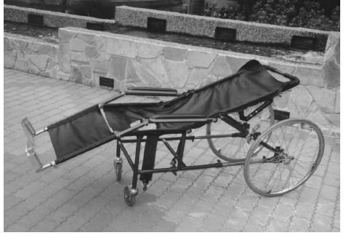

*Figure 2.1* A Prototype of dual-purpose wheelchair by Meng-Hui Hsu

# (*Mohan et al., 2001)*, developed “*Design of Multipurpose Wheel Chair for Physically Challenged and Elder People*”. The design is a variation of a wheelchair with eating table and defecating hole in its seat as shown in Fig.2.2.

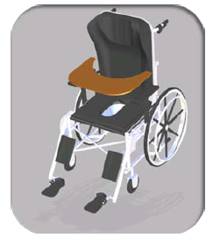

*Figure 2.2* Multipurpose Wheel Chair for Physically Challenged and Elder People

According to a recent survey conducted, it is found that, thirty – eight percent (38%) of nursing staffs suffer work-related back injuries requiring time away from work,12% of nursing staffs consider leaving nursing due to low back pain at average age 39, Nursing staff aides have also experienced significant injury (Khan et al., 2011).

They developed a “*Synthesis of Trolley Cum Wheelchair for Patient Handling*”. A hospital bed that can transform itself into a wheelchair as shown in Fig. 2.3 and Fig.2.4. The transition from trolley cum to wheelchair was done by using a four-bar mechanism.

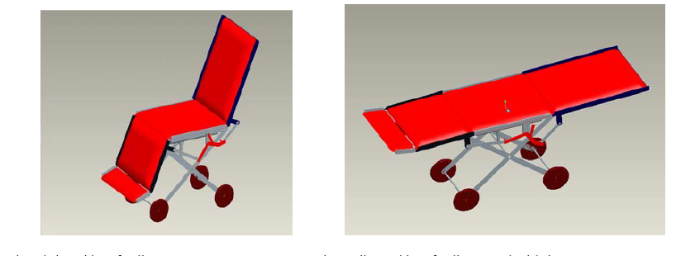*Fig 2.3* Chair position of trolley cum wheelchair *Fig. 2.4*. Trolley position of trolley cum

Chen et al. (2014)*,* in his paper entitled “*Design of the Wheelchair Bed*” developed a wheelchair that is able to adjust its backrest position. This design is a posture chair with adjustable bed one type of wheelchair, bed chair attitude switch and wheelbase adjustment results shown in Fig. 2.5. This Wheelchair Bed is designed for the elderly and people with disabilities to promote physical rehabilitation and improve safety performance.

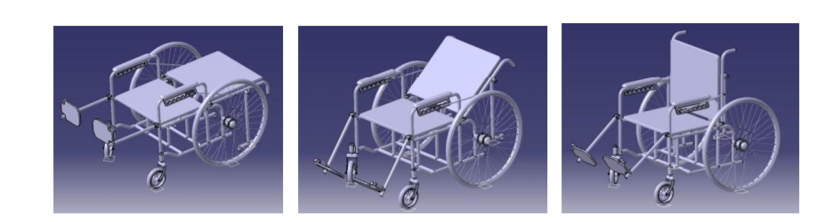

*Figure* 2.53D Model of Wheelchair Bed

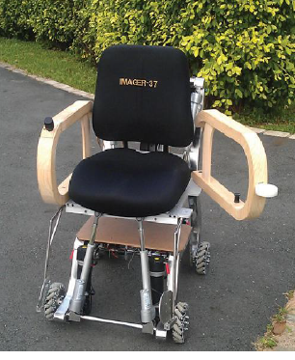Hsu et al. (2013)*,* published a paper entitled “*Mobility Assistance Design of the Intelligent Robotic Wheelchair*” this wheelchair has motorized wheels that can be controlled by a joystick, a movable armrest and an adjustable backrest as shown in Fig2.6.

*Figure 2.6* Intelligent Robot Wheelchair

# Project Report for Smart Wheel Chair

# The recent developments of science and technology has drastically changed the way a normal person lives his life, There are certain groups of disabled persons who have not been able to benefit from this improvement of wheelchair.

# A smart wheelchair can be defined as mobile robot with seats or as a uniquely modified power wheelchair which is equipped by a control system and variant sensors. Therefore, smart navigation methods are important aspects of a smart wheelchair. Navigation methods are divided onto three categories according to levels of assistance; Shared control, semi-autonomous control and autonomous control. There were advantages on each category for autonomous and semi-autonomous were, patients could relax once in a while, when a command was given to the smart wheelchair and the shared control it gives more of the independency feel for the person on how they want to move their wheelchairs (Mohammad et al., 2015).

# According to Sabin et al. (2013)*,* some smart wheelchairs develop in the past, provides only mobility with the use of joystick or buttons. The new generation of smart wheelchair develops new features using Artificial Intelligence and Embedded System. The developers aim to provide aid to those handicapped and physically challenged persons by giving them mobility which greatly help them on Figure 2.7which shows their work on a smart wheelchair.

# Capture

# *Figure 2.7* Mechanical Design for smart wheelchair

**Evaluation and design of a Hospital bed to be manufactured**

Hospitals, rehabilitation homes, nursing homes and retirement homes around the world are dependent upon a quality medical staff to maximize safety of individuals. Staff professionalism, facility quality and the condition of equipment are all key components in medical care which must be taken into account when designing hospitals. Particularly, hospital beds are of recent concern around the world. One of the hospital bed design stated by Brian Catalano and Todd Coolidge of Research entitled “*Evaluation and Design of a Hospital bed to be manufactured and used in Chine”* is the Intensive Unit Care beds Epic II. These beds are design upon effective treatment of patient by both medical and nursing staffs. The Epic II is Stryker Medical’s most technologically advanced hospital bed.

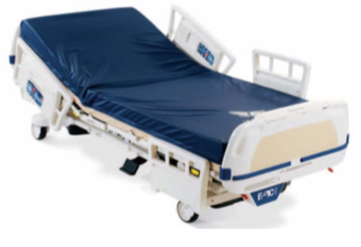Advanced features of this bed include “Zoom” technology which is a bed frame that is motor driven to alleviate stress caused to a nurse’s back by the constant pushing and pulling of the bed during patient transport. The Epic II posture controls feature a backrest that can rotate from 0° to 90°. The knee gatch, or knee elevation, is from 0° to 30° and the trend, or lower leg elevation, can rotate from 12° to 12°. These controls are all electronic and are powered by 115 volts alternating current. This bed also features manual release controls for all the variable posture adjustments in case of an emergency with the patient occurs.

*Figure 2.8* Epic II

**Hospital Equipment dimensions from related study of convertible stretcher to wheelchair**

*Table 1* International Journal of Research in Advent Technology “A Review on Development of Wheelchair cum Stretcher with dimension”

|  |  |  |
| --- | --- | --- |
| **Sr. No.** | **Specification** | **Dimension (mm)** |
| 1 | Overall length | 1000-1100 |
| 2 | Overall width open | 650-720 |
| 3 | Overall height | 910-950 |
| 4 | Seat height from floor | 480-510 |
| 5 | Slope of Sea | 1°-3° |
| 6 | Slope of backrest with respect to floor | 5°-7° |
| 7 | Distance between seat and footrest | 400-450 |
| 8 | Armrest height from seat | 220-230 |
| 9 | Seat dept | 420-440 |
| 10 | Clearance of footrest from floor | 90-200 |
| 11 | Clearance of frame from floor | 100±10 |
| 12 | Wheel diameter | 609.6*38.1 |
| 13 | Weight of the wheel chair | 25 kg Max |

|  |  |
| --- | --- |
| E:\Desktop\Conference\Poster\render 1.JPG  *Figure 2.9* Convertible stretcher | E:\Desktop\Conference\Poster\1.JPG  *Figure 2.10* Convertible Wheelchair |

**Dimensions of hospital beds, stretchers and wheelchair.**

**: For stretcher**

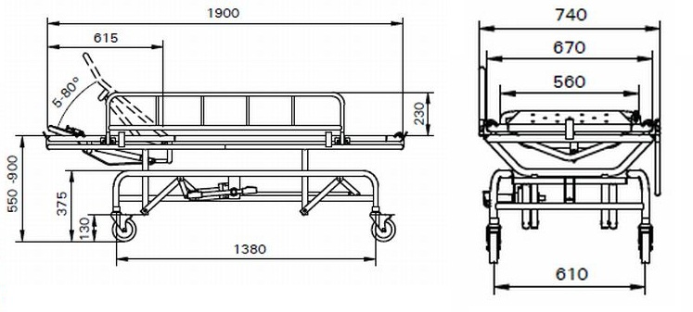

*Figure 2.11* Stretcher Dimension

Length: 1900mm Width: 740mm Height: 550 – 900mm

**For Wheelchair:**

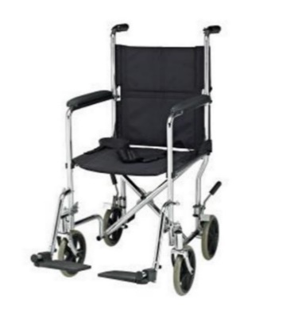Standard manual wheelchairs are the most frequently used wheelchairs in today’s market. Standard wheelchairs weigh over 35 lbs. without the front riggings, they have a seat width and depth between 16 and 20 inches, and have fixed or detachable armrests.

*Figure 2.12* Wheelchair Dimensions

**For hospital bed**

* 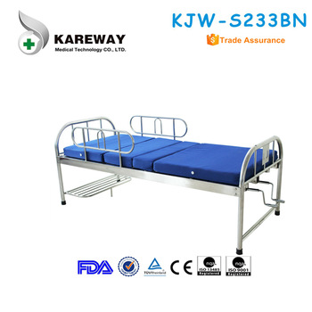Length: 2030mm Width: 900mm Height: 500mm

*Figure 2.13* Hospital Bed Dimensions

**Standard materials used in making Hospital beds**

* Metallic steel angle iron
* Metallic steel tubes
* Metallic steel Strips
* Castor wheels
* Nuts, Bolts, Screws, Washers, Flats, Rubber items & paint etc.
* Metal sheets
* Poly-urethane foam, chip wood, handles
* Fasteners

**Synthesis**

The review of related literature by the researchers is a mix of foreign and local articles. Based on the past studies and literatures that had been gathered, the researchers believe that there is a huge risk in terms of physical injury among healthcare workers by using the traditional way of lifting and transferring of patient. Therefore, the researchers considered all the related articles stated on the review of related literature as a guide in designing a new ergonomically designed smart hospital bed with attachable- detachable stretchair (stretcher and wheelchair) to contribute to the improvement of the work experiences of the healthcare workers that are involve in the process of lifting and transferring of patients.

Upon further research, the proponents came up with the idea that both healthcare workers and patients can benefit from the improved transferability and movability that the attachable – detachable stretchair will introduce. The proposed stretchair would lessen the lifting process in transferring patients from hospital bed that will lessen the risk of gaining Musculoskeletal Disorder (MSDs) of healthcare workers.

With these literatures, specifically literature Chen et al. (2014)*,* hadpublished, Jingtao Chen wheelchair/stretcher design concept gave the researchers a significant idea of how this study could be achieved. Through thatconcept, the researchers found things to improve on the design. First, the researchers will develop a semi-automatic transformation from stretcher to wheelchair with a simple push of a button, this will be done by using Arduino Programming. Second, the security of the design will be greatly improved by using Radio-Frequency Identification (RFID) Technology, this will give the assigned nursing assistants to unlock and lock the stretcher.

**CHAPTER III**

**METHODOLOGY**

This chapter provides information about the research method that will be used in this study, followed by the hardware design and software development of the proposed ergonomically designed smart hospital bed with attachable – detachable Stretchair.

**Research Methods**

The researchers used a combination of two (2) research methods, qualitative and quantitative type of research, in order to gather information with regard to the study. According to Saul McLeod (2017),qualitative research is when data are collected through participant’s observation and interview and analyzed from descriptions of informants. For the quantitative research, data are collected through measuring things and analyzed through numerical comparisons and statistical inferences.

**Source of Data**

This will help the researchers in providing information that will support the whole study accurately. Initial data are gathered from healthcare workers from different ward stations of General Emilio Aguinaldo Memorial Hospital and Korean – Philippine Friendship Hospital. For the data of Pre and Post – test, the researcher gathered data in M.V Santiago Medical and Diagnostic Center – Indang. This was done through survey questionnaires, asking brief questions through interviews, and observation of existing equipment that was used and healthcare worker’s condition in the process of transferring the patients from bed to stretcher or wheelchair. Researchers determined that there healthcare workers who are involved in lifting and transferring of patients from both hospital bed going to stretcher and wheelchair, they are Nurses and IWD.

**Project Construction Procedure**

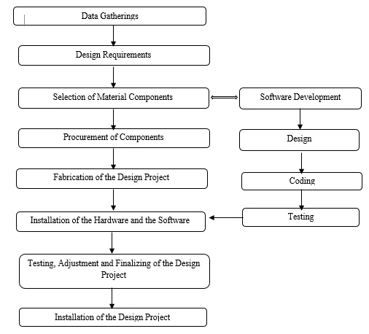This section shows the step by step procedure of how the study will be developed and the specific components that will be used in the study. Figure 3.4 shows a visual representation of the development of the system.

*Figure 3* Project Development Process Flow

**Data Gatherings**

The researchers conducted an interview, observation, survey questionnaires and literature review in order for them to gather data that will serve as a pattern in designing the proposed prototype as well as accomplishing the study.

**Design Requirements**

The design of the project started with the idea of making a way for patients to be more comfortable and to help the healthcare workers to better the treatment given by the help of the technology that can be used.

**Selection of Materials and Components**

For the selection of the materials and components used for the project, the researchers used materials that are related in mechanical principle of making a hospital bed, stretcher and wheelchair.

**Software Development**

In this stage, the researcher will now get an overall idea of the problem. The programmer will identify the goal, variables that can be controlled and the constraints. Specify all the quantities in mathematical notation and checking the model for completeness and correctness. The software that will be used is “Arduino IDE” since the hardware that will be used is Arduino

**Purchasing of the Material Components**

The researchers ordered materials and components that can be found on the market and some parts were fabricated.

**Fabrication of the Design Project**

The project is fabricated using researcher’s design for the stretchair and its mechanism with the help of certain people who are experts and more knowledgeable on this matter.

**Installation of the Hardware and Software**

The Arduino serves as the computer hardware of the system that controls the rotation of motor and the locking/unlocking of the wheelchair from the stretcher using RFID module.

**Adjustment and Finalizing the Design Project**

Adjustment was made after several testing of the project. It was finalized after the output of the testing met the desired result.

**Installation of Auxiliaries/Accessories of the Apparatus**

After testing, auxiliaries and accessories that is needed for the project are assembled.

**Data Gathering procedure**

Below are the following data gathering procedures that will be conducted by the researchers.

**Observation**

This procedure was used by the researcher to determine the process and nature of healthcare workers who are lifting and transferring patients from bed to stretcher or wheelchair. This had helped the researchers to see their conditions experienced and the use of existing equipment in this kind of process.

**Interviews**

The researchers gathered information by asking brief questions from some of the healthcare workers regarding the occurring problem on the said process. This procedure will allow the researcher to clearly check and verify the results from the conducted survey.

**Survey questionnaires**

Validated survey questionnaires are distributed to the healthcare workers to gather information regarding the profile of healthcare worker in terms of their gender, age, profession as a healthcare worker , number of years in the job and work – related questions about the pain experiencing while lifting and transferring of patients. This method was used to provide proof of the existing problem in this study.

The researcher used the Convenience Sampling Technique or also known as Availability sampling which is a type of method in conducting survey that relies on data collection from population members who are conveniently available to participate in the study. On this case, the researcher considered this technique on conducting survey from a specific medical center since it is not easy to gather data from different hospitals and medical center in Cavite and get the sample size of the total population due to some restrictions.

**Literature Reviews**

Literature review is one of the important sources the researchers have used for gathering related or similar studies that will support the study in terms of determining what approaches might be of most benefit in further developing the topic. This will also benefit the researchers in proving that the study could be possible and doable. The main sources of related studies and articles that will be gathered are from published literature in textbooks and journals both printed and electronics.

**Research instrument**

**REBA or Rapid Entire Body Assessment**

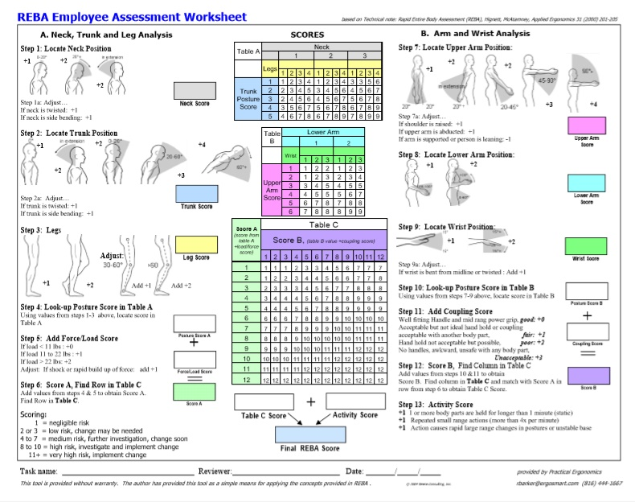It is an ergonomic assessment tool that uses systematic process to evaluate whole body postural MSD and risk associated with job task. The researchers used a single page worksheet to evaluate required or selected body posture, forceful exertions due to load, type of movement or actions, repetitions, and coupling with regard in the process of lifting and transferring patient from bed to stretcher or wheelchair. The researcher used a separated worksheet for the data in transferring patients from bed to stretcher and another data for transferring patient from bed to wheelchair.

*Figure 3.1* REBA Assessment worksheet

Using the REBA worksheet, the researchers assigned a score for each of the following body regions: wrist, forearm, elbows, shoulders, neck, trunk, legs and knees. After the data for each region is collected and scored, tables on the form are then used to compile the risk factor variables, generating a single score that represents the level of MSD risk:

*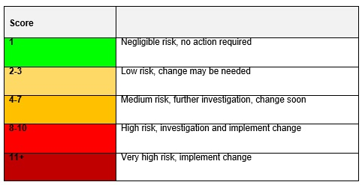Table 3* MSD Score sheet

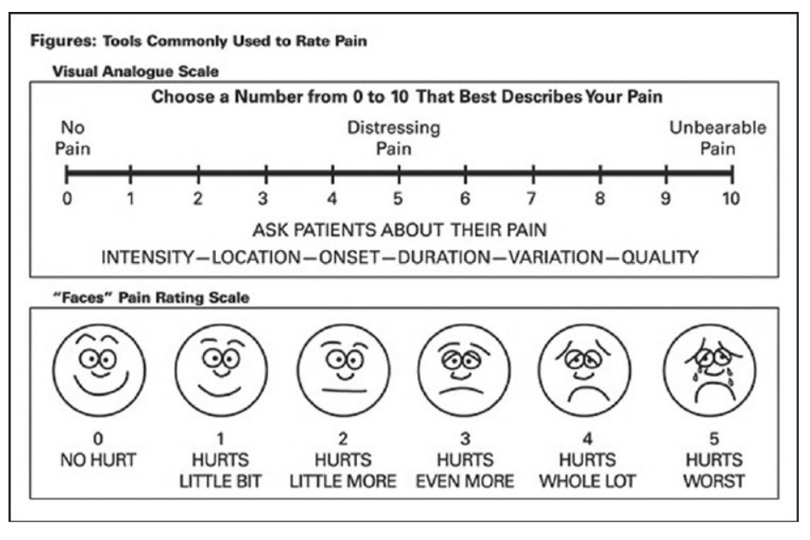 **VAS** or **Visual Analog Scale –** This research instrument is an ergonomic tool that was used by the researchers to asses and determine the level of pain the healthcare workers are experiencing in every part of their body during the process of lifting and transferring of patients. This tool was included on the survey questionnaire that was distributed to the healthcare workers.

***Figure 3.2***REBA score table

*Source: Researchgate.net*

*Figure 3.2* VAS Scoring sheet

**Statistical tool:**

The researchers used a statistical tool to analyze the comparison between the result of pre-test and post-test survey. After the comparison, this tool will prove the effectiveness using the proposed hospital bed for reducing MSDs among healthcare workers in the process of lifting and transferring patient from bed to stretcher or wheelchair

**Process Flowchart**

*Figure 3.3* Process Flowchart

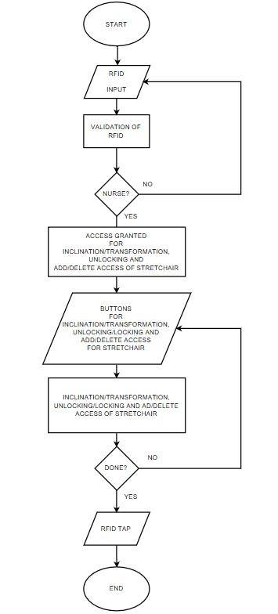

The process of the researcher’s system starts with RFID input, if the RFID that was input is not valid, it will ask another input; else if valid, it will allow the buttons for transformation, inclination and unlocking of stretchair or hospital bed. Thus, after pushing a button for unlocking of equipment, it will unlock the stretchair.

**Block Diagram**

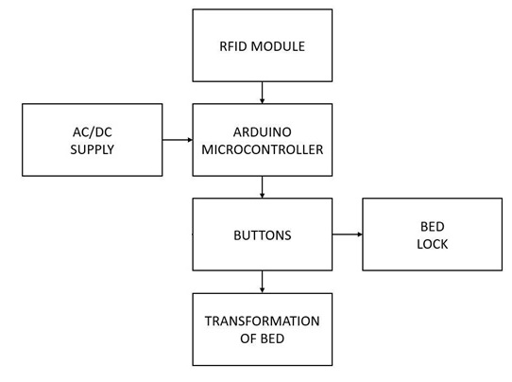

*Figure 3.4* Block Diagram

**Hardware and Software components**

**Microcontroller**

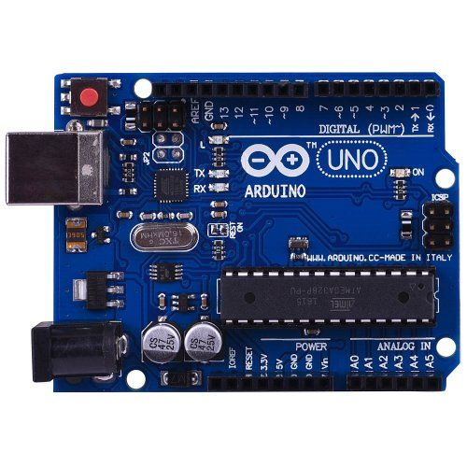

*Figure 3.5* Arduino Uno

**Arduino Uno** is a microcontroller board based on the ATmega328. It has 14 digital input/output pins (of which 6 can be used as PWM outputs), 6 analog inputs, a 16 MHz quartz crystal, a USB connection, a power jack, an ICSP header and a reset button. This microcontroller will control the RFID Lock/Unlock technology and the motor control in the prototype.

**RFID Arduino Module**

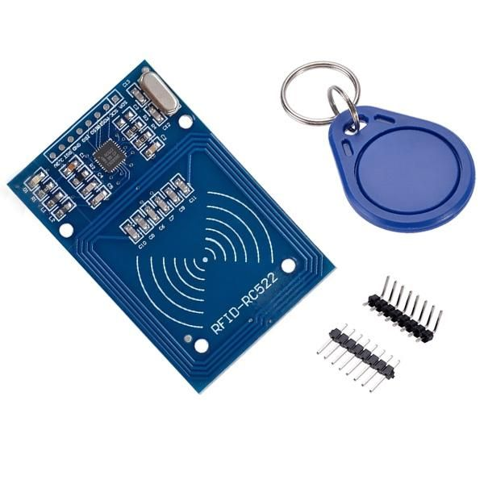

*Figure 3.6* MFRC522 Arduino Module

This RFID (Radio-Frequency Identification) Arduino module is used to control the locking and unlocking of the wheelchair to the hospital bed. RFID systems have two main components, a transponder or a tag which is located on the object or person that the user wants to identify, in this case, it is the wheelchair, and a transceiver or a reader.

**Light-Emitting Diodes (LED)**

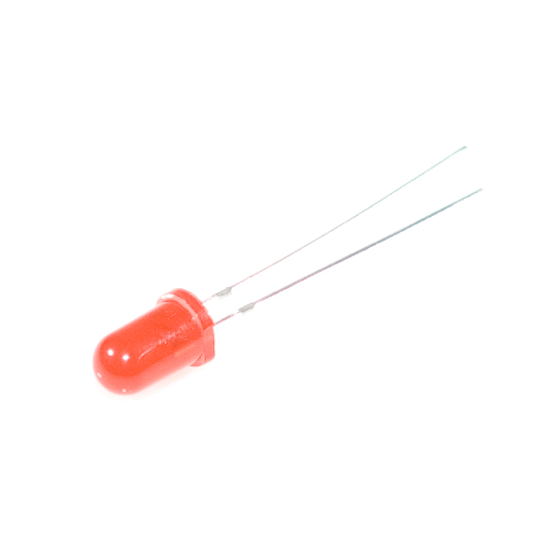

*Figure 3.7* Light-Emitting Diodes

*Rouse (2012)* said that a light-emitting diode (LED) is a semiconductor device that emits visible light when an electric current passes through it. LEDs have no filaments that will burn out and LEDs do not heat up, unlike the traditional incandescent light bulbs. LEDs illuminated solely by the movement of electrons in a semiconductor material. In this study, LEDs will be used as a signaling element that will light if the RFID tag have been given access or not.

**Push Button**

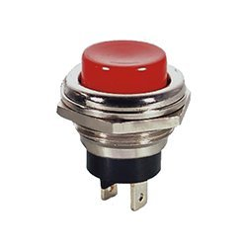

*Figure 3.8* SPST Normally Push Button

A push-button or simply button is a simple switch mechanism for controlling some aspect of a machine or a process. Buttons are typically made out of hard material, usually plastic or metal. The surface is usually flat or shaped to accommodate the human finger or hand, so as to be easily depressed or pushed. This was used by the researchers for the purpose of having control buttons for the slope transformation, lock/unlock of the stretchair and the emergency stop during the process of transforming from stretcher to wheelchair.

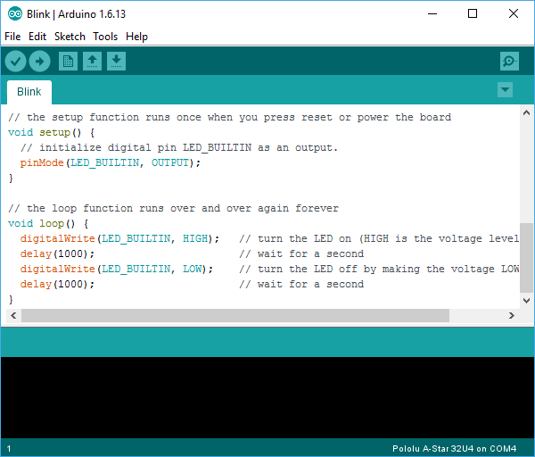**Arduino IDE**

*Figure 3.9* Arduino IDE Application Sample

The Arduino Integrated Development Environment - or Arduino Software (IDE) - contains a text editor for writing code, a message area, a text console, a toolbar with buttons for common functions and a series of menus. It connects to the Arduino and Genuino hardware to upload programs and communicate with them.

**CAD (Computer Aided Design)**



*Figure 3.10* Computer Aided Design

Computer-Aided Design (CAD) is a computer technology that designs a product and documents the design's process. CAD may facilitate the manufacturing process by transferring detailed diagrams of a product’s materials, processes, tolerances and dimensions with specific conventions for the product in question. It can be used to produce either two-dimensional or three-dimensional diagrams, which can then when rotated to be viewed from any angle, even from the inside looking out. A special printer or plotter is usually required for printing professional design renderings.

**Stainless Steel**

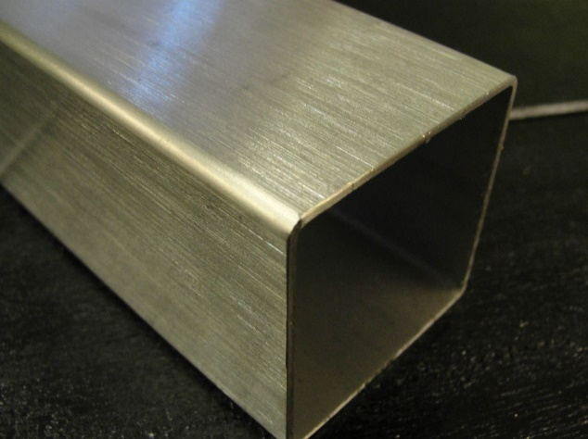

*Figure 3.11* Stainless Steel 304

**Stainless steel** types 304 and 304L. Type 304 is the most versatile and widely used stainless steel. It is also known as 18/8 from the nominal composition of type 304 being eighteen percent (18%) chromium and eight (8%) nickel in valves and dampers, and in many other places where linear motion is required. Hydraulic or pneumatic cylinders inherently produce linear motion. Many other mechanisms are used to generate linear motion from a rotating motor.

**Linear Actuator**

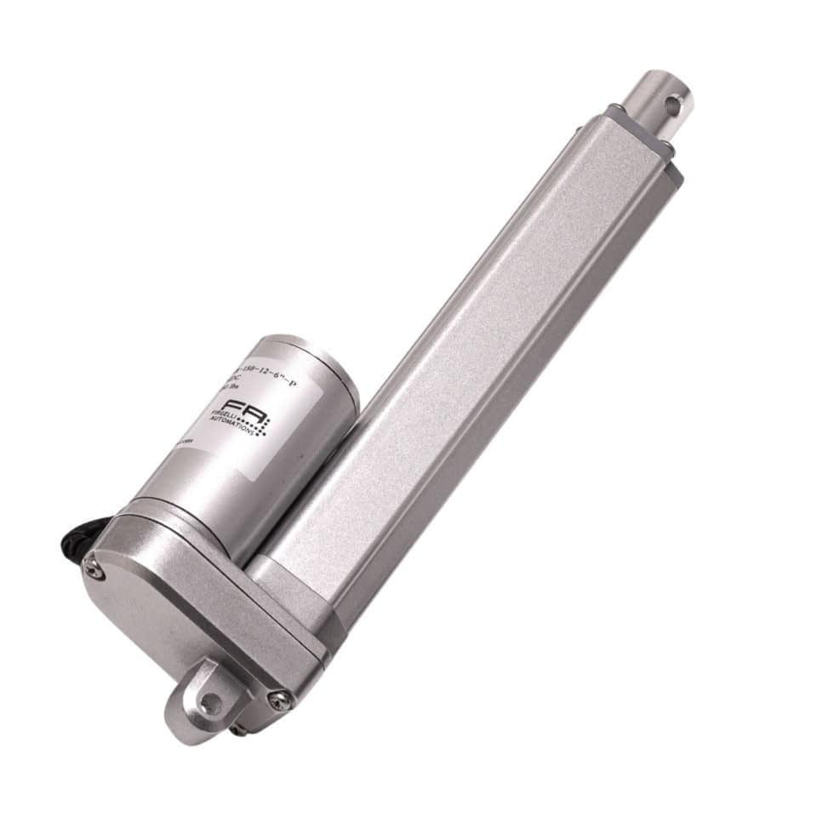

*Figure 3.12*Linear Actuator

In simple terms, a linear actuator is a mechanical device that creates motion in a linear, or straight, line. This varies significantly from the circular motion that is created by conventional motors, thus making the linear actuator unique in its operation. An electric linear actuator is a device that converts the rotational motion of a motor into linear motion – that is push and pull movements. This way it is possible to lift, adjust, tilt, push or pull heavy or hard-to-reach objects, simply by pushing a button. Additionally, actuators provide a safe, quiet and clean movement with accurate motion control. They are energy efficient and have a long lifetime with little or no maintenance. Installing an actuator is very easy compared to hydraulic or pneumatic systems and it takes up much less space, as it has no pumps or hoses. The ability of the actuators to adapt to specific needs ensures well-functioning solutions that are applied in many different aspects for a wide range of applications and products.

**Wheel**

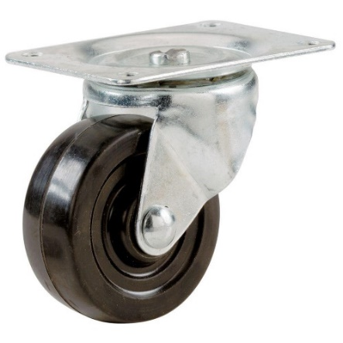

*Figure 3.13* Caster Wheel

A caster (also known as *castor* according to some dictionaries) is a wheeled device typically mounted to a larger object that enables relatively easy rolling movement of the object. Casters are essentially housings that include a wheel and a mounting to install the caster to objects (equipment, apparatus and more). Casters are found virtually everywhere, from office desk chairs to shipyards, and from hospital beds to automotive factories. They range in size from the very small furniture casters to massive industrial casters, and individual load capacities span 100 pounds (45 kg) or less to 100,000 pounds (45 t). Wheel materials include cast iron, plastic, rubber, polyurethane, polyolefin, nylon, thermoplastic rubber, forged steel, stainless steel, aluminum, and more.

**Bolts**

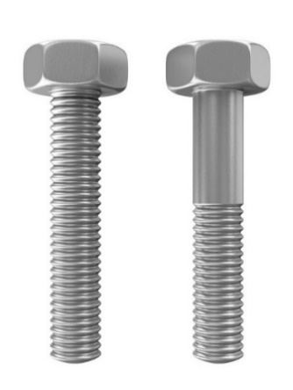

*Figure 3.14* Hex Bolts

A bolt is a form of threaded fastener with an external male thread. Bolts are closely related to, and often confused with, screws.

**Fastener**

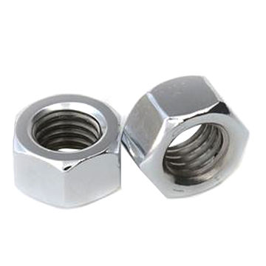

*Figure 3.15* Hex Nuts

A nut is a type of fastener with a threaded hole. Nuts are almost always used in conjunction with a mating bolt to fasten multiple parts together. The two partners are kept together by a combination of their threads' friction (with slight elastic deformation), a slight stretching of the bolt, and compression of the parts to be held together.

**Magnetic Lock**

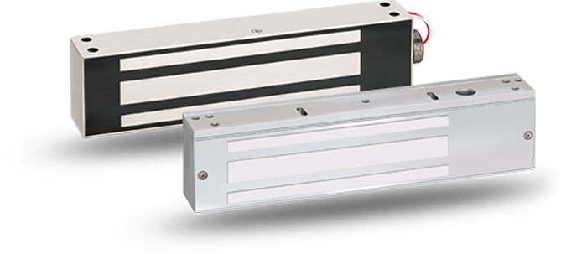

*Figure 3.16* Magnetic Lock

An electromagnetic lock, is a locking device that consists of an electromagnet and an armature plate. There are two main types of electric locking devices. Locking devices can be either "fail safe" or "fail secure". A fail-secure locking device remains locked when power is lost. Fail-safe locking devices are unlocked when de-energized. Direct pull electromagnetic locks are inherently fail-safe. Typically the electromagnet portion of the lock is attached to the door frame and a mating armature plate is attached to the door. The two components are in contact when the door is closed. When the electromagnet is energized, a current passing through the electromagnet creates a magnetic flux that causes the armature plate to attract to the electromagnet, creating a locking action. Because the mating area of the electromagnet and armature is relatively large, the force created by the magnetic flux is strong enough to keep the door locked even under stress.

**System Model**

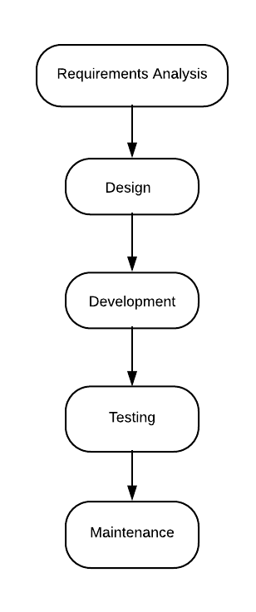

*Figure 3.17* Waterfall System Model

The researcher have used waterfall system model for it is the most suited or logical model to use for the topic. The researcher for this study need to ensure the comfortability of the nurses when using the proposed equipment and the durability of bed for the safety of patients.

**Proposed Design**

Below are the illustrations of the proposed design of ergonomically designed smart hospital bed with attachable – detachable “Stretchair”:

**Ergonomically Designed Smart Hospital bed with attachable - detachable Stretchair** (when Stretchair is attached)

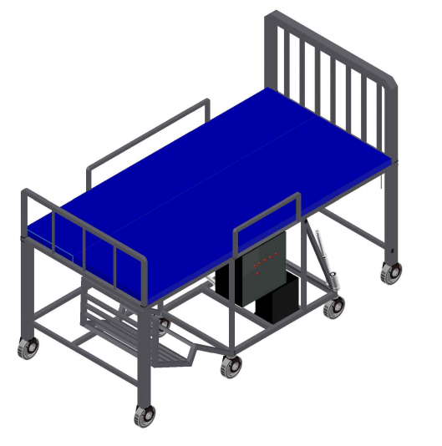

*Figure 3.18* Ergonomically Designed Smart Hospital bed with attachable - detachable Stretchair

**Stretchair (when stretchair is detached)**

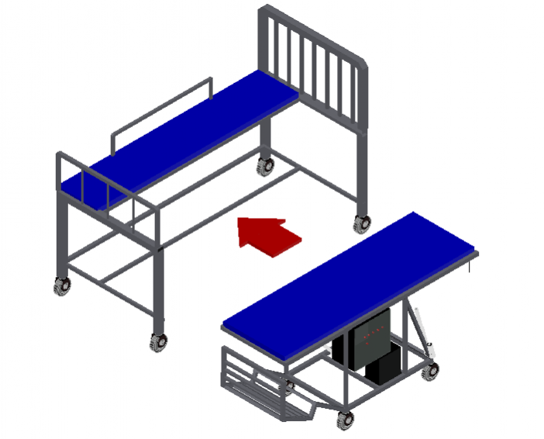

*Figure 3.19*Stretchair Design

**Stretcher Mode**

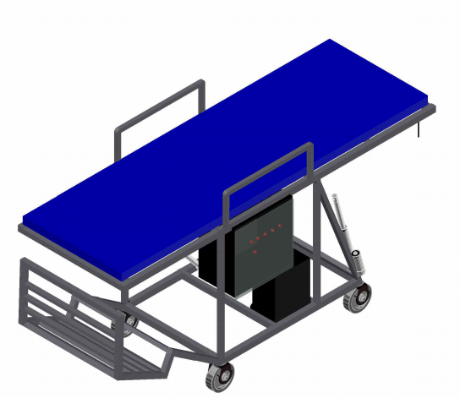

*Figure 3.20*Stretcher Mode Design

**Wheelchair Mode**

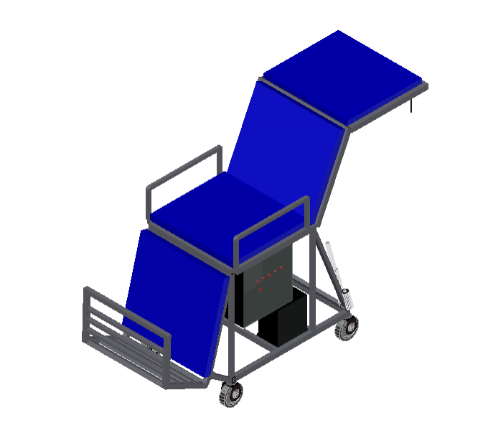

*Figure 3.21*Wheelchair Mode Design

**Dimensions of the proposed design**

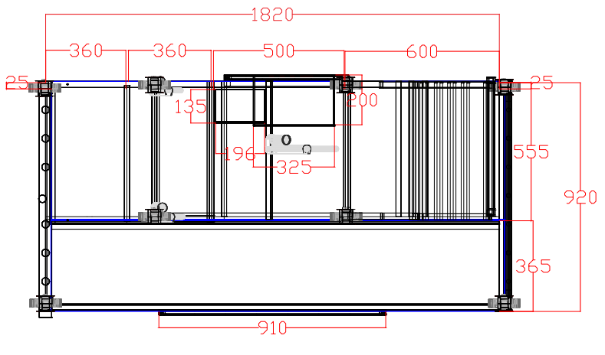

*Figure 3.22*Dimension of the proposed design top view

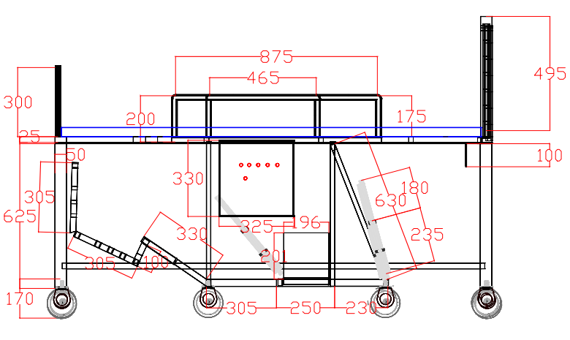

*Figure 3.23*Dimension of the proposed design side view

**Project testing, evaluation and validation**

In order to fulfill certain requirements, the proposed Ergonomically Designed Smart hospital bed with attachable – detachable Stretchair will be tested, evaluated and validated in different aspects.

**Functionality Test**

During the functionality test, the proposed ergonomically designed smart hospital bed with attachable – detachable stretchair is tested under certain conditions to determine if it complies with its specified functionality requirements. The researcher conducted an inspection through paper checklist to determine if the proposed equipment complies on its intended function.

**User-Friendliness Test**

The respondents will try out the system, and will pay attention to the following considerations: how comprehensive the user interface and how the demo can clearly explain the system’s function. The result of the survey is tabulated and the weighted arithmetic mean are calculated, based on Equation (1)

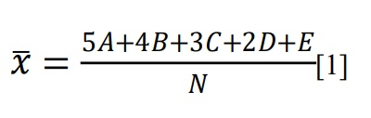Where N = number of respondents

A, B, C, D and E = number of responses for the ratings 5,4,3,2, and 1 respectively.

The result was based in the grading scale shown in Table 1

*Table 3.1* User’s FriendlinessGrading Scale

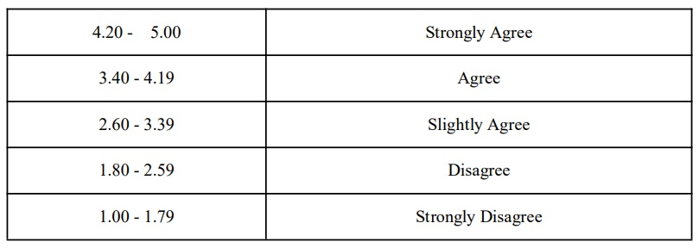

**Effectiveness**

Pre-survey and Post-survey to the healthcare worker of General Emilio Aguinaldo Memorial hospital and Korean – Philippine friendship hospital are conducted to determine the effectiveness of the proposed equipment. To test and validate the pre-survey and post- survey, the researcher had used Statistical tool to compare the result and through this method, the researchers were able to determine the effectiveness of the proposed equipment.

**Effectiveness of Reducing of MSD risk factor**

Re-evaluation of REBA (Rapid Entire Body Assessment) was conducted to determine if the level of MSD risks are lessened.

**Accuracy in determining the Standard set – up time**

The researcher computed the accuracy using sample size formula for the validation in determining the standard set up time for the process of transferring patient from hospital bed going stretcher and wheelchair.

Below is the formula in computing sample size:

*n = ${\left(\frac{zs}{e}\right)}^{2}$*

Where:

*n =* sample size the researchers want to determine

*z =* number of normal standard deviations needed for desired confidence

*s =* sample standard deviation

*e =* maximum acceptable error

Typical values of z used in this computation are:

*Table 3.2* Typical values of z

|  |  |
| --- | --- |
| **Desired Confidence (%)** | ***z Value*** |
| 90 | 1.65 |
| 95 | 1.96 |
| 95.5 | 2.00 |
| 98 | 2.33 |
| 99 | 2.58 |

**CHAPTER IV**

**RESULT AND DISCUSSION**

**Presentation of project and design**

This chapter provides the result and discussion of various testing methods, illustrations of existing hospital equipment, proposed hospital equipment and analysis of Data gathered from the series of testing applied. By conducting researches and design planning, the researchers were able to meet the major objectives which is to reduce the risk of musculoskeletal disorder among health worker who are involved in the process of transferring patients from hospital bed going to stretcher and wheelchair. The researcher compared the result of the pre – test and post - test survey result and discussed the significanct differences.

**Initial gathering of information**

About six (6) months ago the researchers were able to gather information and conducted an initial survey among forty – two (42) healthcare workers of General Emilio Aguinaldo Memorial hospital and Korean – Philippines Friendship Hospital, who are involved in lifting and transferring patients from hospital bed going to Stretcher and Wheelchair. These information were used by the researchers during the proposal defense of the study to prove that there is problem that should be solved or improved for the said process. Moreover, the researchers were able to observe the nature of work of the healthcare worker and what are the equipment that are being used during the process of transferring. Through this, analysis was done for the benefits of the development of the study.

**Existing Hospital bed, stretcher, wheelchair and traditional way of transferring.**

The existing hospital equipment that are involved in the process of transferring are separated from stretcher and wheelchair which makes the health workers exert more physical strength in lifting and carrying patients during the transferring method. Researchers proved that the risk of musculoskeletal disorder during transferring and using of existing hospital equipment is very high. And through survey, it was revealed that 100% of health care workers respondents are experiencing different level of pain on different parts of their body.The following illustrations that are attached below are based from the existing hospital equipment that are being used inside the General Emilio Aguinaldo Memorial hospital and Korean – Philippines Friendship hospital.

|  |  |
| --- | --- |
| **Existing hospital Bed** | |
| *Figure 4.1* Existing Hospital bed | *Figure 4.2* Existing Hospital bed |
| *Figure 4.3* Existing Hospital bed | *Figure 4.4* Existing Hospital bed |

|  |
| --- |
| **Existing wheelchair** |
| *Figure 4.5* Existing Wheelchair |

|  |  |
| --- | --- |
| **Existing stretcher** | |
| *Figure 4.6* Stretcher | *Figure 4.7* Existing Stretcher |
| *Figure 4.8* Stretcher | *Figure 4.9* Stretcher |

|  |  |
| --- | --- |
| **Existing way of transferring patient from hospital bed to Wheelchair** | |
| *Figure 4.10* Existing way of transferring from hospital bed to Wheelchair | *Figure 4.11* Existing way of transferring from hospital bed to Wheelchair |
| **Existing way of transferring patient from hospital bed to stretcher** | |
| *Figure 4. 12* Existing way of transferring from hospital bed to Stretcher | |
| *Figure 4.13* Existing way of transferring from hospital bed to Stretcher | *Figure 4.14* Existing way of transferring from hospital bed to Stretcher |

**Proposed Hospital Bed Equipment: The “Stretchair”**

This proposed hospital equipment aims to improve the process of transferring the patient from hospital bed going to stretcher, wheelchair and vice versa that can reduce the Physical use and risk of MSDs of healthcare workers.

For the transformation of hospital bed to stretcher, using the lock/unlock mechanism which would make the stretchair (¾ portion of the hospital bed) detached from the hospital bed in an efficient manner, the users would just push the lock/unlock button in order for them to detach the stretchair by pulling it from the other portion of the hospital bed.

For the wheelchair transformation, the users would just push the button that has preset values which is 0, 45 and 88 degree slope of wheelchair back rest and a fixed slope for the lower part of the body with its foot rest. This proposed equipment and transformation reduces the physical strain experienced by the healthcare workers from carrying and lifting the patient when transferring.

**Actual Photo of the proposed hospital bed/equipment.**

***Hospital bed Mode***

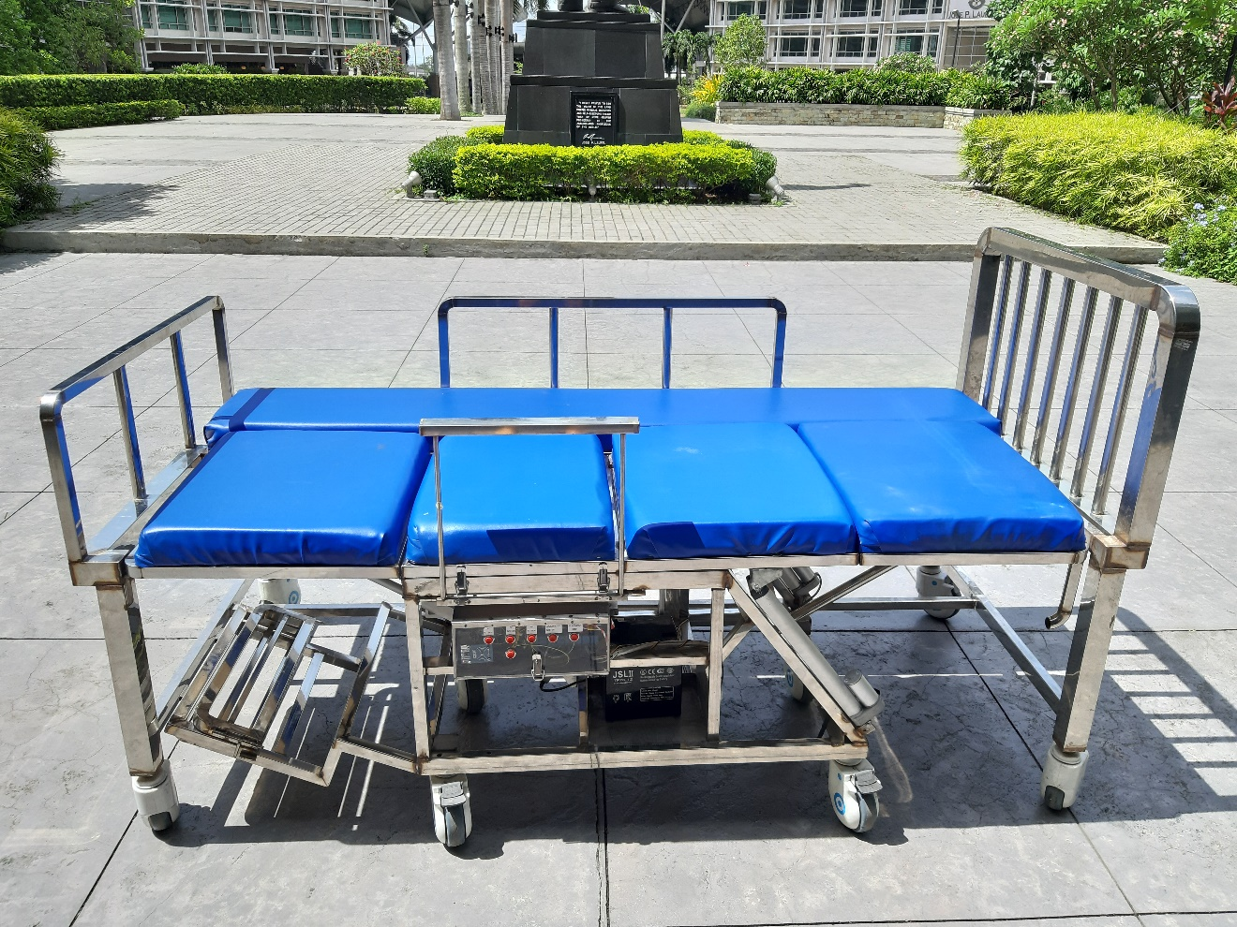

*Figure 4.15* Actual Photo of Hospital bed Mode

***Stretcher Mode***

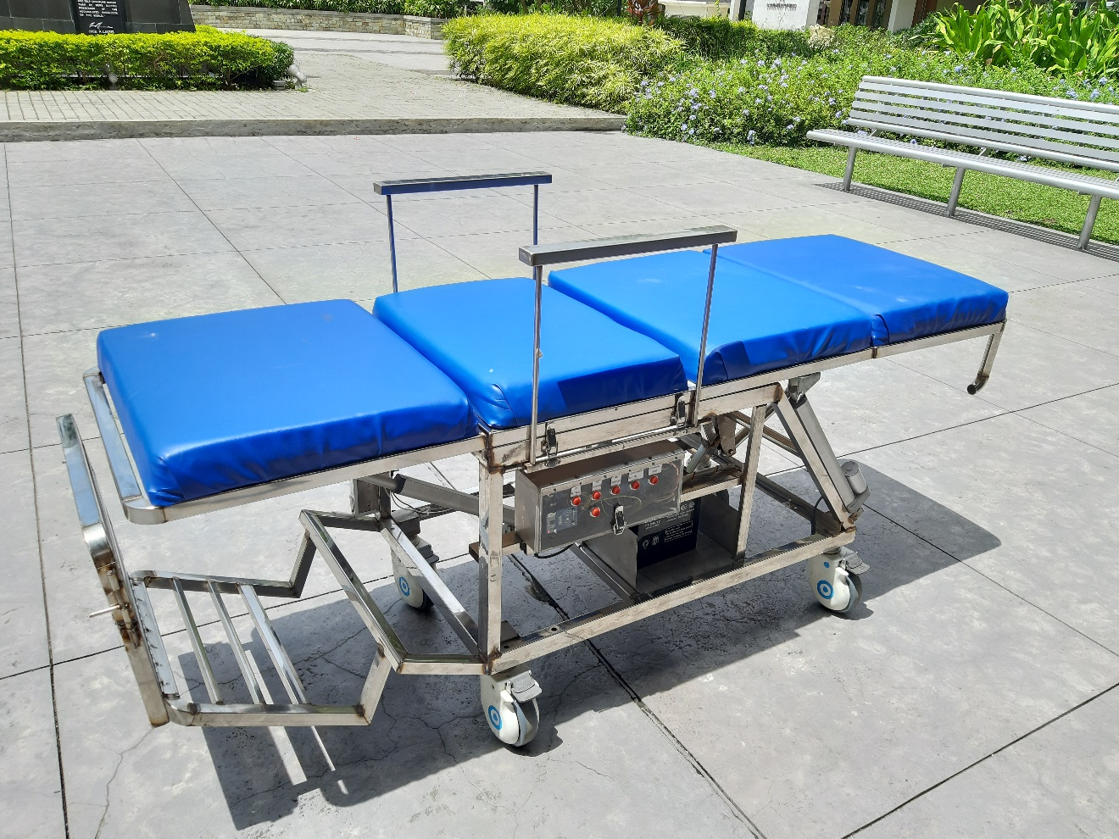

*Figure 4.16* Actual Photo of Stretcher Mode

***Wheelchair Mode***

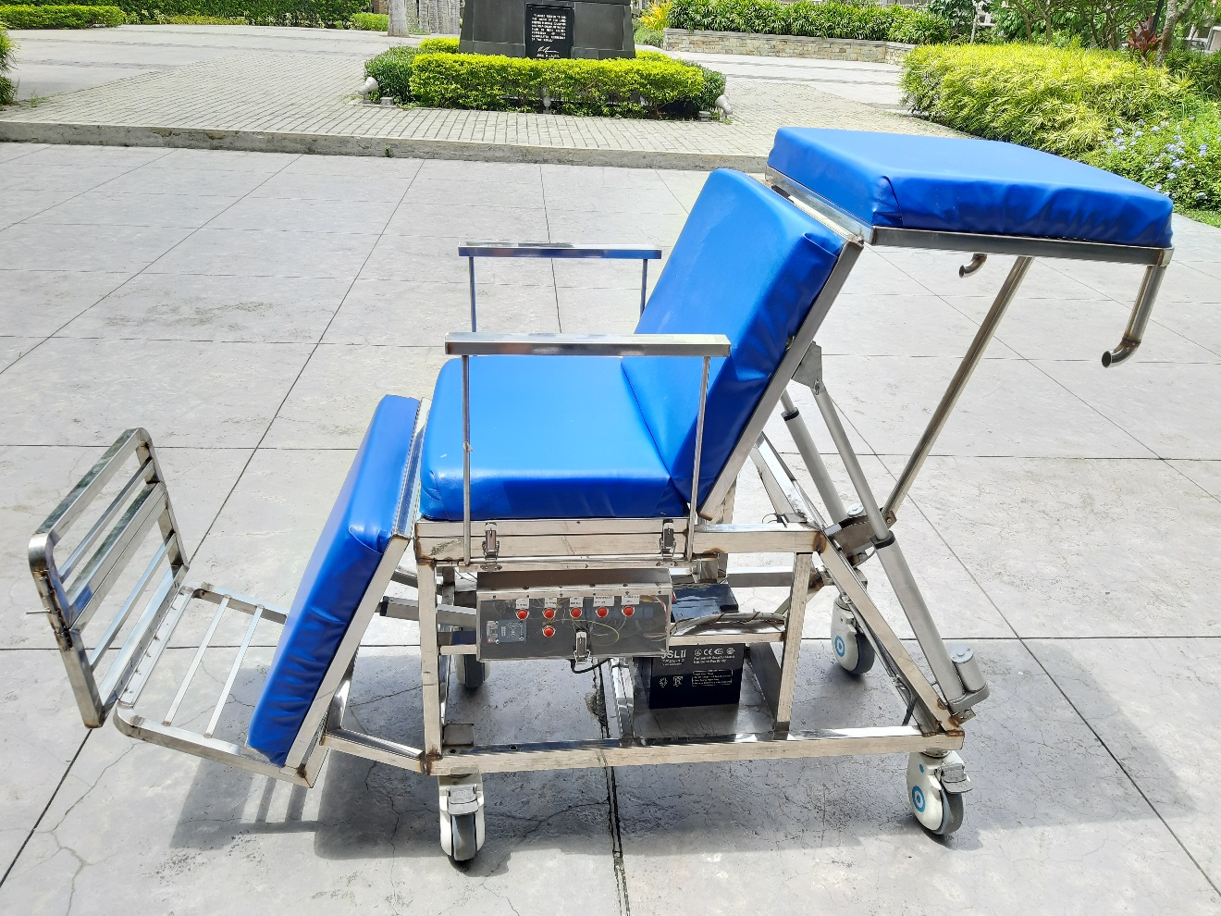

*Figure 4.17* Actual Photo of Wheelchair

**Machine mechanism**

**Inclination and transformation**

This mechanism lets the project to incline or transform to the desired inclination of 45° or transform onto a wheelchair using linear actuator to move the upper part and lower part of the stretchair. As the inclination or transformation is undergoing, it could not be stopped unless “emergency stop” button was pushed.

**Locking and Unlocking of the Stretchair**

This part of mechanism lets the stretchair to be unlocked or locked with the help of magnetic lock that was installed on the stationary part of the bed.

**Emergency Stop**

This part was to stop the process abruptly for the purpose of safety or jamming of something during the process of transformation or inclination. This will let the user have time to stop an accident or wrecking the project. Users could not push another button if they push the “EMERGENCY STOP” button unless they push the “EMERGENCY STOP” button again to revert it back to stretcher mode.

**Parts of the Proposed Prototype**

This part shows the illustrations and description of parts of the proposed prototype

*Table 4* Parts of the Proposed Prototype

|  |  |
| --- | --- |
| **Parts** | **Description** |
| **Caster Wheels** | Caster wheelsare those which are made specifically for the purpose of providing portability to care beds, wheelchair and stretchers or hospital. |
| **Handgrip** | The push handle is located on the back of the wheelchair and allows the user to stand straighter. |
| **Arm rest of the wheelchair** | Arm rests are secured to the frame in two places and it can be assembled manually after using the stretcher mode. |
| **Foot rest of the wheelchair** | A fixed foot plate is attached to provide support surface where the user’s foot is resting on top of it. |
| **Frame** | The frame is the rigid and tubular structure that supports the seat, wheels, hospital bed and stretcher. |
| **Controls** | The controls of the Stretchair has its 0 degree, 45 degree, 88 degree and emergency stop buttons on it. And it is attached of RFID Arduino module on the left side part of the control.  This control allows the user to have an access when transforming stretcher mode to wheelchair mode and vice versa. |
| **Head board** | A frame that is attached on the head and end of the hospital bed. |
| **Side Rails** | A side rails is put on the left side of the hospital bed which serves as protection for the patient and prevent patient from falling. |

**Operation of the proposed prototype**

Table 4.5 and Table 4.6 Shows the step by step process of using the proposed prototype when transferring patients.

*Table 4.1* Hospital Bed to Stretcher Mode Process

|  |  |
| --- | --- |
|  | **HOSPITAL BED TO STRETCHER MODE PROCESS** |
| **1** | Switch on the Stretchair |
| **2** | Tap the RFID Card to the RFID Scanning Device |
| **3** | Unlocking the Strechair to its Hospital Bed. |
| 4 | Attaching or Detaching the Stretchair by pulling or pushing |
| 5 | Deploying the side-arms |
| 6 | Navigating the Stretchair |
| 7 | Attaching the Stretchair back to its Hospital Bed. |
| **8** | Locking the Stretcher to its Hospital Bed |

*Table 4.2* Hospital Bed to Wheelchair Mode Process

|  |  |
| --- | --- |
|  | **HOSPITAL BED TO WHEELCHAIR MODE PROCESS** |
| **1** | Switch on the Stretchair |
| **2** | Tap the RFID Card to the RFID Scanning Device |
| **3** | Unlocking the Strechair to its Hospital Bed. |
| 4 | Attaching or Detaching the Stretchair by pulling or pushing |
| 5 | Deploying the side-arms |
| **6** | Increase or Decrease the Stretchairs’ Slope |
| 7 | Navigating the Stretchair in Wheelchair mode. |
| 8 | Attaching the Stretchair back to its Hospital Bed. |
| **9** | Locking the Stretcher to its Hospital Bed. |

**Components Specification**

|  |  |  |
| --- | --- | --- |
| **Illustration** | **Specification** | |
| *https://cdn.shopify.com/s/files/1/0615/2193/products/FA-35-12-X-P_1_v2_2x_d0d1c580-2bb5-4cbc-877e-365ae727c333_1024x1024.jpg?v=1551467775Figure 4.18* Linear Actuator  Specification  **Linear Actuator** | STROKE LENGTH: | 300mm |
| INPUT VOLTAGE: | 12VDC |
| SPEED: | 12mm / s |
| MAX PUSH LOAD: | 900N |

|  |  |  |
| --- | --- | --- |
| Image result for arduino mega*Figure 4.19* Arduino Mega  Specification  **Arduino Mega** | OPERATING VOLTAGE: | 5V |
| INPUT VOLTAGE: (RECOMMENDED) | 7-12V |
| INPUT VOLTAGE (LIMIT): | 6-20V |
| DC CURRENT PER I/O PIN: | 40mA |
| DC CURRENT FOR 3.3V PIN: | 50mA |

|  |  |  |
| --- | --- | --- |
| Image result for RFID arduino module  *Table 4.20* RFID Reader Specification  **RFID Reader** | OPERATING FREQUENCY: | 13.56MHz |
| SUPPLY VOLTAGE: | 3.3V |
| CURRENT: | 13-26mA |
| READ RANGE: | APPROX. 3CM |
| MAX DATA TRANSFER: | 10Mbit / s |

|  |  |  |
| --- | --- | --- |
| *Image result for step down regulatorTable 4.21* Stepdown Regulator Specification  **Stepdown Regulator** | INPUT VOLTAGE: | 4.5-40 VDC |
| OUTPUT VOLTAGE: | 1.5-35 VDC |
| VOLTAGE REGULATION: | + / - OF 0.5% |
| OPERATING TEMPERATURE RANGE: | -40℃ ~ +85℃ |

|  |  |  |
| --- | --- | --- |
| Image result for magnetic lock  *Table 4.22* Magnetic Lock Specification  **Magnetic Lock** | CURRENT DRAW | 500mA @ 12VDC : 250mA @ 24VDC |
| OPERATING TEMPERATURE RANGE: | -10 ~ 55℃ |
| HOLDING FORCE: | UP TO 1200 lbs |

|  |  |  |
| --- | --- | --- |
| Related image  *Table 4.23* Battery Specification  **Battery** | VOLTAGE: | 12V |
| CAPACITY: | 26Ah |

**Result of testing, evaluation and validation**

One of the major parts of this study is presenting all of the results of testing, evaluation and validation of it. This will also prove if the researcher fulfilled the objectives of the study. This part consists of different kinds of testing methods, evaluation and validation process.

**Initial data gathering method and survey test**

This data was used by the researchers for them to support the proposal period of this study. About six (6) months ago the researchers gathered information and conducted an initial survey from forty – two (42) healthcare workers of General Emilio Aguinaldo Memorial Hospital and Korean – Philippines Friendship hospital in order for this study to prove that there is pain experiencing in the existing way of transferring patients from Hospital Bed going to stretcher or wheelchair and vice versa.

The following are the REBA evaluation result and survey result of the initial test which consist their demographic profile and their pain experiencing during the transferring method.

**Demographic profile**

* + - **Gender Preference of the Respondents**

*Table 4.**3* Percentage of Gender according to Survey result

|  |  |  |
| --- | --- | --- |
| **Gender of the Respondents** | | |
| **Sex Category** | **Frequency** | **Percentage** |
| Male | 19 | 45.20% |
| Female | 23 | 54.80% |
| Total | 42 | 100% |

* + - **Age of the Respondents in Years**

*Table 4.4* Percentage of Age according to survey result

|  |  |  |
| --- | --- | --- |
| **Age of the Respondents** | | |
| Age interval | Frequency | Percentage |
| 21 – 25 | 5 | 11.90% |
| 26 – 29 | 10 | 23.80% |
| 30 – 35 | 10 | 23.80% |
| 36 – 40 | 2 | 4.80% |
| 41 – 45 | 6 | 14.30% |
| 46 – 50 | 9 | 21.49% |
| Total | 42 | 100% |

* + - **Profession of the Respondents**

*Table 4.5* Percentage of Position of the Respondents in the Hospital

|  |  |  |
| --- | --- | --- |
| **Position of the respondents in the Hospital** | | |
| Position | Frequency | Percentage |
| IWD | 15 | 35.70% |
| Nurse | 27 | 64.30% |
| Total | 42 | 100% |

**Work and Pain Experiences**

***From hospital bed to Stretcher***

* + - **Frequency of the Respondents who are Carrying and Transferring Patient from Hospital Bed to Stretcher and Vice Versa**

|  |  |  |
| --- | --- | --- |
| **Response** | **Frequency** | **Percent** |
| Yes | 42 | 100% |

*Table 4.6* Percentage of response if they are carrying and transferring patients from Hospital Bed to Stretcher and Vice Versa

* + - **Response of the Respondents if they are Experiencing Pain Cause by Carrying/Transferring Patient**

*Table 4.7*Percentage of response if they are experiencing pain/tiredness

|  |  |  |
| --- | --- | --- |
| **Response** | **Frequency** | **Percentage** |
| Meron | 42 | 100% |

* + - **Level of Pain in every parts of the body**

*Table 4.8*Level of Pain in Different Parts of the Body Experienced by the Respondents when Transferring/Carrying patients from hospital bed to Stretcher and vice versa

|  |  |  |  |
| --- | --- | --- | --- |
| **Body parts** | **Mean** | **Std. Deviation** | **Interpretation** |
| Neck | 0.69 | 1.158 | Walang sakit |
| Shoulder | 1.81 | 1.311 | Di Gaano kasakit |
| Upper Back | 2.64 | 1.032 | Masakit |
| Elbow | 1.02 | 1.220 | Di Gaanong Kasakit |
| Lower Back | 2.60 | 1.191 | Masakit |
| Arm Wrist | 2.12 | 1.596 | Masakit |
| Thigh | 1.71 | 1.367 | Di Gaanong Kasakit |
| Knee | 1.52 | 1.418 | Di Gaanong Kasakit |
| Calf or Leg | 1.57 | 1.417 | Di Gaanong Kasakit |
| Feet or Ankle | 1.38 | 1.481 | Di Gaanong Kasakit |
| Finger | 1.10 | 1.226 | Di Gaanong Kasakit |

*Note:*

*5.00 – 4.00 Sobrang sakit 3.99 – 3.00 Nakakaabalang Sakit*

*2.99 – 2.00 Masakit 1.99 – 1.00 Di Gaano Kasakit*

*0.99 – 0.00 Walang sakit*

Table 4.6 and 4.7 shows the result of pain experienced during transferring of patients from Hospital bed going to stretcher and it has shown that 100% of those health worker who are involved on this process was experiencing pain. While table 4.8 shows the body parts that are most likely to experience pain which are upper back, lower back and arm wrist, the rest are having only mild pain.

***From hospital bed to wheelchair***

* + - **Frequency of the Respondents who are Carrying and Transferring Patient from Hospital Bed to wheelchair and Vice Versa**

| **Response** | **Frequency** | **Percent** |
| --- | --- | --- |
| Yes | 42 | 100% |

*Table 4.9* Percentage of response if they are carrying and transferring patients from Hospital Bed to Wheelchair and Vice Versa

* + - **Response of the Respondents if they are Experiencing Pain Cause by Carrying/Transferring Patient**

*Table 4.10*Percentage of response if they are experiencing pain/tiredness

|  |  |  |
| --- | --- | --- |
| **Response** | **Frequency** | **Percentage** |
| Meron | 42 | 100% |

* + - **Level of Pain in every parts of the body**

*Table 4.11*Level of Pain in Different Parts of the Body Experience by the Respondents when Transferring/Carrying patients from hospital bed to Wheelchair and vice versa

|  |  |  |  |
| --- | --- | --- | --- |
| **Body parts** | **Mean** | **Std. Deviation** | **Interpretation** |
| Neck | 0.67 | 1.119 | Walang Sakit |
| Shoulder | 2.07 | 1.156 | Msakit |
| Upper Back | 2.60 | 1.037 | Masakit |
| Elbow | 0.74 | 1.014 | Walang Sakit |
| Lower Back | 2.67 | 0.928 | Masakit |
| Arm Wrist | 1.62 | 1.268 | Di Gaano Kasakit |
| Thigh | 1.40 | 1.466 | Di Gaano Kasakit |
| Knee | 1.50 | 1.469 | Di Gaano Kasakit |
| Calf or Leg | 1.26 | 1.308 | Di Gaano Kasakit |
| Feet or Ankle | 1.14 | 1.389 | Di Gaano Kasakit |
| Finger | 1.24 | 1.394 | Di Gaano Kasakit |

*Note:*

*5.00 – 4.00 Sobrang sakit 3.99 – 3.00 Nakakaabalang Sakit*

*2.99 – 2.00 Masakit 1.99 – 1.00 Di Gaano Kasakit*

*0.99 – 0.00 Walang sakit*

Table 4.9 and 4.10 shows the result of pain experienced during transferring of patients from Hospital bed going to stretcher and it has shown that 100% of those health workers who are involved on this process were experiencing pain. While table 4.11 shows the body parts that are most likely to experience pain which are shoulder, upper back and lower back, the rest are having only mild pain.

**REBA Evaluation from Existing/Traditional method**

Next to survey is the REBA Evaluation of traditional method of those two processes. This method is also used to determine the exposure of individual workers to ergonomic risk factor associate with entire body MSD. Using the REBA sheets, the researchers evaluate the healthcare workers that are involved in the process of transferring patients from hospital bed going to stretcher and wheelchair and assigned a score of each of the following body parts such as Neck, trunk, leg, arm and wrist.

*Table 4.12* REBA Score sheet

|  |  |
| --- | --- |
| **Score** | **Interpretation** |
| 1 | Negligible risk, no action required |
| 2-3 | Low risk, change may be needed |
| 4-7 | Medium risk, further investigation and implement change |
| 8-10 | High risk, investigation and implement change |
| 11+ | Very high risk, implement change |

The table above is the REBA score sheet that was used by the researcher to determine the interpretation based on the score that was evaluated during the REBA Assessment. It tells of how risky the method is and if it is needed for the traditional method to implement change.

***From Hospital Bed to Strecher process***

Figure shows the Initial Rapid Entire Body Assessment Evaluation for traditional lifting and transferring process from hospital bed going to stretcher.

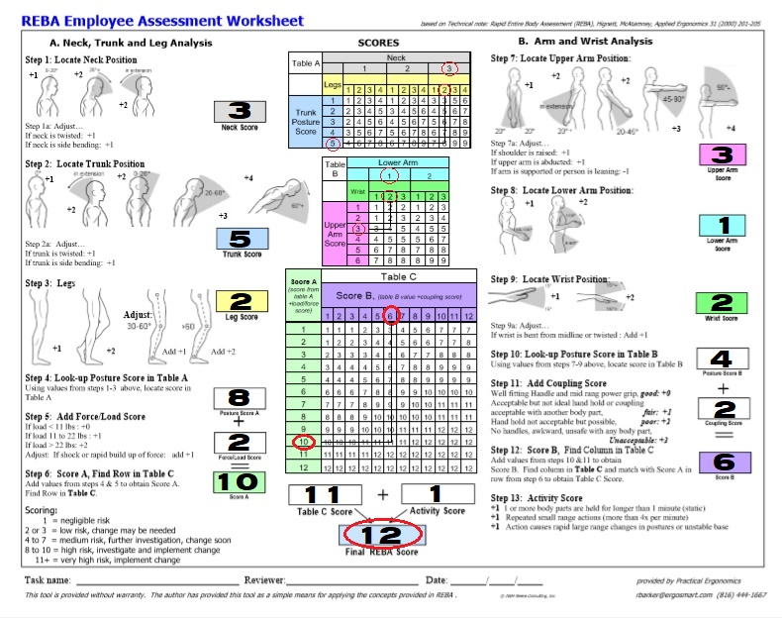

*Figure 4.24*Reba Employee Assessment for stretcher

*Table 4.13* Stretcher transferring processREBA Interpretation

|  |  |
| --- | --- |
| **Interpretation** | **Score** |
| Very High Risk, implement change | **12** |

***From Hospital Bed to Wheelchair process***

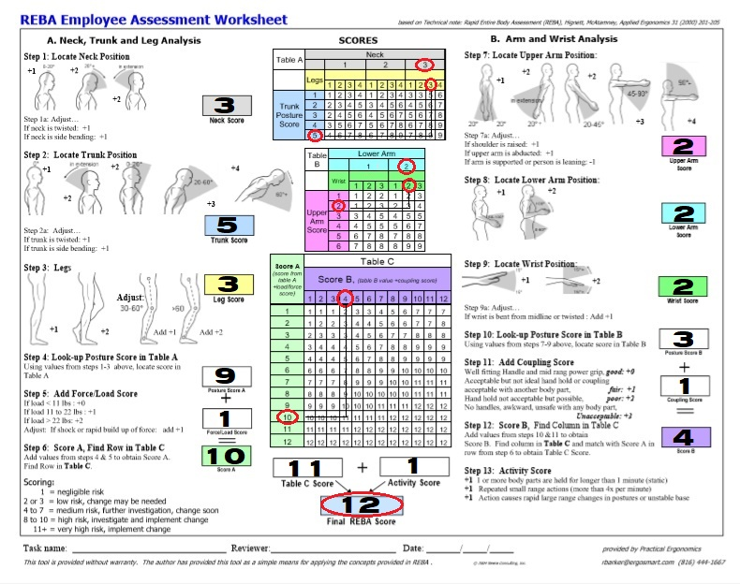Figure shows the Rapid Entire Body Assessment Evaluation for traditional lifting and transferring process from hospital bed going to wheelchair

*Figure 4.25*Reba Employee Assessment for Wheelchair

*Table 4.14* Wheelchair transferring process REBA Interpretation

|  |  |
| --- | --- |
| **Interpretation** | **Score** |
| Very High Risk, implement change | **12** |

**Analysis from Initial Data Gathering**

***Demographics***

## Based on the result, the female nurses and nursing profession had the highest frequency that are involve on the process of transferring patients and are experiencing pain during transferring, as per the article entitled “Work Related Musculoskeletal Disorders in Female Nursing Personnel: Prevalence and Impact*”* said that*,* The occurrence of WRMSDs (Work – Related Musculoskeletal Disorders) has become an occupational health concern worldwide. Female workers were said to be more likely to sustain WRMSDs due to after-work responsibilities including parenting, undertaking domestic loads, insufficient rest time and lack of exercise. Among healthcare workers, nurses were among the workers with high risks for WRMSDs because of their overwhelming burden of work. Aside from profession and gender, ages of the healthcare workers were also considered, majority of age of healthcare on this activity ranges from 26 to 29 and 30 to 35. According to article entitled “Work related musculoskeletal disorders among hospital nurses in rural Maharashtra, India: A multi centre survey**” ,** ages 25 to 35 of healthcare workers who are involved on transferring patients are more likely to carry, lift and transfer patients for they are the one who have enough strength and more capability on doing it compare to those personnel aged 35 and above.

***Pain Experienced***

The second part of the results shows the work experiences of forty – two (42) healthcare workers during Transferring and carrying of patients from Hospital bed going to Stretcher and to Wheelchair. It was proved that there is pain present for both process. It was also determined that this process contributes a big factor on having body pains from lifting and transferring of patient from bed to stretcher or wheelchair, since the survey results tells that 100% of the those healthcare workers who are involved in the said process experiencing pain on different parts of their body.

***REBA Evaluation***

By using REBA (Rapid Entire Body Assessment), Musculoskeletal Disorder factor was described on both process, with a risk score of twelve (12) which means very high risk and needs to implement change. This gathered data was serves as one of the major reasons why the proposed prototype was made. Through this, the researchers came up with the idea of designing an ergonomically smart hospital bed with attachable – detachable “Stretchair”. The term “Stretchair” is the combination of stretcher and wheelchair, and the stretcher which is the detachable part of the hospital bed can be assembled and transformed into a wheelchair. The equipment will help lessen the risk of Musculoskeletal Disorder (MSD) and provide a safer and comfortable process of transferring patient without putting the healthcare worker’s health at risk.

**Effectiveness of the proposed prototype using:**

**Post - test and Pre - test of the Proposed Hospital bed Equipment through survey**

To determine the effectiveness of the proposed prototype, the researchers conducted a Post and Pre – Test of the proposed Hospital bed equipment through survey questionnaire among twenty – five (25) Health care workers respondents of M.V Santiago Diagnostic and Medical Center. Some of the pre – test and post - test result was compared through statistical tool and analysis, and the interpretations will determine the effectiveness.

The following are survey results about their Demographic profile and the comparison of their Pain experiencing when using traditional way of transferring and when after using the proposed prototype.

**Demographic Profile**

* + - **Gender Preference of the Respondents**

| **Gender Category** | **Frequency** | **Percent** |
| --- | --- | --- |
| Male | 10 | 40% |
| Female | 15 | 60% |
| Total | 25 | 100% |

*Table 4.15* Gender preferences of the Respondents

* + - **Age of the Respondents in Years**

*Table 4.16* Age of preferences of the respondents in year

| **Age Interval in Years** | **Frequency** | **Percent** |
| --- | --- | --- |
| 21 – 25 | 8 | 24% |
| 26 – 30 | 9 | 36% |
| 31 – 35 | 6 | 32% |
| 36 – 40 | 2 | 8% |
| Total | 25 | 100% |

* + - **Profession of the resoindent**

| **Profession** | **Frequency** | **Percent** |
| --- | --- | --- |
| IWD | 6 | 24% |
| Nurse | 19 | 76% |
| Total | 25 | 100% |

*Table 4.17* Profession of the Respondents

**Work and Pain Experiences**

***From Hospital bed going to Stretcher***

**Pre – Survey:**

* + - **Frequency of the Respondents who are Carrying and Transferring Patient from Hospital Bed to Stretcher and Vice Versa**

| **Response** | **Frequency** | **Percent** |
| --- | --- | --- |
| Yes | 25 | 100% |

*Table 4.18* Frequency of the Respondents who are carrying and transferring patients from hospital bed to stretcher and vice versa

* + - **Response of the Respondents if they are Experiencing Pain Cause by Carrying/Transferring Patient**

*Table 4.19* Response of Respondents if they are experiencing pain cause by carrying/transferring patients

| **Response** | **Frequency** | **Percent** |
| --- | --- | --- |
| “Meron” | 25 | 100% |

* + - **Response of the Respondents if they are Contented to the Means of Carrying/Transferring Patient**

*Table 4.20* Response of the respondents if they are contented

| **Response** | **Frequency** | **Percent** |
| --- | --- | --- |
| Yes | 15 | 60% |
| No | 10 | 40% |
| Total | 25 | 100% |

**Post - Survey:**

* + - **Response of the Respondents if they are Experiencing Pain when carrying/Transferring Patients using Stretchair.**

*Table 4.21* Response of the Respondents if they experience pain

| **Response** | **Frequency** | **Percent** |
| --- | --- | --- |
| “Meron” | 1 | 4% |
| “Wala” | 24 | 96% |
| Total | 25 | 100% |

* + - **Kind of Pain Experience by the Respondents Cause by Using Stretchair in Carrying/Transferring Patient**

*Table 4.22* Kind of experience cause by using Stretchair

| **Kind of Pain** | **Frequency** | **Percent** |
| --- | --- | --- |
| Numbness (Pangangalay) | 1 | 4% |
| None | 24 | 96% |
| Total | 25 | 100% |

***From Hospital Bed to Wheelchair***

**Pre – Survey:**

* + - **Frequency of the Respondents who are Carrying and Transferring Patient from Bed to Wheelchair and Vice Versa**

*Table 4.23* Frequency of Respondents

| **Response** | **Frequency** | **Percent** |
| --- | --- | --- |
| Yes | 25 | 100% |

* + - **Response of the Respondents if they are Experiencing Pain Cause by Carrying/Transferring Patient**

*Table 4.24* Response of respondents if they experiencing pain cause by traditional method

| **Response** | **Frequency** | **Percent** |
| --- | --- | --- |
| “Meron” | 25 | 100% |

* + - **Response of the Respondents if they are Contented to the Means of Carrying/Transferring Patient**

*Table 4.25* Response of the respondents if they contented of traditional method

| **Response** | **Frequency** | **Percent** |
| --- | --- | --- |
| Yes | 14 | 56% |
| No | 11 | 44% |
| Total | 25 | 100% |

**Post – Survey:**

* + - **Kind of Pain Experience by the Respondents Cause by Using Stretchair in Carrying/Transferring Patient**

*Table 4.26* Kind of pain experienced cause by using Stretchair

| **Kind of Pain** | **Frequency** | **Percent** |
| --- | --- | --- |
| Numbness (Pangangalay) | 1 | 4% |
| None | 24 | 96% |
| Total | 25 | 100% |

* + - **Response of the Respondents if they are Experiencing Pain when Carrying/Transferring Patients using Stretchair**

Table 4.27 Response of respondents if they are experiencing pain using stretchair

| **Response** | **Frequency** | **Percent** | |
| --- | --- | --- | --- |
| “Meron” | 1 | | 4% |
| “Wala” | 24 | | 96% |
| Total | 25 | | 100% |

**Statistical Analysis and interpretation**

**Summary of post – test and pre – test from survey on each process**

***Hospital Bed to Stretcher process***

*Table 4.28* Hospital bed to stretcher process

|  |  |  |  |  |
| --- | --- | --- | --- | --- |
| **HOSPITAL BED TO STRETCHER** | | | | |
| **Kind of**  **Pain Experienced** | **PRE – SURVEY TEST**  (UsingTraditional way) | | **POST SURVEY TEST**  (Using Stretchair) | |
| **Percentage** | **Frequency** | **Percentage** | **Frequency** |
| Meron | 100% | 25 | 4% | 1 |
| Wala | 0 | 0 | 96% | 24 |
| Total | 100% | 25 | 100% | 25 |

***Hospital bed to Wheelchair process***

*Table 4.29* Hospital bed to wheelchair

|  |  |  |  |  |
| --- | --- | --- | --- | --- |
| **HOSPITAL BED TO WHEELCHAIR** | | | | |
| **Kind of**  **Pain Experienced** | **PRE – SURVEY TEST**  (Using Traditional way) | | **POST SURVEY TEST**  (Using Stretchair) | |
| **Percentage** | **Frequency** | **Percentage** | **Frequency** |
| Meron | 100% | 25 | 4% | 1 |
| Wala | 0 | 0 | 96% | 24 |
| Total | 100% | 25 | 100% | 25 |

According to the survey result, the twenty – fove (25) respondents on the pre- survey had experienced carrying and transferring patients from Hospital bed going to Stretcher and Wheelchair. One hundred percent of them also revealed that they experiencing pain when they transfer patients using the traditional way of transferring. After the pre – survey test, the researchers conducted a post - test by letting the same respondents use the proposed prototype with the guidance of the researchers and filled out another survey questionnaire which is the post – survey test. The post – survey results tells that only one (1) out twenty - five (25) respondents had experienced mild pain from some parts of the body according to the table above. Those results are compared together and it was determined that ninety – six percent (96%) of respondents who had experienced traditional method, have not experienced pain while using the New Hospital bed equipment. This means that the new Ergonomically Hospital bed is effective on not experiencing pain when transferring patients from hospital bed going to stretcher.

**Mean Comparison of the Pain Experience in the Body Parts of the Respondents when Regular Stretcher and Ergonomically Designed Smart Hospital Bed with Attachable – Detachable Stretchair using Wilcoxon Signed Ranks Test**

*Table 4.30* Mean Comparison of the pain experienced in stretcher process using Wilcoxon Signed rank Test

|  |  |  |  |  |  |  |  |
| --- | --- | --- | --- | --- | --- | --- | --- |
| **Body Parts** | **Group** | **Mean** | **Std. Deviation** | **Mean Difference**  **(Stretcjair – Stretcher)** | **Z** | ***p-Value*** | **Interpretation** |
| Neck | Stretcher | 1.40 | 1.354 | -1.40 | -3.663 | 0.000 | The decrease in pain is significant |
| Stretchair | 0.00 | 0.000 |
| Shoulders | Stretcher | 1.80 | 1.301 | -1.80 | -4.050 | 0.000 | The decrease in pain is significant |
| Stretchair | 0.00 | 0.000 |
| Upper Back | Stretcher | 2.32 | 1.282 | -2.28 | -4.225 | 0.000 | The decrease in pain is significant |
| Stretchair | 0.04 | 0.200 |
| Elbow | Stretcher | 1.88 | 1.394 | -1.88 | -3.897 | 0.000 | The decrease in pain is significant |
| Stretchair | 0.00 | 0.000 |
| Lower Back | Stretcher | 3.32 | 1.069 | -3.32 | -4.417 | 0.000 | The decrease in pain is significant |
| Stretchair | 0.00 | 0.000 |
| Arm Wrist/Hand | Stretcher | 2.24 | 1.363 | -2.24 | -4.025 | 0.000 | The decrease in pain is significant |
| Stretchair | 0.00 | 0.000 |
| Thigh | Stretcher | 2.28 | 1.275 | -2.28 | -4.058 | 0.000 | The decrease in pain is significant |
| Stretchair | 0.00 | 0.000 |
| Knee | Stretcher | 2.16 | 1.313 | -2.12 | -3.998 | 0.000 | The decrease in pain is significant |
| Stretchair | 0.04 | 0.200 |
| Calf or Leg | Stretcher | 1.60 | 1.080 | -1.60 | -3.974 | 0.000 | The decrease in pain is significant |
| Stretchair | 0.00 | 0.000 |
| Feet/Ankle | Stretcher | 1.60 | 1.041 | -1.60 | -3.992 | 0.000 | The decrease in pain is significant |
| Stretchair | 0.00 | 0.000 |
| Finger | Stretcher | 1.60 | 1.190 | -1.60 | -3.872 | 0.000 | The decrease in pain is significant |
| Stretchair | 0.00 | 0.000 |

*Note:*

*For Mean: 5.00 – 4.15 Intense Pain 4.14 – 3.32 Moderately Strong Pain 3.31 – 2.49 Moderate Pain*

*2.48 – 1.66 Minor Pain 1.65 – 0.83 Mild Pain 0.82 – 0.00 No Pain*

*For p-Value: * * - With Significant Difference at 0.05 level of confidence.*

**Mean Comparison of the Pain Experience in the Body Parts of the Respondents when Regular Wheelchair and Ergonomically Designed Smart Hospital Bed with Attachable – Detachable Stretchair using Wilcoxon Signed Ranks Test**

*Table 4.31* Mean Comparison of the pain experienced in wheelchair process using Wilcoxon Signed rank Test

|  |  |  |  |  |  |  |  |
| --- | --- | --- | --- | --- | --- | --- | --- |
| Body Parts | Group | Mean | Std. Deviation | Mean Difference  (Stretcjair – Stretcher) | Z | *p-Value* | Interpretation |
| Neck | Stretcher | 1.52 | 0.918 | -1.52 | -4.102 | 0.000 | The decrease in pain is significant |
| Stretchair | 0.00 | 0.000 |
| Shoulders | Stretcher | 2.00 | 1.080 | -2.00 | -4.276 | 0.000 | The decrease in pain is significant |
| Stretchair | 0.00 | 0.000 |
| Upper Back | Stretcher | 2.16 | 1.463 | -2.16 | -4.149 | 0.000 | The decrease in pain is significant |
| Stretchair | 0.00 | 0.000 |
| Elbow | Stretcher | 1.96 | 1.338 | -1.96 | -3.988 | 0.000 | The decrease in pain is significant |
| Stretchair | 0.00 | 0.000 |
| Lower Back | Stretcher | 2.92 | 1.152 | -2.92 | -4.430 | 0.000 | The decrease in pain is significant |
| Stretchair | 0.00 | 0.000 |
| Arm Wrist/Hand | Stretcher | 2.36 | 1.221 | -2.32 | -4.162 | 0.000 | The decrease in pain is significant |
| Stretchair | 0.04 | 0.200 |
| Thigh | Stretcher | 2.36 | 1.221 | -2.36 | -4.164 | 0.000 | The decrease in pain is significant |
| Stretchair | 0.00 | 0.000 |
| Knee | Stretcher | 2.08 | 1.115 | -2.08 | -4.123 | 0.000 | The decrease in pain is significant |
| Stretchair | 0.00 | 0.000 |
| Calf or Leg | Stretcher | 2.00 | 1.258 | -2.00 | -4.064 | 0.000 | The decrease in pain is significant |
| Stretchair | 0.00 | 0.000 |
| Feet/Ankle | Stretcher | 2.04 | 1.136 | -2.04 | -4.158 | 0.000 | The decrease in pain is significant |
| Stretchair | 0.00 | 0.000 |
| Finger | Stretcher | 1.98 | 1.060 | -1.98 | -4.174 | 0.000 | The decrease in pain is significant |
| Stretchair | 0.00 | 0.000 |

*Note: For Mean: 5.00 – 4.15 Intense Pain 4.14 – 3.32 Moderately Strong Pain 3.31 – 2.49 Moderate Pain*  *2.48 – 1.66 Minor Pain 1.65 – 0.83 Mild Pain 0.82 – 0.00 No Pain*   
*For p-Value: * * - With Significant Difference at 0.05 level of confidence.*

Based from the Table 4.30 and Table 4.31 which is the result of pre – test and post – test of both two processes (Hospital bed to Stretcher and wheelchair), the pain experienced by the health workers using the traditional way of transferring was decreased by the help of new ergonomically designed Hospital bed proposed by the researcher. Through the use of statistical tool Wilcoxon Signed rank test, pre – survey and post survey are compared in terms of pain experiencing in different parts of the body. Survey results was described and the interpretation tells that the decrease in pain on using the new method from pain experienced during traditional way of transferring has significant difference.

**Effectiveness using:**

**REBA Evaluation of new process using the proposed prototype.**

The researchers determine that during transferring of patients using the proposed prototype, risk of MSD was reduced from twelve (12) (very high risk) down to seven (7) (Medium risk) to both processes (Hospital bed – Stretcher/Wheelchair). This only mean that the said prototype can reduce very high risk of MSD among health care workers who are experiencing pain when doing traditional transferring of patients from hospital bed going to stretcher and wheelchair and vice versa. The figure below shows the REBA Employees Assessment Sheet when using the proposed prototype.

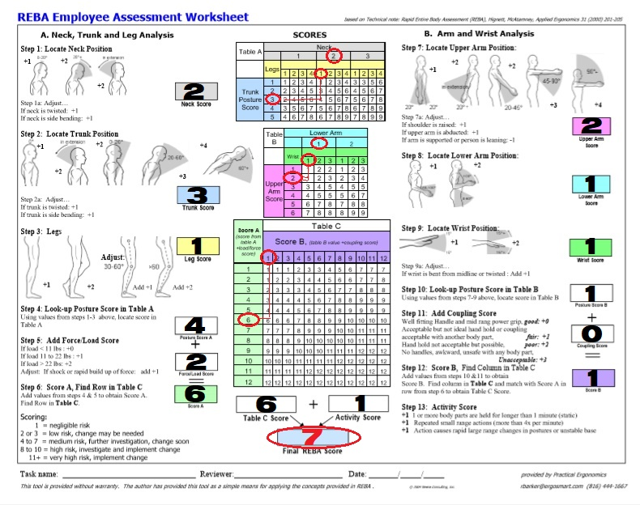 *Figure 4.26* REBA Evaluation of new process using the proposed prototype

*Table 4.32* REBA Evaluation for new process using the proposed prototype

|  |  |
| --- | --- |
| **Interpretation** | **Score** |
| Medium Risk | **7** |

**REBA Evaluation result Summary**

Comparison of REBA Evaluation of traditional process VS REBA Evaluation of new process using proposed prototype.

*Table 4.33* REBA Evaluation Summary Result

|  |  |  |
| --- | --- | --- |
| **SCORE** | | |
| **Methods** | **Traditional method of transferring** | **New method using the proposed prototype** |
| **From Hospital Bed to Stretcher** | 12 | 7 |
| **From Hospital bed to Wheelchair** | 12 |
| **Interpretation** | Very high Risk - Need to implement change | Medium Risk- Further investigation |

Base on the result of REBA (Rapid Entire Body Assessment) Comparison of those two (2) method, the overall REBA score of the Ergonomically Designed Smart Hospital Bed equipment is seven (7) which indicates Medium Risk and need further investigation. From this score the level of risk is reduced from score of twelve (12) which is the traditional method of transferring. The Risk of Musculoskeletal Disorder among healthcare worker is lessened through the use of the new design of Hospital bed equipment and it provides lesser fatigue to the health workers and comfortability to the patients as well.

**Technical Testing**

This part includes: Functionality test and User’s friendliness test. This will tell if the proposed prototype will comply on its given function and if the prototype is easy to use and learn.

***Functionality test***

In this test, the researchers were able to test the functionality of the individual skill of the Stretchair by completing a series of task. Twenty – five (25) Trials each process are considered on testing the prototypes functionality.

*Table 4.34* Skill Performance Guide

|  |  |
| --- | --- |
| **Functionality Performance** | **Description** |
| *“P”*  *(Passed)* | Task independently and safely accomplished. Unless otherwise specified, the skill may be performed in any manner. |
| A pass may be awarded if the subject passed a more difficult version of the same skill. |
| “F”  (Failed) | Task incomplete. |
| Unsafe performance |
| Likely to be unsafe in the opinion of the clinician or tester |
| Hospital Bed part malfunction |
| Stretchair part malfunction |
| **Safety Performance** | **Description** |
| “S”  (Safe) | None of the unsafe criteria were met. |
| Though a failing performance score will be awarded in such circumstances, a safe score can be awarded to a person who states that he/she cannot do and/or will not attempt a skill. |
| “US”  (Unsafe) | Subject requires appropriate significant assistance intervention to prevent acute injury to the subject or others. Performing a skill quickly is not, in and of itself, unsafe. |
| A significant acute injury occurred. |
| During interview questions the nurses describes the method of performing a skill too dangerous. |
| Specific risks and whether they warrant an unsafe score or merely a recorded comment can be found later in the section on individual skills. |

Table 4.41 shows the table shows the scale for scoring Skill performance task that will be completed by the respondent*.*

*Table 4.35* Functionality performance Test Results

|  |  |  |  |
| --- | --- | --- | --- |
| **Functionality Performance** | | | |
| **Individual Process** | **Passed** | **Failed** | **Total** |
| RFID Access Control | 25 | 0 | 25 |
| Increase Inclination to 45° | 22 | 3 | 25 |
| Increase Inclination to 88° | 21 | 4 | 25 |
| Decrease Inclination to 45° | 24 | 1 | 25 |
| Decrease Inclination to 0° | 22 | 3 | 25 |
| Lock the Stretchair to the bed | 25 | 0 | 25 |
| Unlock the Stretchair to the bed | 24 | 1 | 25 |
| Stop when emergency Stop button is pressed | 25 | 0 | 25 |
| **Total** | **188** | **12** | **200** |

*Table 4.36* Safety performance Test Results

|  |  |  |  |
| --- | --- | --- | --- |
| **Safety Performance** | | | |
| **Individual Process** | **Safe** | **Unsafe** | **Total** |
| RFID Access Control | 25 | 0 | 25 |
| Increase Inclination to 45° | 25 | 0 | 25 |
| Increase Inclination to 88° | 25 | 0 | 25 |
| Decrease Inclination to 45° | 25 | 0 | 25 |
| Decrease Inclination to 0° | 25 | 0 | 25 |
| Lock the Stretchair to the bed | 25 | 0 | 25 |
| Unlock the Stretchair to the bed | 25 | 0 | 25 |
| Detaching of Stretchair from the bed | 25 | 0 | 25 |
| Attaching of Stretchair to the bed | 25 | 0 | 25 |
| Stop when emergency Stop button is pressed | 25 | 0 | 25 |
| **Total** | **150** | **0** | **250** |

Table 4.35 and table 4.36 shows the Functionality Test and safety performance results that had been tested and completed by twenty – five (25) trials evaluation on each process

*Table 4.37* Overall Functionality and safety performance Score

|  |  |  |  |
| --- | --- | --- | --- |
| Category | Functionality Performance | Total Safety Score (%) |  |
| Score (%) |  |  |
|  |  |  |
|  |  |  |  |
| 25 trials each process | **94%** | **100%** |  |
|  |  |  |  |

Table 4.37 shows the results of the overall Stretchairs’s skill and functionality; the score provided the data needed to compute the percentage scoring of the total Performance and total safety score. Equation below were used to calculate the percentage scoring for the test:

$$\frac{Total P}{(No. of trials)} x 100\%$$

***Performance Score =***

$\frac{Total S}{(No. of Trials) }x$ 100%

***Total Safety Score =***

As the results, the Total performance score got 94% in functionality test and 100% Safety performance. Thus, the whole system can execute all its function as expected.

***User – Friendliness test***

The proponents created a survey questionnaire among twenty five (25) Healthcare workers of M.V Santiago Diagnostic and Medical Center regarding on the user-friendliness of the whole system. The respondents will check and evaluate the system whether they agree or disagree with the verbal interpretation and description of the item. The proponents chose in the five (5) selections given in the survey, it is composed of the following options: Strongly Agree, Agree, Slightly Agree, Disagree and Strongly Disagree.

*Table 4.38* User’s friendliness survey result

|  |  |  |  |  |  |  |  |  |
| --- | --- | --- | --- | --- | --- | --- | --- | --- |
|  | **Item** | **Item Description** | **Strongly** | **Agree** | **Slightly** | **Disagree** | **Strongly** | **Total** |
|  | **No.** |  | **Agree** |  | **Agree** |  | **Disagree** |
|  |  |  | **(5)** | **(4)** | **(3)** | **(2)** | **(1)** |
| **User-friendliness** | 1 | The user can easily get in and get out from the system. | 22 | 3 | 0 | 0 | 0 | **25** |
|  |  |  |  |  |  |  |
| 2 | The system is easy to | 19 | 6 | 0 | 0 | 0 | **25** |
|  | learn |  |  |  |  |  |
| 3 | The system is easy to | 17 | 8 | 0 | 0 | 0 | **25** |
|  | use |  |  |  |  |  |
| 4 | The interface is | 16 | 18 | 1 | 0 | 0 | **25** |
|  | pleasant to look at |  |  |  |  |  |
| 5 | The figures/buttons | 14 | 7 | 4 | 0 | 0 | **25** |
|  | were clearly identified |  |  |  |  |  |
| 6 | The system user |  |  |  |  |  | **25** |
|  | interface clearly tells its | 17 | 8 | 0 | 0 | 0 |
|  | function |  |  |  |  |  |
| **Accuracy** | 7 | The system executes its | 16 | 17 | 2 | 0 | 0 | **25** |
|  | functions effectively |  |  |  |  |  |
| 8 | The system |  |  |  |  |  | **25** |
|  | is error free | 13 | 7 | 5 | 0 | 0 |
| 9 | The system performs |  |  |  |  |  | **25** |
|  | the command given by | 17 | 8 | 0 | 0 | 0 |
|  | the user |  |  |  |  |  |

Table 4.39 shows the scale that correspond to the verbal interpretation that was used the survey.

*Table 4. 39* Weighted average per question and its verbal interpretation for User Friendliness Test

|  |  |  |  |  |
| --- | --- | --- | --- | --- |
| **User Friendliness** | | | |  |
| **Itemno.** | **Item Description** | **Mean** | **Interpretation** |  |
|  |
|  |
|  |
| 1 | The user can easily get in and get out from the system | 4.88 | Strongly Agree |  |
|  |  |  |
| 2 | The system is easy to learn | 4.76 | Strongly Agree |  |
|  |  |  |
| 3 | The system is easy to use | 4.68 | Strongly Agree |  |
|  |  |
| 4 | The interface is pleasant to the eyes | 4.60 | Strongly Agree |  |
| 5 | The figures were clearly identified | 4.40 | Strongly Agree |  |
| 6 | The system user interface clearly tells its function | 4.68 | Strongly Agree |  |
|  | **Grand Mean** | **5.6** | **Strongly Agree** |  |

Table 4.39 shows the weighted average and its verbal interpretation for each question for the User Friendliness Test. The User Friendliness Rate was calculated based on Equation stated below.

***User’s Friendliness = $\frac{Grand Mean}{6} x 100\%=\frac{5.6}{6}x 100\%=93.33\%$***

As the results suggests, the system proved to be user friendly. The respondents strongly agree that system was easy to get in and get out, easy to learn, easy to use, the interface clearly identified its figures with their respective functions and the user interface is pleasant to look at. The results from the 6 questions under User-Friendliness proved that the system was significantly user friendly. Therefore, the system has a user-friendly rate of 93.33% and this value indicates that users will be able to interact with the system with minimal guidance.

**Comparison of Traditional Lifting Force and Prototype`s Force requirement**

**(Difference of force requirements)**

The computation was conducted to differentiate the force requirement between traditional lifting and prototype’s force requirement that will see ergonomic advantageous improvement.

***Traditional Lifting Force for both Process of transferring to Stretcher and wheelchair***

**Lifting force computation:**

*(According to previous study of an Ergonomically Hospital bed)*

Formula: F = mg (lifting against gravity)

F = Force required to lift the patient

m = Mass of the patient

g = Gravity

Solution: Based on human average weight:

Male = 70~90kg

Female = 45~70kg

F = mg

F= 90 x 9.81

Fmax = 882.9

Solutions for 45kg and 70kg:

@45kg

F = mg

F = 45 x 9.81

F = 441.45N

@70kg

F = mg

F = 70 x 9.81

F = 686.7N

***For the Stretchair***

There is no lifting force needed to apply by the nurse because the bed can be transformed to a wheelchair/stretcher by using push buttons and it is just detachable from the stationary bed. Thus, the healthcare workers who will use the proposed prototype does not have to use his/her full physical strength to transfer a patients from hospital bed going to stretcher of wheelchair. It only means that the process and physical strength used during this moment was being reduced and it is a big factor on not reducing the high risk of MSDs.

But since the bed is detachable, the force needed only by the nurse is the pushing and pulling the stretchair from the stationary bed. The computations are as follows;

**Pushing/pulling force computation:**

Formula: F = f x W/R (pushing/pulling aided by wheels)

F = Force required to move the stretchair (push/pull)

F = the coefficient of rolling friction = 0.09in @ 3mph (for steel surfaces)

W = Load on the caster wheel = Patient`s Weight + Transferable Bed`s Weight

R = Radius of the wheel = 4in

Solution: The attachable/detachable bed has four (4) wheels, dividing the force into 4.Say, Load on the wheel is [90KG (for Comparison) + 50KG (stretchair)],

Then, F = f x W/R

F = 0.09in x ((90KG + 120KG) x 9.81 m/s2)/4in

F = 46.35225N / 4 wheels

Fmax of ­prototype = 11.588N; Use = 12N [Requiring at least 1 Nurse to push/pull

Solutions for 45KG and 70KG of the Female and Male Patient

@45KG

F = f x W/R

F = 0.09in x ((45KG + 120KG) x 9.81m/s2)/4in

F = 36.4196N / 4 wheels

Fprototype = 9.105N [Requiring at least 1 Nurse to push/pull]

@70KG

F = f x W/R

F = 0.09in x ((70KG + 120KG) x 9.81m/s2)/4in

F = 41.094N / 4 wheels

Fprototype = 10.484N [Requiring at least 1 Nurse to push/pull]

According to Stanislaus County, Date August 2001, Analysis Provided by: Lyle Andersen, PT, CWCE et al.

*Table 4.40* Maximum Requirements for Functional Activities; Push/Pull

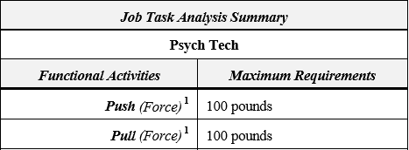

Whereas, 100 pounds force maximum requirements = 444.822 Newtons to push/pull the wheelchair/stretcher;

From above calculations we researchers calculated that:

For 90KG: 12N (maximum requirement),

For 70KG: 10.484N (maximum requirement),

For 45KG: 9.105N (maximum requirement),

Therefore,

Let the maximum force requirement use for the comparison of force needed in the calculations and in the maximum requirements according to the summary given by the Stanislaus County;

12N < 444.822N;

Then, we can say that the prototype we had is on the scale of Job Task Analysis Summary.

**Comparison of Traditional Lifting Force to Prototype`s Pushing/Pulling Force**

*Table 4.41* Comparison of the computed forces of the Nurses by transferring a patient

|  |  |  |  |
| --- | --- | --- | --- |
|  | **Weight** | **Lifting Force** | **Pushing/Pulling Force** |
| Female | @45KG | 441.45N | 9.105N |
| Female and Male | @70KG | 686.7N | 10.484N |
| Male | @90KG | 882.9 | 11.588N |

**Standard Set – up time**

One of the requirements of finished prototype is to determine what would be the standard set – up time on each processes during transformation. It is very important to know the time taken of those processes for it to be ready to function, to be prepared for the transition of the proposed prototype and to know how long the transition can be finished on every process. The table below is the result of computing the standard set – up time of every process

*Table 4.42* Standard Set – Up time of each process

|  |  |  |  |
| --- | --- | --- | --- |
| **PROCESS** | | | |
| Standard Set – Up Time | Hosp. Bed to Stretchair | Hosp. Bed to Wheelchair | Stretchair to Wheelchair |
| **17.89 Second** | **44.33 Second** | **33.82 Seconds** |

In order to determine the Standard set – up time the researchers conducted a time study and computed first the sample size needed using Five (5) trials. After getting the sample size the researcher were able to know how many trials needed to record a data of every process. After time study, the recorded data was used to compute the standard set – up time using the standard time equation with Personal allowance of five percent (5%) and Basic fatigue allowance of four percent (4%). Below are the equation that were used to compute the Sample size and Standard time of each process.

***Sample Size****= ${\left(\frac{zs}{e}\right)}^{2}$*

Where:

*n =* sample size the researchers want to determine

*z =* number of normal standard deviations needed for desired confidence

*s =* sample standard deviation

*e =* maximum acceptable error

***Standard Set – Up time***

**Standard time = Normal time x (Allowance factor + 1)**

Where:

Normal time = Average time

Allowance factor = Four (4%) Basic Fatigue + Five (5%) Personal Allowance

**CHAPTER V**

**SUMMARY, CONCLUSION AND RECOMMENDATION**

**Summary**

The study entitled “ERGONOMICALLY DESIGNED SMART HOSPITAL BED WITH ATTACHABLE – DETACHABLE STRETCHAIR” was conducted for the healthcare worker who are involve in the process of transferring patients from hospital bed going to stretcher and wheelchair and vice versa. The researcher conducted an initial data gathering such as survey and REBA Evaluation. It was determined that healthcare workers who are transferring patient from hospital bed to stretcher and wheelchair was having a very high risk of Musculoskeletal disorders with a score of 12 from REBA Evaluation, The initial survey result support this statements as it tells that 100% of the respondents are experiencing pain during the said process which is the traditional method. Thus, the researcher came up to a study of making a new design of hospital bed to ease the said problem. To fulfill it, objectives are expressed and this are fabrication of the proposed equipment, reducing the risk of MSD and conducting various testing to validate the proposed prototype.

To achieve the given objectives, the researcher used various hardware components such as the linear actuator which is the responsible for increasing and decreasing the slope of the stretchair and a magnetic lock is used to hold the detachable Stretchair to its respective hospital bed. Arduino was used and interface with the linear actuator and the magnetic lock to make it suitable in performing the given functions of the system.

After the whole system is completed, the researchers conducted various testing and validation methods to a selected respondents. Those testing methods are: Pre – test and post – test method under this is the comparison of pre survey – post survey and REBA Evaluation. For the validation of the prototype in terms of technicality the researcher conducted a user’s friendliness test and functionality test.

After a long period of research and study, the researcher was able to meet its objectives by using the New Ergonomically Hospital bed.

**Conclusion**

In conclusion, using the new ergonomically design hospital bed, Testing method showed good results as the Risk of Musculoskeletal disorder was reduced from a score of 12 which means very high risk to a score of 7 which means medium risk, this comparison only tells that the proposed project is effective on reducing pain and risk of MSD among healthcare worker who are transferring patients.

The system can function normally depending on the user’s desire and it is easy to use and learn, the results also shows that the system can do all its basic functions that the proponents expected that’s why the functionality test has resulted to 94% functionality performance.

**Recommendation**

The following are the list of recommendation that would like to suggest by the researcher for future improvement and innovations of “Ergonomically Designed Smart Hospital bed with attachable – detachable Stretchair”

* + For the material used, research for another lightweight stainless materials.
  + For the automation, research for alternative components that would make the stretchair fully automated.
  + Research for another mechanism that would make the prototype adjustable to its minimum and maximum standard height.
  + Add a railing to inner side part of the stationary bed for easer attachments of the Stretchair.

**REFERENCES**

De Castro et al. (2009). Occupational Health and Safety Issues among Nurses in the Philippines. Retrieve From:https://www.ncbi.nlm.nih.gov/pmc/articles/PMC2797477/#!po=15.3226

Jess white. (2015). No.1 threat to your nurses: Injuries from lifting patients. Retrieve From: [*http://www.healthcarebusinesstech.com/nurses-safe-lifting-patients/*](http://www.healthcarebusinesstech.com/nurses-safe-lifting-patients/) Jinky Leilanie et al. (2008). Analysis of Trends of Occupational Injury in the Philippines: Implication for Policy.

Daniel Zwerdling. (2015). Even proper technique Exposed Nurse’s spine to Dangerous Forces.

Daniel Zwerdling. (2015). Hospitals fail to protect Nursing staff from becoming patient. Audrey Nelson et al. (2004). EVIDENCE-BASED PRACTICES FOR SAFE PATIENT HANDLING AND MOVEMENT. Retrieve from: http://www.seiu1991.org/files/2013/07/Audrey_Nelson_Safe_Patient_Handling. df

Bernice D. Owen. (2000). Preventing Injuries Using an Ergonomic Approach. Retrieve From: https://aornjournal.onlinelibrary.wiley.com/doi/abs/10.1016/S0001 2092(06)61908-X

Waters et al. (2006). NIOSH Research Efforts to Prevent Musculoskeletal Disorders in the Healthcare Industry.

Elcam Medical. (2017). The Role of Nurses Inside and Outside the Hospital. Retrieve from: *http://www.infusesafety.com/the-role-of-nurses-inside-and-outside-the-hospital*

TrioTree. (2016). Role and Responsibilities of Nurses in Hospitals and Healthcare. Retrieve from:*http://triotree.com/blog/role-and-responsibilities-of-nurses in-hospitals-and healthcare/*

TineHealth. (2017). The Role of Nurses in Hospital Quality Improvement. Retrieve from: *http://tinehealth.com/2017/06/05/the-role-of-nurses-in-hospital-quality improvement/*

A.B. de Castro et al. (2009). Occupational Health and Safety Issues Among Nurses in the Philippines. Retrieve from <https://www.ncbi.nlm.nih.gov/pmc/articles/PMC2797477/#!po=15.3226>

Edlich RF et al. (2004). Prevention of Disabling Back Injuries in Nurses by the use of Mechanical Patient Lift Systems. Retrieve from: <https://www.ncbi.nlm.nih.gov/pubmed/15698378>

T.M. Cage et al. (2016). Stretcher Safety. Retrieve from: <https://www.emsreference.com/articles/article/stretcher-safety>

R.J. Ramteke et al. (2016). Advancement in Stretcher and Wheelchair. Retrieve from: <http://www.ijraset.com/fileserve.php?FID=5818>

S.N. Waghmare et al. (2015). Design and Analysis of Compact Stretcher with Rubber Shock Absorbers. Retrieve from:<https://www.ijerst.com/ijerstadmin/upload/IJEETC_554b900ec33f2.pdf>

David Page. (2012). Studies Report on Stretcher Errors & Rate Protective Gear. Retrieve from: https://www.jems.com/articles/print/volume-37/issue-8/patient care/studies-report stretcher-errors-rate-pro.html

J. Matos et al. (2011). Modeling Decisions for Hospital Bed Management. Retrieve from: https://www.researchgate.net/publication/221334930_Modeling_Decisions_for_ ospita _Bed_Management_-_A_Review

J. Matos et al. (2011). Modeling Decisions for Hospital Bed Management. Retrieve from: https://www.semanticscholar.org/paper/Modeling-Decisions-for-Hospital-Bed Management-A-Matos-Rodrigues/9a6a8f8070d33aa31e1d882ee63ee76c5e4e63f4

Jess White. (2015). No.1 Threat to your Nurses: Injuries from Lifting patients. Retrieve From: [*http://www.healthcarebusinesstech.com/nurses-safe-lifting-patients/*](http://www.healthcarebusinesstech.com/nurses-safe-lifting-patients/)

A.B. de Castro et al. (2009). Occupational Health and Safety Issues Among Nurses in the Philippines. Retrieve from: <https://www.ncbi.nlm.nih.gov/pmc/articles/PMC2797477/#!po=15.3226> US Bureau of Labor Statistics. (2015). Nonfatal Occupational Injuries and Illnesses: Cases with days away from work. Retrieve from: <https://www.bls.gov/iif/oshwc/osh/case/osch0053.pdf>

**APPENDIX A**

**Appendix #1.** Computation of Theoretical Weight for Hospital bed and Stretchair

Total Theoretical Weight (approx.)

Total Weight = (density of material) x (total volume)

Total Volume = Cross sectional area x Length

1. Cross sectional area of square tube for stretchair = 50mm2
2. Cross sectional area of square tube for stationary bed = 100mm2
3. Cross sectional area of square tube for stationary bed = 50mm2
4. Cross sectional area of tube for the headboard, footboard & armrest = 30mm2
5. Cross sectional area of rectangular tube for the armrest = 625mm2

Total Theoretical Weight (approx.)

1. Total volume of square tubes for stretchair

= (50 x 625 x 4) + (50 x 622 x 2) + (50 x 170 x 2) + (50 x 520 x 10)

= 464200

1. Total volume of square tubes for stationary bed

= (100 x 625 x 4) + (100 x 495 x 2) + (100 x 920 x 2) + (100 x 275 x 2)

= 588000

1. Total volume of square tubes for stationary bed

= (50 x 1720 x 2)

= 172000

1. Total volume of tube for the headboard, footboard & armrest

= (30 x 490 x 7) + (30 x 295 x 3)

= 129450

1. Total volume of rectangular tube for the armrest

= (625 x 465 x 2) + (625 x 910 x 1)

= 1150000

Total Volume = 464200 + 588000 + 172000 + 129450 + 1150000

Total Volume of Stainless Steel Materials = 2503650mm3 = 25036.5 cm3

Weight of Stainless Steel Materials = (7.7 g/cm3) x (25036.5 cm3)

= 192781.05 g = 192.78105 KG

Weight of Battery and Accessories = Assume 30 kg (with safety)

Total Weight = 192.78105 + 30 = 222.78105 KG

For computations` additional safety purposes,

Let Weight of the Whole Bed = 230 KG

Total Theoretical Weight of Stretchair

1. Total Volume for square tubes

= (50 x 625 x 4) + (50 x 622 x 2) + (50 x 170 x 2) + (50 x 520 x 10)

= 464200

1. Total volume of rectangular tube for the armrest

= (625 x 465 x 2)

= 581250

Total Volume = 464200 + 581250 = 1045450 mm3

Total Volume of Stainless Steel Materials = 1045450 mm3 = 10454.5mm3

Weight of Stainless Steel Materials = (7.7 g/cm3) x (10454.5 mm3) = 80.49965 KG

Weight of Battery and Accessories = Assume 30KG (with safety)

Total Weight = 80.49965 + 30 = 110.49965 KG

For computation`s additional safety purpose,

Let Weight of the Whole Stretcher = 120 KG

Total Theoretical Weight of Stationary Bed

1. Total volume of square tubes for stationary bed

= (100 x 625 x 4) + (100 x 495 x 2) + (100 x 920 x 2) + (100 x 275 x 2)

= 588000

1. Total volume of square tubes for stationary bed

= (50 x 1720 x 2)

= 172000

1. Total volume of rectangular tube for the armrest

= (625 x 910 x 1)

= 568750

Total Volume = 588000 + 172000 + 568750 = 1328750 mm3 = 13287.5 mm3

Weight of Stainless Steel Materials = (7.7 g/cm3) x (13287.5 mm3) =102.31375KG

Weight of Battery and Accessories = Assume 5KG (with safety)

Total Weight = 102.31375 + 5 = 107.31375

For computations` additional safety purposes,

Let Weight of the Whole Stationary Bed = 110 KG

: Total Weight of the Whole Hospital Bed = 230 KG:

: Total Weight of Stretcher + Total Weight of Stationary Bed

= 120 + 110 = 230 KG

**Appendix #2.** Computation for the Stationary Bed Capacity

The following computations are based from parts of the prototype where it can be considered critical and that will always be subjected to a force. This computation is to showcase the approximate forces that can be held by the stationary bed.

Materials Used: Stainless Steel (Square Tube) – Welded

Cross-sectional area: 50mm2

Thickness = 2 mm; Braces Length = 555 mm

Material Yield Strength = 505Mpa

1. Assuming equally distributed load on Stationary Bed brace:

Formula: S = MZ; M = WL (Equally Distributed load)

Where: S = Strength

M = Maximum Bending moment

Z = Section Modulus

W = Concentrated Load (Patient`s Weight)

L = Length of the square tubes needed

Solution: S = M/Z

S = 505MPa

Z = BH2/6 – bh3/6H

= (50mm) (50mm)2/ 6 – (48mm) (48mm)3/ (6 x 50mm)

Z = 3138.61 mm3

Therefore,

Max. Moment = (S)(Z) = (505MPa) (3138.61mm3)

Max. Moment = 1.58x106 N – mm

Computing for the Concentrated Force (Load per Brace).

M = WL; W = M/L

W = (1.58x106 N – mm)/555mm

WS1 = 2.86 KN

1. Assuming load for the support grill tubes for the headboard brace:

Material Used: Stainless Steel (Circular Tube) – Welded

Cross-sectional area: Do = 10mm, Di = 6.5mm

Thickness = 1 mm; Braces Length = 495 mm

Material Yield Strength = 505Mpa

Formula: S = M/Z; M = WL/7 (Assumed Axial Stress in Compression)

Where: S = Strength (Yield)

M = Maximum Bending Moment

Z = Section Modulus

W = Assumed Concentrated Load (Patient`s Weight)

L = Length of Brace

Solution: S = M/Z;

S = 505MPa

Z = π/32 [(Do4 - Di4)/Do] (For Circular Tube Cross Tube Cross-Section)

= π/32 [(104 – 6.54)/10]

Z = 80.65mm3

Therefore,

Max. Moment = (S)(Z) = (505 MPa) (80.65mm3)

Max. Moment = 40.73x103 N*mm

Computing for the Concentrated Force (Support For the Headboard).

M = WL/7; W = 7M/L

W = 7(40.73X103 N*mm)/495mm

WS2 = 0.58 KN

1. Assuming load for the support grill tubes for the footboard brace:

Material Used: Stainless Steel (Circular Tube) – Welded

Cross-sectional area: Do = 10mm, Di = 6.5mm

Thickness = 1 mm; Braces Length = 300 mm

Material Yield Strength = 505Mpa

Formula: S = M/Z; M = WL/3 (Assumed Axial Stress in Compression)

Where: S = Strength (Yield)

M = Maximum Bending Moment

Z = Section Modulus

W = Assumed Concentrated Load (Patient`s Weight)

L = Length of Brace

Solution: S = M/Z;

S = 505MPa

Z = π/32 [(Do4 - Di4)/Do] (For Circular Tube Cross Tube Cross-Section)

= π/32 [(104 – 6.54)/10]

Z = 80.65mm3

Therefore,

Max. Moment = (S)(Z) = (505 MPa) (80.65mm3)

Max. Moment = 40.73x103 N*mm

Computing for the Concentrated Force (Support for the Footboard).

M = WL/3; W = 7M/L

W = 3(40.73X103 N*mm)/300mm

WS2 = 0.41 KN

1. Total Load that can be held by the Legs of the Stationary Bed

Materials Used: Stainless Steel (Square Tube) – Welded

Cross-sectional area: 50mm2

Thickness = 2 mm; Braces Length = 555 mm

Material Yield Strength = 505Mpa

Formula: S = F/A (Assumed Axial Stress in Compression)

Where: S = Strength (Yield)

F = Load

A = Cross-sectional area

Solution: S = F/A;

S = 505 MPa

A = BH - bb

= (100mm) (100mm) - (98mm) (98mm)

A = 396mm2

Computing for the Load (Leg`s Capacity)

F = SA

F = (505MPa) (396mm2)

F = 199.98 KN x 4 legs

FLegs (Stationary Bed) = 799.92 KN

**Appendix #3.** Computation for the Stretchair Bed Capacity

The following computations are based from parts of the prototype where it can be considered critical and that will always be subjected to a force. This computation is to showcase the approximate forces that can be held by the stretchair.

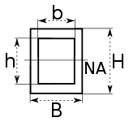Materials Used: Stainless Steel (Square Tube) – Welded

Cross-sectional area: 50mm2

Thickness = 2 mm; Braces Length = 555 mm

Material Yield Strength = 505Mpa

1. Assuming equally distributed load on one Stretchair brace:

Formula: S = MZ; M = WL/8 (Equally Distributed load)

Where: S = Strength

M = Maximum Bending moment

Z = Section Modulus

W = Concentrated Load (Patient`s Weight)

L = Length of the square tubes needed

Solution: S = M/Z

S = 505MPa

Z = BH2/6 – bh3/6H

= (50mm) (50mm)2/ 6 – (48mm) (48mm)3/ (6 x 50mm)

Z = 3138.61 mm3

Therefore,

Max. Moment = (S)(Z) = (505MPa) (3138.61mm3)

Max. Moment = 1.58x106 N – mm

Computing for the Concentrated Force (Load per Brace).

M = WL/8; W = 8M/L

W = 8(1.58x106 N – mm)/555mm

WS1 = 22.77 KN

1. Assuming Distributed Load, Maximum at Midspan of one Stretchair Brace:

Formula: S = MZ; M = WL/6 (Equally Distributed load)

Where: S = Strength

M = Maximum Bending moment

Z = Section Modulus

W = Concentrated Load (Patient`s Weight)

L = Length of the square tubes needed

Solution: S = M/Z

S = 505MPa

Z = BH2/6 – bh3/6H

= (50mm) (50mm)2/ 6 – (48mm) (48mm)3/ (6 x 50mm)

Z = 3138.61 mm3

Therefore,

Max. Moment = (S)(Z) = (505MPa) (3138.61mm3)

Max. Moment = 1.58x106 N – mm

Computing for the concentrated force (Load per Brace).

M = WL/6, W = 6M/L

W = 6(1.58x106 N – mm)/555mm

WS2 = 17.08 KN

There were two midspan part of the Stretchair;

Therefore,

WS2 x 2 = 17.08 KN x 2

WS2’ = 34.16 KN

1. Assuming Distributed Load, Maximum at one End of Stretchair Brace:

Formula: S = M/Z; M = 2WL/9 $\sqrt{3}$ (Distributed Load, Max. at one End)

Where: S = Strength (Yield)

M = Maximum Bending Moment

Z = Section Modulus

W = Concentrated Weight (Load)

L = Length of Brace

Solution: S= M/Z

S = 505MPa

Z = BH2/6 – bh3/6H

= (50mm) (50mm)2/ 6 – (48mm) (48mm)3/ (6 x 50mm)

Z = 3138.61 mm3

Therefore,

Max. Moment = (S)(Z) = (505MPa) (3138.61mm3)

Max. Moment = 1.58x106 N – mm

Computing for the concentrated force (Load per Brace).

M = 2WL/9 $\sqrt{3}$: W = (9 $\sqrt{3}$)M/2L

W = (9 $\sqrt{3}$)(1.58x106N – mm)/ (2) (555mm)

WS3 = 22.19 KN

Computing for the Average Max. Load that can be held by a Stretchair Brace:

WAVE = (WS1 + WS2’ + WS3)/3

= (22.77 + 34.16 + 22.19) KN/3

WS(AVE) = 26.37 KN; WS(MN) = 22.19 KN

Note that the computed forces for the stretchair are also only based on one stretchair brace (to ensure more safety allowance), therefore having the actual number of 4 braces (will mostly be subjected to force) will make it safer, dividing the force, and creating lesser stress for the brace itself.

1. Assuming Shearing at a Brace`s Welded Ends (Stretchair)

Formula: S = F/A (Shearing)

Where: S = Strength (Yield)

F = Load

A = Cross-sectional area

Solution: S = F/A;

S = 505 MPa

A = BH - bb

= (50mm) (50mm) - (48mm) (48mm)

A = 196mm2

Computing for the Load (Load per Brace).

F = SA

F = (505MPa) (196mm2)

F = 98.98 KN x 2 Ends

FWELDED ENDS (STRETCHAIR BRACE) = 197.96 KN per brace

1. Total Load that can be held by the Legs of the Stretchair

Formula: S = F/A (Assumed Axial Stress in Compression)

Where: S = Strength (Yield)

F = Load

A = Cross-sectional area

Solution: S = F/A;

S = 505 MPa

A = BH - bb

= (50mm) (50mm) - (48mm) (48mm)

A = 196mm2

Computing for the Load (Leg`s Capacity)

F = SA

F = (505MPa) (196mm2)

F = 98.98 KN x 4 legs

FLegs (Stretchair) = 395.92 KN

1. Total Load that can be held by the Caster wheels of the Stretchair

Swivel Caster Wheel Capacity (Ave.) = 12KG x 4pcs. = 480KG

Total Load to be supported by the wheel: Wheel capacity

Total Weight of Stretchair + Total weight of Stationary Bed + Patient`s Weight (assume max weight)

From Wheel Capacity = 120KG + 110KG + Patient`s Weight

Patient`s Weight = Wheel Capacity -120KG - 110KG

= 480KG - 120KG - 110KG

Therefore,

Max. Allowable Patient`s Weight ≤ 250KG for Safety

**Appendix #4.** Summary of Allowable Loadings per Critical Parts

|  |  |
| --- | --- |
| CRITICAL PART | ALLOWABLE LOAD (WITH FACTOR OF SAFETY = 2) |
| Stationary Bed Brace | 2.86 KN / 2 = 1.43 KN |
| Stationary Bed Brace`s Welded Ends | 799.92 KN / 2 = 399.96 KN |
| Stationary Bed Brace`s Supports | 0.99 KN / 2 = 0.495 KN |
| Stretchair Brace | 26.37 KN / 2 = 13.19 KN |
| Stretchair Brace`s Welded Ends | 197.96 KN / 2 = 98.98 KN |
| Stretchair Brace`s Supports | 395.92 KN / 2 = 197.96 KN |
| Stationary Bed Wheels | 1.08 KN / 2 = 0.54 KN |
| Stretchair Wheels | 1.18 KN / 2 = 0.59 KN |

**Appendix #5.** Program Codes

**HOSPITAL BED FUNCTIONS**

#include <SPI.h>

#include <MFRC522.h>

#include <millisDelay.h>

#include <SoftwareSerial.h>

#include <EEPROMex.h>

#include "Arduino.h"

#define btn0 22

#define btn45 24

#define btnMax 26

#define btnLock 34

#define btnEmergency 30

#define relayActuator1Forward 23

#define relayActuator1Backward 25

#define relayActuator2Forward 27

#define relayActuator2Backward 29

#define relayMagneticLock 31

#define limitActuator 4

#define btnAddDel 32

SoftwareSerial mySerial (10, 11);

//For Mega: RST->5, SDA(SS)->53, MOSI->51, MISO->50, SCK->52

//For UNO: RST->9, SDA(SS)->10, MOSI->11, MISO->12, SCK->13

constexpr uint8_t RST_PIN = 5;

constexpr uint8_t SS_PIN = 53;

constexpr uint8_t NR_OF_READERS = 1;

MFRC522 mfrc522[NR_OF_READERS]; // Create MFRC522 instance.

MFRC522 mfrc522load(SS_PIN, RST_PIN);

millisDelay actuatorDelay;

String rfidCardRead, rfidCard1, rfidCard2, rfidCard3;

const int maxAllowedWrites = 80;

const int memBase = 0;

int addressCharArray1 = 1, addressCharArray2 = 21, addressCharArray3 = 41, intLength = 10;

char writeRFID1[10] = "", writeRFID2[10] = "", writeRFID3[10] = "";

char getRFID1[] = "", getRFID2[] = "", getRFID3[] = "";

int currentState = 0, btn0Read, btn45Read, btnMaxRead, btnLockRead, btnEmergencyRead, btnAddDelRead, limitActuatorRead, positionState = 1;

int flagControl = 0, flagLock = 0, flagEmergency = 0, flagButton = 0, flagAddDelete = 0, flagLogin = 0, flagLogout = 0;

String serial = "";

long fullDelay = 30000, halfDelay = 15000;

/* **This is where we include different libraries, define different functions and constants. */**

void setup() {

// put your setup code here, to run once:

Serial.begin(9600);

mySerial.begin(9600);

SPI.begin();

pinMode(btn0, INPUT_PULLUP); pinMode(btn45, INPUT_PULLUP); pinMode(btnMax, INPUT_PULLUP);

pinMode(btnLock, INPUT_PULLUP); pinMode(btnEmergency, INPUT_PULLUP); pinMode(btnAddDel, INPUT_PULLUP);

pinMode(limitActuator, INPUT_PULLUP);

pinMode(relayActuator1Forward, OUTPUT); pinMode(relayActuator1Backward, OUTPUT);

pinMode(relayActuator2Forward, OUTPUT); pinMode(relayActuator2Backward, OUTPUT); pinMode(relayMagneticLock, OUTPUT);

digitalWrite(relayActuator1Forward, HIGH); digitalWrite(relayActuator1Backward, HIGH);

digitalWrite(relayActuator2Forward, HIGH); digitalWrite(relayActuator2Backward, HIGH); digitalWrite(relayMagneticLock, LOW);

EEPROM.setMemPool(memBase, EEPROMSizeMega);

EEPROM.setMaxAllowedWrites(maxAllowedWrites);

delay(100);

mySerial.println();

homePosition();

getMyRFID1(); delay(100);

getMyRFID2(); delay(100);

getMyRFID3(); delay(100);

for (uint8_t reader = 0; reader < NR_OF_READERS; reader++) {

mfrc522[reader].PCD_Init(SS_PIN, RST_PIN); // Init each MFRC522 card, for one card

Serial.print(F("Reader "));

Serial.print(reader);

Serial.print(F(": "));

mfrc522[reader].PCD_DumpVersionToSerial();

}

mfrc522load.PCD_Init();

mySerial.println("START");

// currentState = 7; //use to register main user card

}

**/*This is where we set-up the RFID Card reader and other button functions */**

void loop() {

// put your main code here, to run repeatedly:

// testButton();

if (currentState == 0) {

for (uint8_t reader = 0; reader < NR_OF_READERS; reader++) {

if (mfrc522[reader].PICC_IsNewCardPresent() && mfrc522[reader].PICC_ReadCardSerial()) { //if there a card

dump_byte_array(mfrc522[reader].uid.uidByte, mfrc522[reader].uid.size); //a function thats read the card

MFRC522::PICC_Type piccType = mfrc522[reader].PICC_GetType(mfrc522[reader].uid.sak);

mfrc522[reader].PICC_HaltA();

mfrc522[reader].PCD_StopCrypto1();

mySerial.println(); mySerial.println("THE CARD"); mySerial.println(rfidCardRead);

if (rfidCardRead == rfidCard1) {

mySerial.println("RFID MATCH"); rfidCardRead = ""; currentState = 1; flagAddDelete = 1; flagLogin = 1; flagLock = 0;

flagControl = 0; mySerial.println("ON"); delay(100);

for (uint8_t reader = 0; reader < NR_OF_READERS; reader++) {

mfrc522[reader].PCD_Init(SS_PIN, RST_PIN); // Init each MFRC522 card, for one card

Serial.print(F("Reader ")); Serial.print(reader); Serial.print(F(": "));

mfrc522[reader].PCD_DumpVersionToSerial();

}

mfrc522load.PCD_Init(); delay(1000);

} else if (rfidCardRead == rfidCard2) {

mySerial.println("RFID MATCH"); rfidCardRead = ""; currentState = 1; flagAddDelete = 0; flagLogin = 2; flagLock = 0;

flagControl = 0; mySerial.println("ON"); delay(100);

for (uint8_t reader = 0; reader < NR_OF_READERS; reader++) {

mfrc522[reader].PCD_Init(SS_PIN, RST_PIN); // Init each MFRC522 card, for one card

Serial.print(F("Reader ")); Serial.print(reader); Serial.print(F(": "));

mfrc522[reader].PCD_DumpVersionToSerial();

}

mfrc522load.PCD_Init(); delay(1000);

} else if (rfidCardRead == rfidCard3) {

mySerial.println("RFID MATCH"); rfidCardRead = ""; currentState = 1; flagAddDelete = 0; flagLogin = 3; flagLock = 0;

flagControl = 0; mySerial.println("ON"); delay(100);

for (uint8_t reader = 0; reader < NR_OF_READERS; reader++) {

mfrc522[reader].PCD_Init(SS_PIN, RST_PIN); // Init each MFRC522 card, for one card

Serial.print(F("Reader ")); Serial.print(reader); Serial.print(F(": "));

mfrc522[reader].PCD_DumpVersionToSerial();

}

mfrc522load.PCD_Init(); delay(1000);

} else {

mySerial.println("RFID NOT MATCH "); rfidCardRead = "";

}

}

}

}

if (currentState == 1) {

for (uint8_t reader = 0; reader < NR_OF_READERS; reader++) {

if (mfrc522[reader].PICC_IsNewCardPresent() && mfrc522[reader].PICC_ReadCardSerial()) { //if there a card

dump_byte_array(mfrc522[reader].uid.uidByte, mfrc522[reader].uid.size); //a function thats read the card

MFRC522::PICC_Type piccType = mfrc522[reader].PICC_GetType(mfrc522[reader].uid.sak);

mfrc522[reader].PICC_HaltA();

mfrc522[reader].PCD_StopCrypto1();

mySerial.println(); mySerial.println("THE CARD"); mySerial.println(rfidCardRead);

if (rfidCardRead == rfidCard1 && flagLogin == 1) {

mySerial.println("RFID MATCH"); rfidCardRead = ""; currentState = 0; flagControl = 1; flagAddDelete = 0; flagLogin = 0;

mySerial.println("OFF"); delay(100);

for (uint8_t reader = 0; reader < NR_OF_READERS; reader++) {

mfrc522[reader].PCD_Init(SS_PIN, RST_PIN); // Init each MFRC522 card, for one card

Serial.print(F("Reader ")); Serial.print(reader); Serial.print(F(": "));

mfrc522[reader].PCD_DumpVersionToSerial();

}

mfrc522load.PCD_Init(); delay(1000);

} else if (rfidCardRead == rfidCard2 && flagLogin == 2) {

mySerial.println("RFID MATCH"); rfidCardRead = ""; currentState = 0; flagControl = 1; flagAddDelete = 0; flagLogin = 0;

mySerial.println("OFF"); delay(100);

for (uint8_t reader = 0; reader < NR_OF_READERS; reader++) {

mfrc522[reader].PCD_Init(SS_PIN, RST_PIN); // Init each MFRC522 card, for one card

Serial.print(F("Reader ")); Serial.print(reader); Serial.print(F(": "));

mfrc522[reader].PCD_DumpVersionToSerial();

}

mfrc522load.PCD_Init(); delay(1000);

} else if (rfidCardRead == rfidCard3 && flagLogin == 3) {

mySerial.println("RFID MATCH"); rfidCardRead = ""; currentState = 0; flagControl = 1; flagAddDelete = 0; flagLogin = 0;

mySerial.println("OFF"); delay(100);

for (uint8_t reader = 0; reader < NR_OF_READERS; reader++) {

mfrc522[reader].PCD_Init(SS_PIN, RST_PIN); // Init each MFRC522 card, for one card

Serial.print(F("Reader ")); Serial.print(reader); Serial.print(F(": "));

mfrc522[reader].PCD_DumpVersionToSerial();

}

mfrc522load.PCD_Init(); delay(1000);

} else {

mySerial.println("RFID NOT MATCH "); rfidCardRead = "";

}

}

}

process();

if (flagEmergency == 1) {

mySerial.println("EMERGENCY STOP");

while (1) {

btnEmergencyRead = digitalRead(btnEmergency); //reading the data of button, if press data = 0, if not data = 1

if (btnEmergencyRead == 0) {

mySerial.println("EMERGENCY STOP PRESSED");

homePosition(); resets(); flagEmergency = 0; flagButton = 0; break;

}

}

}

btnAddDelRead = digitalRead(btnAddDel);

if (btnAddDelRead == 0 && flagAddDelete == 1) {

mySerial.println("STATE 2"); currentState = 2; delay(1000);

}

}

if (currentState == 2) {

btn0Read = digitalRead(btn0); btn45Read = digitalRead(btn45); btnMaxRead = digitalRead(btnMax); btnLockRead = digitalRead(btnLock);

btnAddDelRead = digitalRead(btnAddDel);

if (btn0Read == 0) {

//mySerial.println("CARD1"); currentState = 3;

} else if (btn45Read == 0) {

mySerial.println("CARD2"); currentState = 4;

} else if (btnMaxRead == 0) {

mySerial.println("CARD3"); currentState = 5;

} else if (btnLockRead == 0) {

mySerial.println("DELETE"); currentState = 6;

} else if (btnAddDelRead == 0) {

mySerial.println("STATE 0"); currentState = 0;

rfidCardRead = ""; flagControl = 1; flagAddDelete = 0; flagLogin = 0; delay(1000);

}

}

if (currentState == 3) {

// card1();

}

if (currentState == 4) {

card2();

}

if (currentState == 5) {

card3();

}

if (currentState == 6) {

deleteCard();

}

if (currentState == 7) { //use to register main user card

for (uint8_t reader = 0; reader < NR_OF_READERS; reader++) {

if (mfrc522[reader].PICC_IsNewCardPresent() && mfrc522[reader].PICC_ReadCardSerial()) { //if there a card

dump_byte_array(mfrc522[reader].uid.uidByte, mfrc522[reader].uid.size); //a function thats read the card

MFRC522::PICC_Type piccType = mfrc522[reader].PICC_GetType(mfrc522[reader].uid.sak);

mfrc522[reader].PICC_HaltA();

mfrc522[reader].PCD_StopCrypto1();

rfidCardRead.toCharArray(writeRFID1, rfidCardRead.length() + 1);

mySerial.println(); mySerial.println("THE CARD"); mySerial.println(writeRFID1);

writeMyRFID1(); delay(100);

rfidCardRead = ""; resets(); delay(1000);

}

}

}

}

void dump_byte_array(byte * buffer, byte bufferSize) {

for (byte i = 0; i < bufferSize; i++) {

Serial.print(buffer[i] < 0x10 ? " 0" : "");

Serial.print(buffer[i], DEC);

//const char currentChar = (buffer[i] < 0x10 ? " 0" : "");

rfidCardRead += buffer[i]; //append all buffer to a string type variable

}

}

/* **This is where the RFID Reader will wait for the input of the registered RFID Card. The add/delete function and the emergency stop is in this also. */**

**RFID CARD FUNCTION**

void card1() { //this was disabled

for (uint8_t reader = 0; reader < NR_OF_READERS; reader++) {

if (mfrc522[reader].PICC_IsNewCardPresent() && mfrc522[reader].PICC_ReadCardSerial()) { //if there a card

dump_byte_array(mfrc522[reader].uid.uidByte, mfrc522[reader].uid.size); //a function thats read the card

MFRC522::PICC_Type piccType = mfrc522[reader].PICC_GetType(mfrc522[reader].uid.sak);

mfrc522[reader].PICC_HaltA();

mfrc522[reader].PCD_StopCrypto1();

rfidCardRead.toCharArray(writeRFID1, rfidCardRead.length() + 1);

mySerial.println(); mySerial.println("THE CARD1: "); mySerial.println(writeRFID1);

writeMyRFID1(); delay(100); getMyRFID1(); delay(100);

rfidCardRead = ""; resets(); currentState = 2; delay(500);

}

}

}

void card2() {

for (uint8_t reader = 0; reader < NR_OF_READERS; reader++) {

if (mfrc522[reader].PICC_IsNewCardPresent() && mfrc522[reader].PICC_ReadCardSerial()) { //if there a card

dump_byte_array(mfrc522[reader].uid.uidByte, mfrc522[reader].uid.size); //a function thats read the card

MFRC522::PICC_Type piccType = mfrc522[reader].PICC_GetType(mfrc522[reader].uid.sak);

mfrc522[reader].PICC_HaltA();

mfrc522[reader].PCD_StopCrypto1();

rfidCardRead.toCharArray(writeRFID2, rfidCardRead.length() + 1);

mySerial.println(); mySerial.println("THE CARD2: "); mySerial.println(writeRFID2);

writeMyRFID2(); delay(100); getMyRFID2(); delay(100);

rfidCardRead = ""; resets(); currentState = 2; delay(500);

}

}

}

void card3() {

for (uint8_t reader = 0; reader < NR_OF_READERS; reader++) {

if (mfrc522[reader].PICC_IsNewCardPresent() && mfrc522[reader].PICC_ReadCardSerial()) { //if there a card

dump_byte_array(mfrc522[reader].uid.uidByte, mfrc522[reader].uid.size); //a function thats read the card

MFRC522::PICC_Type piccType = mfrc522[reader].PICC_GetType(mfrc522[reader].uid.sak);

mfrc522[reader].PICC_HaltA();

mfrc522[reader].PCD_StopCrypto1();

rfidCardRead.toCharArray(writeRFID3, rfidCardRead.length() + 1);

mySerial.println(); mySerial.println("THE CARD3:"); mySerial.println(writeRFID3);

writeMyRFID3(); delay(100); getMyRFID3(); delay(100);

rfidCardRead = ""; resets(); currentState = 2; delay(500);

}

}

}

void deleteCard() {

for (uint8_t reader = 0; reader < NR_OF_READERS; reader++) {

if (mfrc522[reader].PICC_IsNewCardPresent() && mfrc522[reader].PICC_ReadCardSerial()) { //if there a card

dump_byte_array(mfrc522[reader].uid.uidByte, mfrc522[reader].uid.size); //a function thats read the card

MFRC522::PICC_Type piccType = mfrc522[reader].PICC_GetType(mfrc522[reader].uid.sak);

mfrc522[reader].PICC_HaltA();

mfrc522[reader].PCD_StopCrypto1();

mySerial.println(); mySerial.println("READED CARD: "); mySerial.println(rfidCardRead);

if (rfidCardRead == rfidCard1) {

mySerial.println("CANT DELETE");

// mySerial.println("DELETE RFID1: "); char deleteRFID1[] = " ";

// EEPROM.writeBlock<char>(addressCharArray1, deleteRFID1, intLength); delay(100);

// getMyRFID1();

} else if (rfidCardRead == rfidCard2) {

mySerial.println("DELETE RFID2: "); char deleteRFID2[] = " ";

EEPROM.writeBlock<char>(addressCharArray2, deleteRFID2, intLength); delay(100);

getMyRFID2();

} else if (rfidCardRead == rfidCard3) {

mySerial.println("DELETE RFID3: "); char deleteRFID3[] = " ";

EEPROM.writeBlock<char>(addressCharArray3, deleteRFID3, intLength); delay(100);

getMyRFID3();

}

rfidCardRead = ""; resets(); mySerial.println("DONE"); currentState = 2; delay(500);

}

}

}

**\* This is where the user can delete a card, by pushing the add/delete button, then tapping the desired card to delete and add, and then pressing the Card 2 or Card 3 button and then pressing again the Add/Delete button to finally save and log-out. */**

**EEPROM Code**

void getMyRFID1() {

EEPROM.readBlock<char>(addressCharArray1, getRFID1, intLength);

rfidCard1 = String(getRFID1);

mySerial.print("SAVE RFID1: "); mySerial.println(rfidCard1);

}

void getMyRFID2() {

EEPROM.readBlock<char>(addressCharArray2, getRFID2, intLength);

rfidCard2 = String(getRFID2);

mySerial.print("SAVE RFID2: "); mySerial.println(rfidCard2);

}

void getMyRFID3() {

EEPROM.readBlock<char>(addressCharArray3, getRFID3, intLength);

rfidCard3 = String(getRFID3);

mySerial.print("SAVE RFID3: "); mySerial.println(rfidCard3);

}

void writeMyRFID1() {

mySerial.print("WRITE RFID1: ");

EEPROM.writeBlock<char>(addressCharArray1, writeRFID1, intLength);

mySerial.println(writeRFID1);

}

void writeMyRFID2() {

mySerial.print("WRITE RFID2: ");

EEPROM.writeBlock<char>(addressCharArray2, writeRFID2, intLength);

mySerial.println(writeRFID2);

}

void writeMyRFID3() {

mySerial.print("WRITE RFID3: ");

EEPROM.writeBlock<char>(addressCharArray3, writeRFID3, intLength);

mySerial.println(writeRFID3);

}

**/* This is where the user can add RFID Card, by pushing the add/delete button, then tapping the desired card to delete and add, and then pressing the Card 2 or Card 3 button and then pressing again the Add/Delete button to finally save and log-out. */**

**Actuator Codes**

void homePosition() {

digitalWrite(relayActuator1Backward, LOW); digitalWrite(relayActuator2Forward, LOW); //activate the relay to power on th actuator

while (1) {

limitActuatorRead = digitalRead(limitActuator); //reading the data of limit switch, if trigger data = 0, if not data = 1

if (limitActuatorRead == 0) { //deactivate when limit switch is triggered

delay(1000); digitalWrite(relayActuator1Backward, HIGH); digitalWrite(relayActuator2Forward, HIGH); positionState = 1; delay(100); break;

}

}

}

void position1() {

mySerial.println("POSITION 1 START");

if (positionState == 3) { //activate relay to power on actuator and start the timer

digitalWrite(relayActuator1Backward, LOW); digitalWrite(relayActuator2Forward, LOW); //actuatorDelay.start(fullDelay);

while (1) {

btnEmergencyRead = digitalRead(btnEmergency); //reading the data of button, if press data = 0, if not data = 1

limitActuatorRead = digitalRead(limitActuator);

if (limitActuatorRead == 0) { //when timer is finished deactivate the relay to power off actuator

digitalWrite(relayActuator1Backward, HIGH); digitalWrite(relayActuator2Forward, HIGH); actuatorDelay.stop(); delay(100); break;

} else if (btnEmergencyRead == 0) { //if button emergency is press, deactivate the relay to power off actuator, go to flagEmergency 1

digitalWrite(relayActuator1Backward, HIGH); digitalWrite(relayActuator2Forward, HIGH); actuatorDelay.stop(); flagEmergency = 1; delay(100); break;

}

// if (actuatorDelay.isFinished()) { //when timer is finished deactivate the relay to power off actuator

// digitalWrite(relayActuator1Backward, HIGH); digitalWrite(relayActuator2Forward, HIGH); actuatorDelay.stop(); delay(100); break;

// } else if (btnEmergencyRead == 0) { //if button emergency is press, deactivate the relay to power off actuator, go to flagEmergency 1

// digitalWrite(relayActuator1Backward, HIGH); digitalWrite(relayActuator2Forward, HIGH); actuatorDelay.stop(); flagEmergency = 1; delay(100); break;

// }

}

} else if (positionState == 2) {

digitalWrite(relayActuator1Backward, LOW); digitalWrite(relayActuator2Forward, LOW); actuatorDelay.start(halfDelay);

while (1) {

btnEmergencyRead = digitalRead(btnEmergency); limitActuatorRead = digitalRead(limitActuator);

if (limitActuatorRead == 0) { //when timer is finished deactivate the relay to power off actuator

digitalWrite(relayActuator1Backward, HIGH); digitalWrite(relayActuator2Forward, HIGH); actuatorDelay.stop(); delay(100); break;

} else if (btnEmergencyRead == 0) { //if button emergency is press, deactivate the relay to power off actuator, go to flagEmergency 1

digitalWrite(relayActuator1Backward, HIGH); digitalWrite(relayActuator2Forward, HIGH); actuatorDelay.stop(); flagEmergency = 1; delay(100); break;

}

// if (actuatorDelay.isFinished()) {

// digitalWrite(relayActuator1Backward, HIGH); digitalWrite(relayActuator2Forward, HIGH); actuatorDelay.stop(); delay(100); break;

// } else if (btnEmergencyRead == 0) {

// digitalWrite(relayActuator1Backward, HIGH); digitalWrite(relayActuator2Forward, HIGH); actuatorDelay.stop(); flagEmergency = 1; delay(100); break;

// }

}

} else {

allOff(); delay(100);

}

positionState = 1; resets(); flagButton = 0; mySerial.println("POSITION 1 DONE");

}

void position2() {

mySerial.println("POSITION 2 START");

if (positionState == 1) {

digitalWrite(relayActuator1Forward, LOW); digitalWrite(relayActuator2Backward, LOW); actuatorDelay.start(halfDelay);

while (1) {

btnEmergencyRead = digitalRead(btnEmergency);

if (actuatorDelay.isFinished()) {

digitalWrite(relayActuator1Forward, HIGH); digitalWrite(relayActuator2Backward, HIGH); actuatorDelay.stop(); delay(100); break;

} else if (btnEmergencyRead == 0) {

digitalWrite(relayActuator1Forward, HIGH); digitalWrite(relayActuator2Backward, HIGH); actuatorDelay.stop(); flagEmergency = 1; delay(100); break;

}

}

} else if (positionState == 3) {

digitalWrite(relayActuator1Backward, LOW); digitalWrite(relayActuator2Forward, LOW); actuatorDelay.start(halfDelay);

while (1) {

btnEmergencyRead = digitalRead(btnEmergency);

if (actuatorDelay.isFinished()) {

digitalWrite(relayActuator1Backward, HIGH); digitalWrite(relayActuator2Forward, HIGH); actuatorDelay.stop(); delay(100); break;

} else if (btnEmergencyRead == 0) {

digitalWrite(relayActuator1Backward, HIGH); digitalWrite(relayActuator2Forward, HIGH); actuatorDelay.stop(); flagEmergency = 1; delay(100); break;

}

}

} else {

allOff(); delay(100);

}

positionState = 2; resets(); flagButton = 0; mySerial.println("POSITION 2 DONE");

}

void position3() {

mySerial.println("POSITION 3 START");

if (positionState == 1) {

digitalWrite(relayActuator1Forward, LOW); digitalWrite(relayActuator2Backward, LOW); actuatorDelay.start(fullDelay);

while (1) {

btnEmergencyRead = digitalRead(btnEmergency);

if (actuatorDelay.isFinished()) {

digitalWrite(relayActuator1Forward, HIGH); digitalWrite(relayActuator2Backward, HIGH); actuatorDelay.stop(); delay(100); break;

} else if (btnEmergencyRead == 0) {

digitalWrite(relayActuator1Forward, HIGH); digitalWrite(relayActuator2Backward, HIGH); actuatorDelay.stop(); flagEmergency = 1; delay(100); break;

}

}

} else if (positionState == 2) {

digitalWrite(relayActuator1Forward, LOW); digitalWrite(relayActuator2Backward, LOW); actuatorDelay.start(halfDelay);

while (1) {

btnEmergencyRead = digitalRead(btnEmergency);

if (actuatorDelay.isFinished()) {

digitalWrite(relayActuator1Forward, HIGH); digitalWrite(relayActuator2Backward, HIGH); actuatorDelay.stop(); delay(100); break;

} else if (btnEmergencyRead == 0) {

digitalWrite(relayActuator1Forward, HIGH); digitalWrite(relayActuator2Backward, HIGH); actuatorDelay.stop(); flagEmergency = 1; delay(100); break;

}

}

} else {

allOff(); delay(100);

}

positionState = 3; resets(); flagButton = 0; mySerial.println("POSITION 3 DONE");

}

void allOff() {

digitalWrite(relayActuator1Forward, HIGH); digitalWrite(relayActuator1Backward, HIGH);

digitalWrite(relayActuator2Forward, HIGH); digitalWrite(relayActuator2Backward, HIGH);

}

void resets() {

for (uint8_t reader = 0; reader < NR_OF_READERS; reader++) {

mfrc522[reader].PCD_Init(SS_PIN, RST_PIN); // Init each MFRC522 card, for one card

Serial.print(F("Reader ")); Serial.print(reader); Serial.print(F(": "));

mfrc522[reader].PCD_DumpVersionToSerial();

}

mfrc522load.PCD_Init(); delay(100);

}

/* **This lines of code is where we control the functions of the actuator. We had set-up a delay for each state to control the actuator’s position. */**

**Buttons Code**

void process() {

if (flagControl == 0) {

btn0Read = digitalRead(btn0); btn45Read = digitalRead(btn45); btnMaxRead = digitalRead(btnMax);

btnLockRead = digitalRead(btnLock); btnEmergencyRead = digitalRead(btnEmergency);

// Serial.print(btn0Read); Serial.print("\t"); Serial.print(btn45Read); Serial.print("\t"); Serial.print(btnMaxRead); Serial.print("\t");

// Serial.print(btnLockRead); Serial.print("\t"); Serial.print(btnEmergencyRead); Serial.print("\t"); Serial.print(btnAddDelRead);

// Serial.print("\t"); Serial.println(limitActuatorRead);

if (btn0Read == 0 && flagButton == 0) {

flagButton = 1; position1();

} else if (btn45Read == 0 && flagButton == 0) {

flagButton = 1; position2();

} else if (btnMaxRead == 0 && flagButton == 0) {

flagButton = 1; position3();

} else if (btnLockRead == 0 && flagLock == 0) {

mySerial.println("UNLOCK"); digitalWrite(relayMagneticLock, HIGH); flagLock = 1; delay(1000); resets();

} else if (btnLockRead == 0 && flagLock == 1) {

mySerial.println("LOCK"); digitalWrite(relayMagneticLock, LOW); flagLock = 0; delay(1000); resets();

}

}

}

**/* This lines of codes is where control the functions of the buttons. We code this because we want that if we push one button, other buttons cannot be pushed unless the process is done. */**

**APPENDIX B**

**(Other Documents)**

**Appendix #1.** Certificate of English Critic

**Lyceum of the Philippines University**

**Cavite Campus**

This is to certify that the research manuscript entitled:

**ERGONOMICALLY DESIGNED SMART HOSPITAL BED WITH ATTACHABLE - DETACHABLE STRETCHAIR**

Submitted by:

|  |  |
| --- | --- |
| **SHERRIE JOY M. DE LEON**  *Proponent’s Signature* | **RON JUDE JOSHUA M. GRIPO**  *Proponent’s Signature* |
| **BENEDICT IAN V. JIMENEZ**  *Proponent’s Signature* | **RAYCEE KIM S. TAGLE**  *Proponent’s Signature* |

For the degree BSIE, BSECE, BSCPE and BSME under the College of Engineering, Computer studies and Architecture has been read and found it thorough and acceptable with respect to grammar and composition by the undersigned English critic.

**____________________________________** Date of Completion: ­­­­­­_____________

*English Critic’s Signature over printed name (mm/dd/yyyy)*

*Contact #:___________________________*

**Appendix #2.** Appointment of Technical Critic

**Lyceum of the Philippines University**

**Cavite Campus**

This is to inform that the research manuscript entitled: **ERGONOMICALLY DESIGNED SMART HOSPITAL BED WITH ATTACHABLE – DETACHABLE STRETCHAIR.**

Submitted by:

|  |  |
| --- | --- |
| **SHERRIE JOY M. DE LEON**  *Proponent’s Signature* | **RON JUDE JOSHUA M. GRIPO**  *Proponent’s Signature* |
| **BENEDICT IAN V. JIMENEZ**  *Proponent’s Signature* | **RAYCEE KIM S. TAGLE**  *Proponent’s Signature* |

For the degree BSIE, BSECE, BSCPE and BSME under the College of Engineering, Computer studies and Architecture has been duly assigned under your faculty for technical editing and review with respect to from, styles, systems and standards adhere by the institution and the discipline.

**Conforme:**

**­­­­­______________________­­­­­_______________** Date Signed: _____________

*Technical Critic’s Signature over printed name (mm/dd/yyyy)*

**Approved by:**

**______________________________________** Date Signed: _____________

*Area coordinator’s Signature over printed name (mm/dd/yyyy)*

**Appendix #3.** Certificate of Statistical Analysis

**Lyceum of the Philippines University**

**Cavite Campus**

This is to certify that the research manuscript entitled:

**ERGONOMICALLY DESIGNED SMART HOSPITAL BED WITH ATTACHABLE - DETACHABLE STRETCHAIR**

Submitted by:

|  |  |
| --- | --- |
| **SHERRIE JOY M. DE LEON**  *Proponent’s Signature* | **RON JUDE JOSHUA M. GRIPO**  *Proponent’s Signature* |
| **BENEDICT IAN V. JIMENEZ**  *Proponent’s Signature* | **RAYCEE KIM S. TAGLE**  *Proponent’s Signature* |

For the degree BSIE, BSECE, BSCPE and BSME under the College of Engineering, Computer studies and Architecture has been tabulated and analyzed by the undergone statistician with respect to appropriate measurement tools and techniques.

**____________________________________** Date of Completion: ­­­­­­_____________

*English Critic’s Signature over printed name (mm/dd/yyyy)*

*Contact #:___________________________*

**Appendix #4.** Appointment of Research Adviser

**Appointment of Research Adviser**

**April 2018**

Mr/Ms. _______________________

Lyceum of the Philippines University

Gen. Trias, Cavite

Dear Mr. /Ms. __________________.

Greeting in *Veritas et Fortituto, Pro Deo et Patria!*

I am pleased to inform you that have been appointed as Research Advisor of the research study/project entitled: **ERGONOMICALLY DESIGNED SMART HOSPITAL BED WITH ATTACHABLE – DETACHABLE STRETCHAIR** with ______________________________________________________________________________ as your advisee (s)

For your guidance, find attached list of duties and responsibilities.

Sincerely,

______________________________________

*Chairperson’s Signature*

Noted:

Engr. Arnel M. Avelino

*Dean/College Secretary’s Signature*

Accepted:

_______________________________________

*Research Advisor’s Signature over printed Name*

**Appendix #4.1.** Appointment of Research Adviser

**Appointment of Research Adviser**

**April 2018**

Mr/Ms. _______________________

Lyceum of the Philippines University

Gen. Trias, Cavite

Dear Mr. /Ms. __________________.

Greeting in *Veritas et Fortituto, Pro Deo et Patria!*

I am pleased to inform you that have been appointed as Research Advisor of the research study/project entitled: **ERGONOMICALLY DESIGNED SMART HOSPITAL BED WITH ATTACHABLE – DETACHABLE STRETCHAIR** with ______________________________________________________________________________ as your advisee (s)

For your guidance, find attached list of duties and responsibilities.

Sincerely,

____________________________

*Chairperson’s Signature*

Noted:

Engr. Arnel M. Avelino

*Dean/College Secretary’s Signature*

Accepted:

_______________________________________

*Research Advisor’s Signature over printed Name*

**Appendix #5.** Appointment of Research Evaluator

**Appointment of Research Evaluator**

**November 2018**

Mr/Ms. _______________________

Lyceum of the Philippines University

Gen. Trias, Cavite

Dear Mr. /Ms. __________________.

Greeting in *Veritas et Fortituto, Pro Deo et Patria!*

I am pleased to inform you that you have been appointed as one of the Research Panel of Examiners/Evaluator of the Research study/project entitled: **ERGONOMICALLY - DESIGNED SMART HOSPITAL BED WITH ATTACHABLE – DETACHABLE STRETCHAIR.**

As an evaluator, the list of appertaining duties and responsibilities are the following:

1. To Critique and evaluate the above mentioned research study according the standards of research writing, reporting, syntax and format, and with appropriate use of methodologies from titles proposal up to final manuscript.
2. To ascertain that the selection and conduct of the research in relevant, original/innovative, based on the thrusts of the program and exhibits high standards of scholarships.
3. To stand during defenses as member of the research committee and part of the panel of examiners.

Your expert participation is an adamant sign of your commitment to ensure the quality of our student’s research output.

With gratitude and bet regard.

Sincrely,

______________________________ Noted:

*Chairperson’s Signature* Engr. Arnel M. Avelino

*Dean/College Secretary’s Signature*

Accepted:

**Appendix #5.1** Appointment of Research Evaluator

**Appointment of Research Evaluator**

**November 2018**

Mr/Ms. _______________________

Lyceum of the Philippines University

Gen. Trias, Cavite

Dear Mr. /Ms. __________________.

Greeting in *Veritas et Fortituto, Pro Deo et Patria!*

I am pleased to inform you that you have been appointed as one of the Research Panel of Examiners/Evaluator of the Research study/project entitled: **ERGONOMICALLY - DESIGNED SMART HOSPITAL BED WITH ATTACHABLE – DETACHABLE STRETCHAIR.**

As an evaluator, the list of appertaining duties and responsibilities are the following:

1. To Critique and evaluate the above mentioned research study according the standards of research writing, reporting, syntax and format, and with appropriate use of methodologies from titles proposal up to final manuscript.
2. To ascertain that the selection and conduct of the research in relevant, original/innovative, based on the thrusts of the program and exhibits high standards of scholarships.
3. To stand during defenses as member of the research committee and part of the panel of examiners.

Your expert participation is an adamant sign of your commitment to ensure the quality of our student’s research output.

With gratitude and bet regard.

Sincrely,

______________________________ Noted:

*Chairperson’s Signature* Engr. Arnel M. Avelino

*Dean/College Secretary’s Signature*

Accepted:

**Appendix #5.2** Appointment of Research Evaluator

**Appointment of Research Evaluator**

**November 2018**

Mr/Ms. _______________________

Lyceum of the Philippines University

Gen. Trias, Cavite

Dear Mr. /Ms. __________________.

Greeting in *Veritas et Fortituto, Pro Deo et Patria!*

I am pleased to inform you that you have been appointed as one of the Research Panel of Examiners/Evaluator of the Research study/project entitled: **ERGONOMICALLY - DESIGNED SMART HOSPITAL BED WITH ATTACHABLE – DETACHABLE STRETCHAIR.**

As an evaluator, the list of appertaining duties and responsibilities are the following:

1. To Critique and evaluate the above mentioned research study according the standards of research writing, reporting, syntax and format, and with appropriate use of methodologies from titles proposal up to final manuscript.
2. To ascertain that the selection and conduct of the research in relevant, original/innovative, based on the thrusts of the program and exhibits high standards of scholarships.
3. To stand during defenses as member of the research committee and part of the panel of examiners.

Your expert participation is an adamant sign of your commitment to ensure the quality of our student’s research output.

With gratitude and bet regard.

Sincrely,

______________________________ Noted:

*Chairperson’s Signature* Engr. Arnel M. Avelino

*Dean/College Secretary’s Signature*

Accepted:

**Appendix #5.3** Appointment of Research Evaluator

**Appointment of Research Evaluator**

**November 2018**

Mr/Ms. _______________________

Lyceum of the Philippines University

Gen. Trias, Cavite

Dear Mr. /Ms. __________________.

Greeting in *Veritas et Fortituto, Pro Deo et Patria!*

I am pleased to inform you that you have been appointed as one of the Research Panel of Examiners/Evaluator of the Research study/project entitled: **ERGONOMICALLY - DESIGNED SMART HOSPITAL BED WITH ATTACHABLE – DETACHABLE STRETCHAIR.**

As an evaluator, the list of appertaining duties and responsibilities are the following:

1. To Critique and evaluate the above mentioned research study according the standards of research writing, reporting, syntax and format, and with appropriate use of methodologies from titles proposal up to final manuscript.
2. To ascertain that the selection and conduct of the research in relevant, original/innovative, based on the thrusts of the program and exhibits high standards of scholarships.
3. To stand during defenses as member of the research committee and part of the panel of examiners.

Your expert participation is an adamant sign of your commitment to ensure the quality of our student’s research output.

With gratitude and bet regard.

Sincrely,

______________________________ Noted:

*Chairperson’s Signature* Engr. Arnel M. Avelino

*Dean/College Secretary’s Signature*

Accepted:

**Appendix #6.** Proposal Defense Comment Sheet

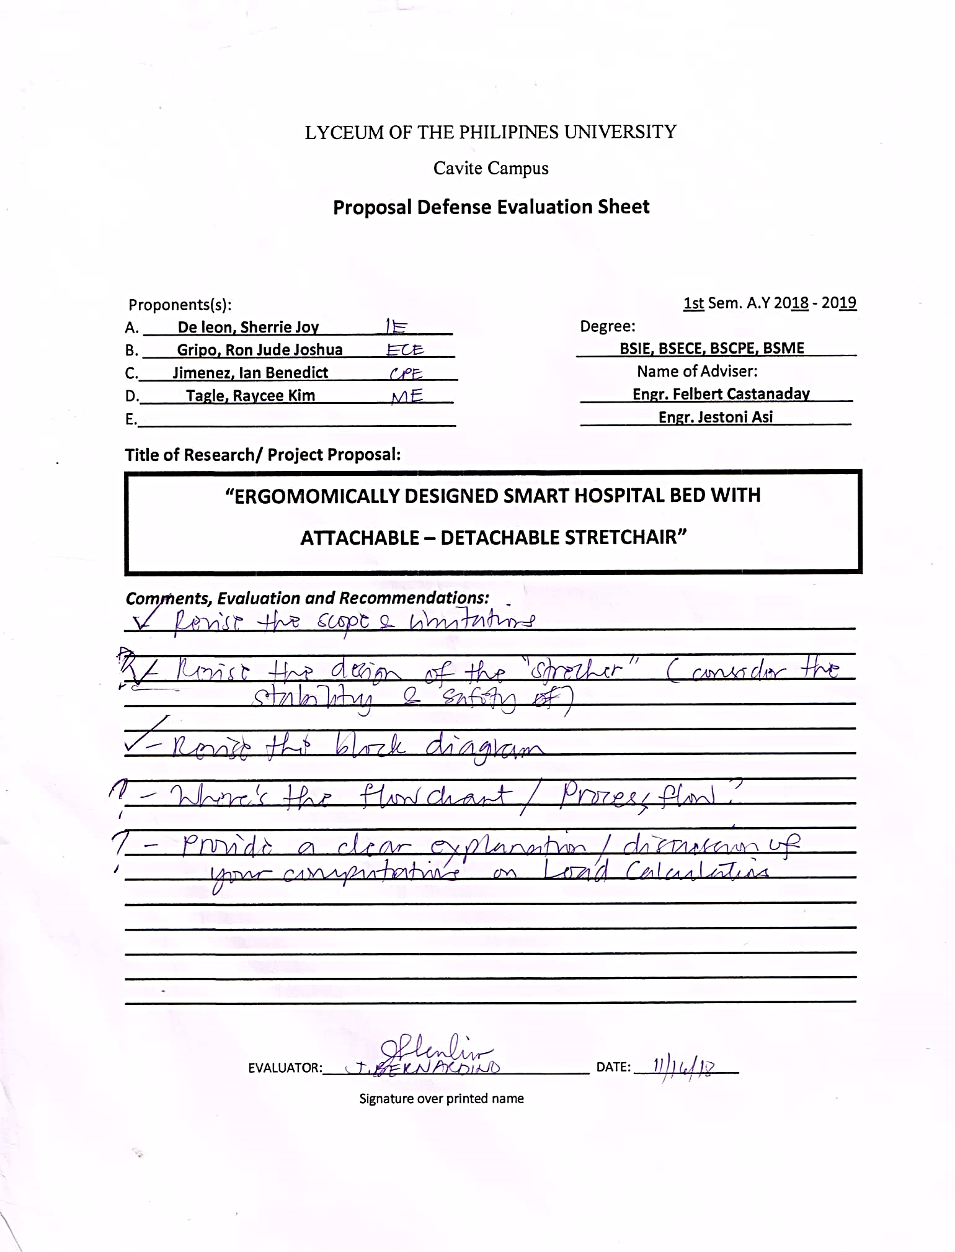

**Appendix #6.1** Proposal Defense Comment Sheet

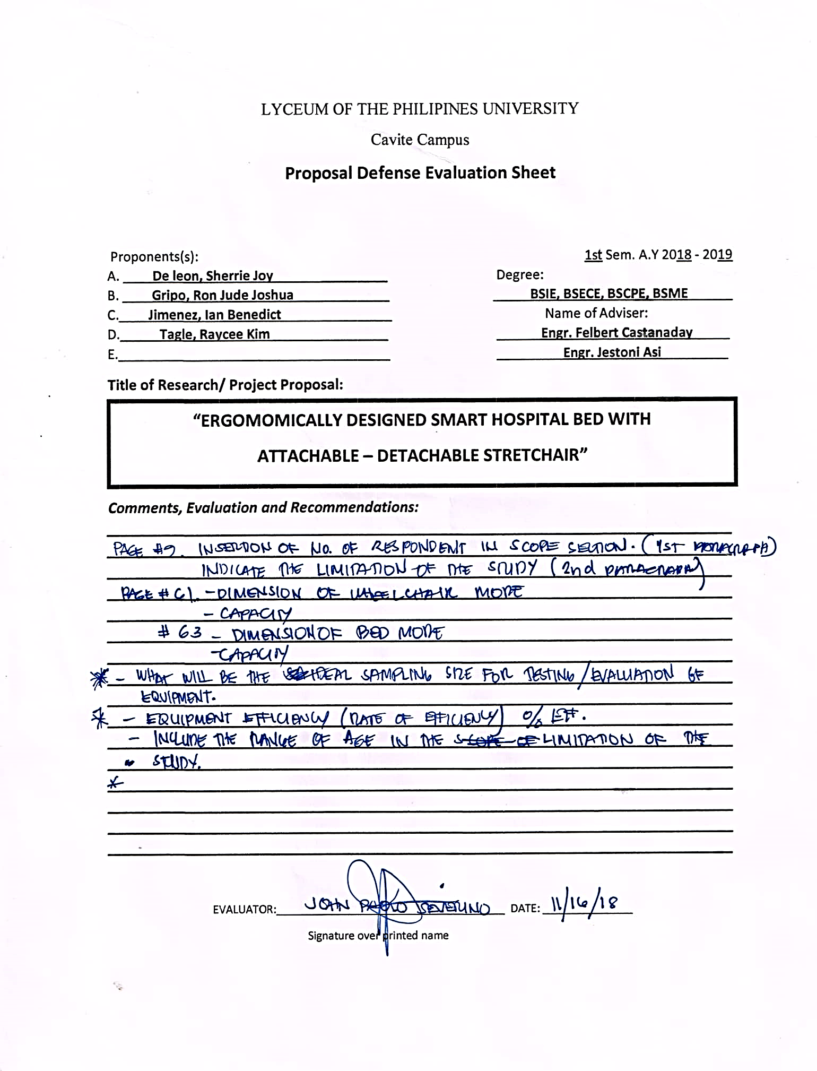

**Appendix #6.2** Proposal Defense Comment Sheet

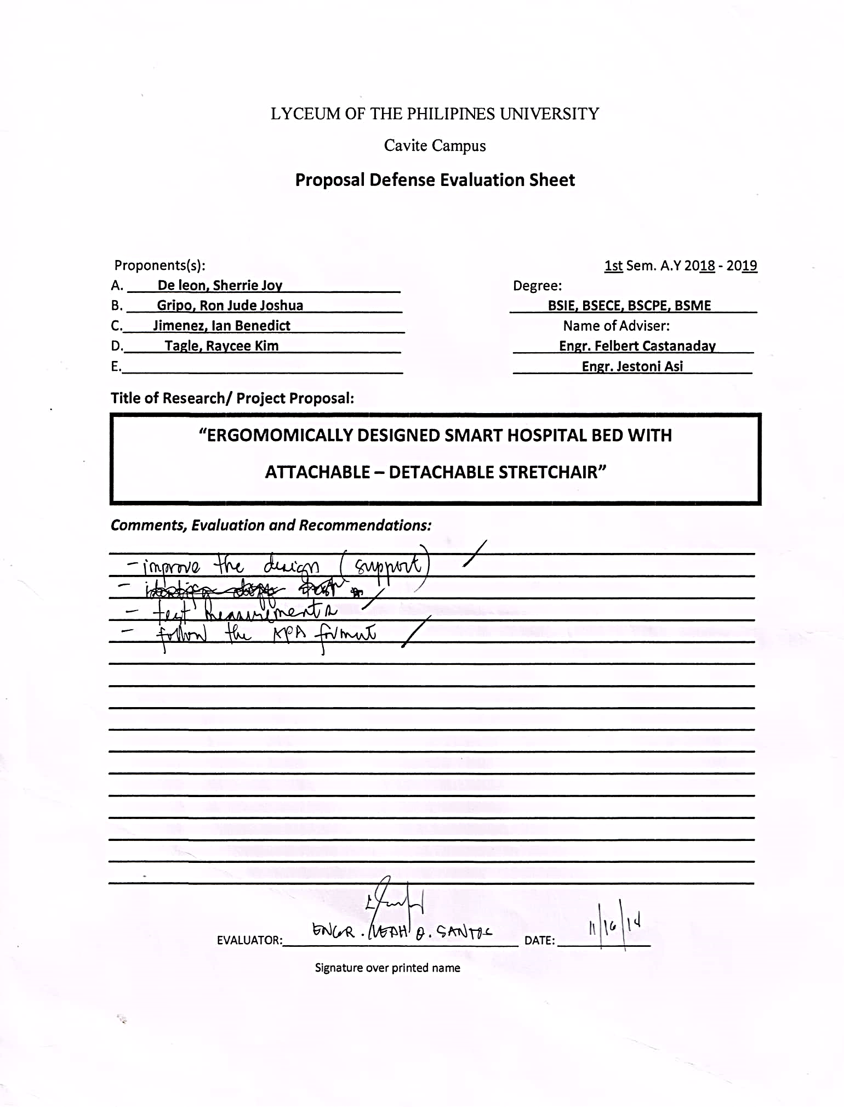

**Appendix #7.** Final Defense Comment Sheet

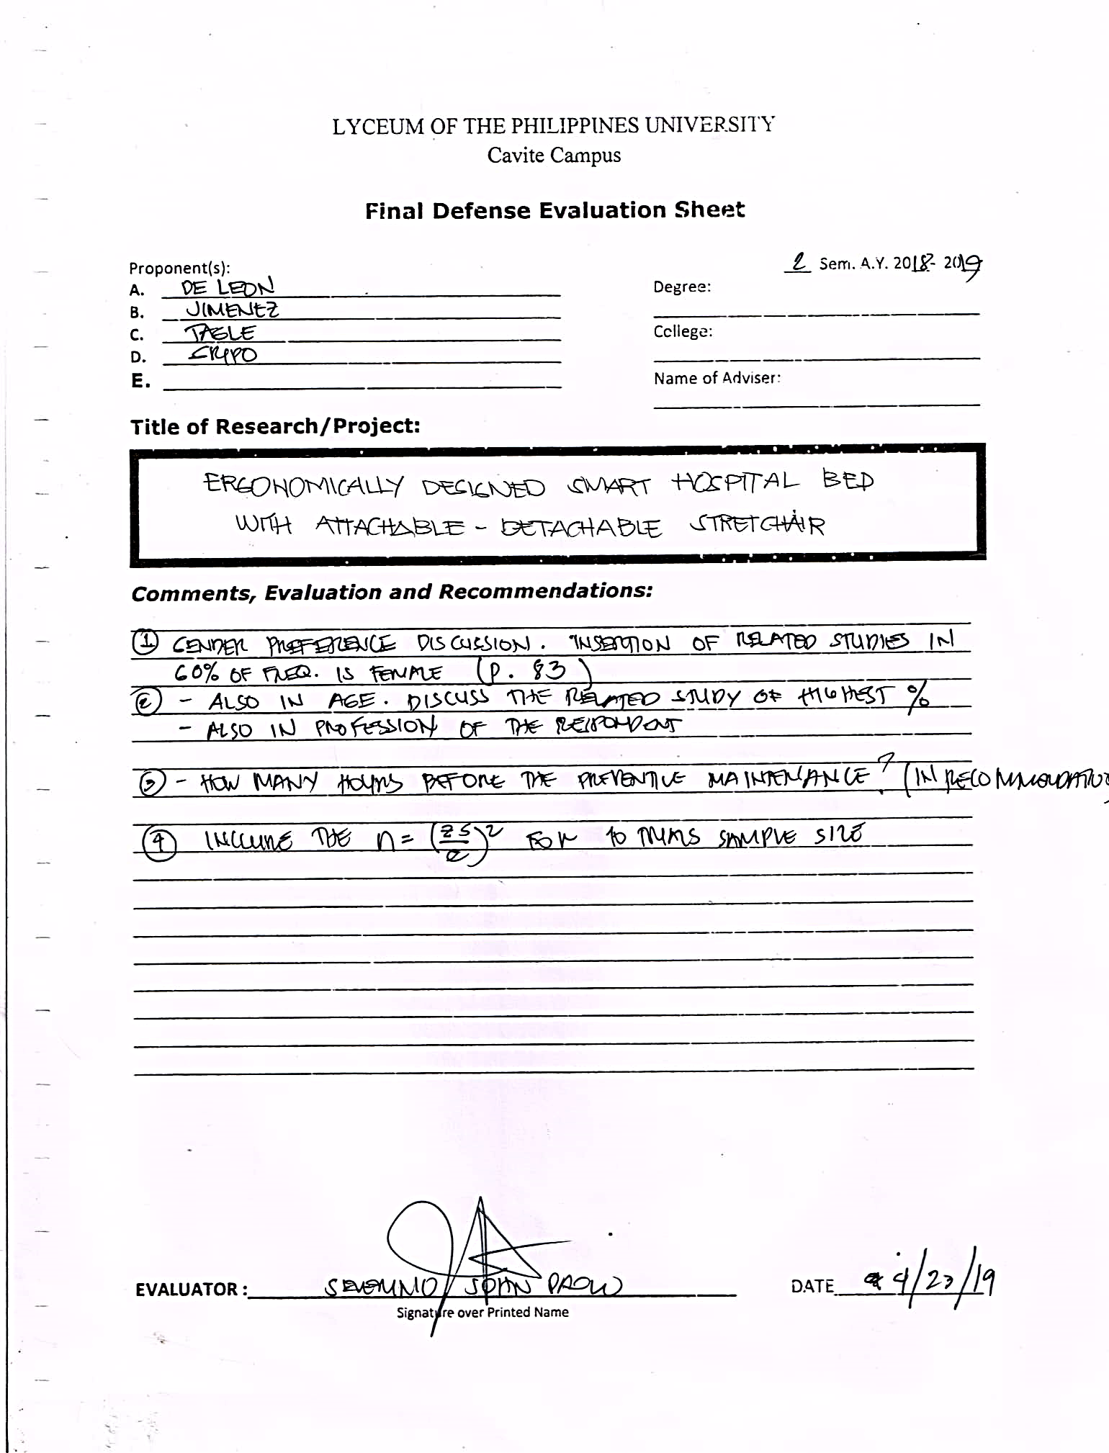

**Appendix #7.1** Final Defense Comment Sheet

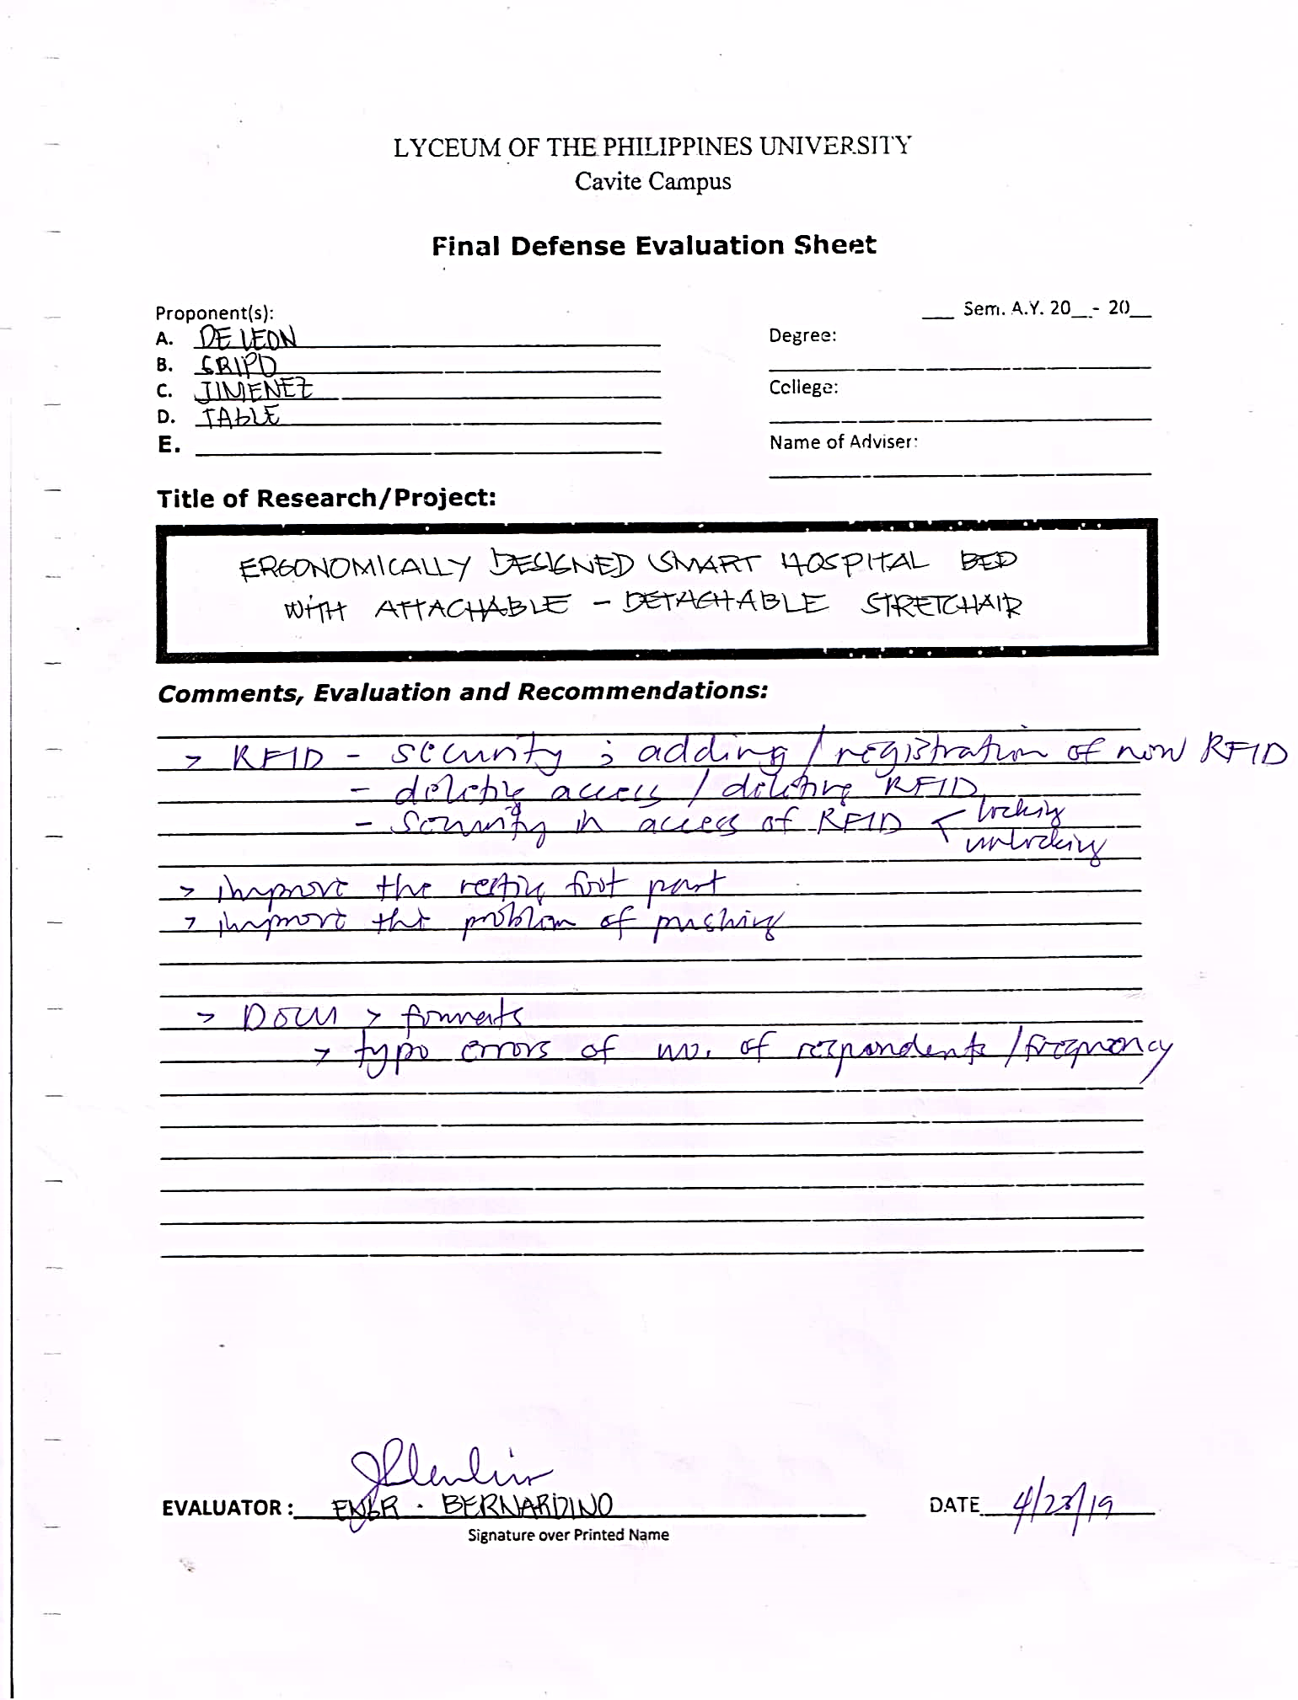

**Appendix #7.2** Final Defense Comment Sheet

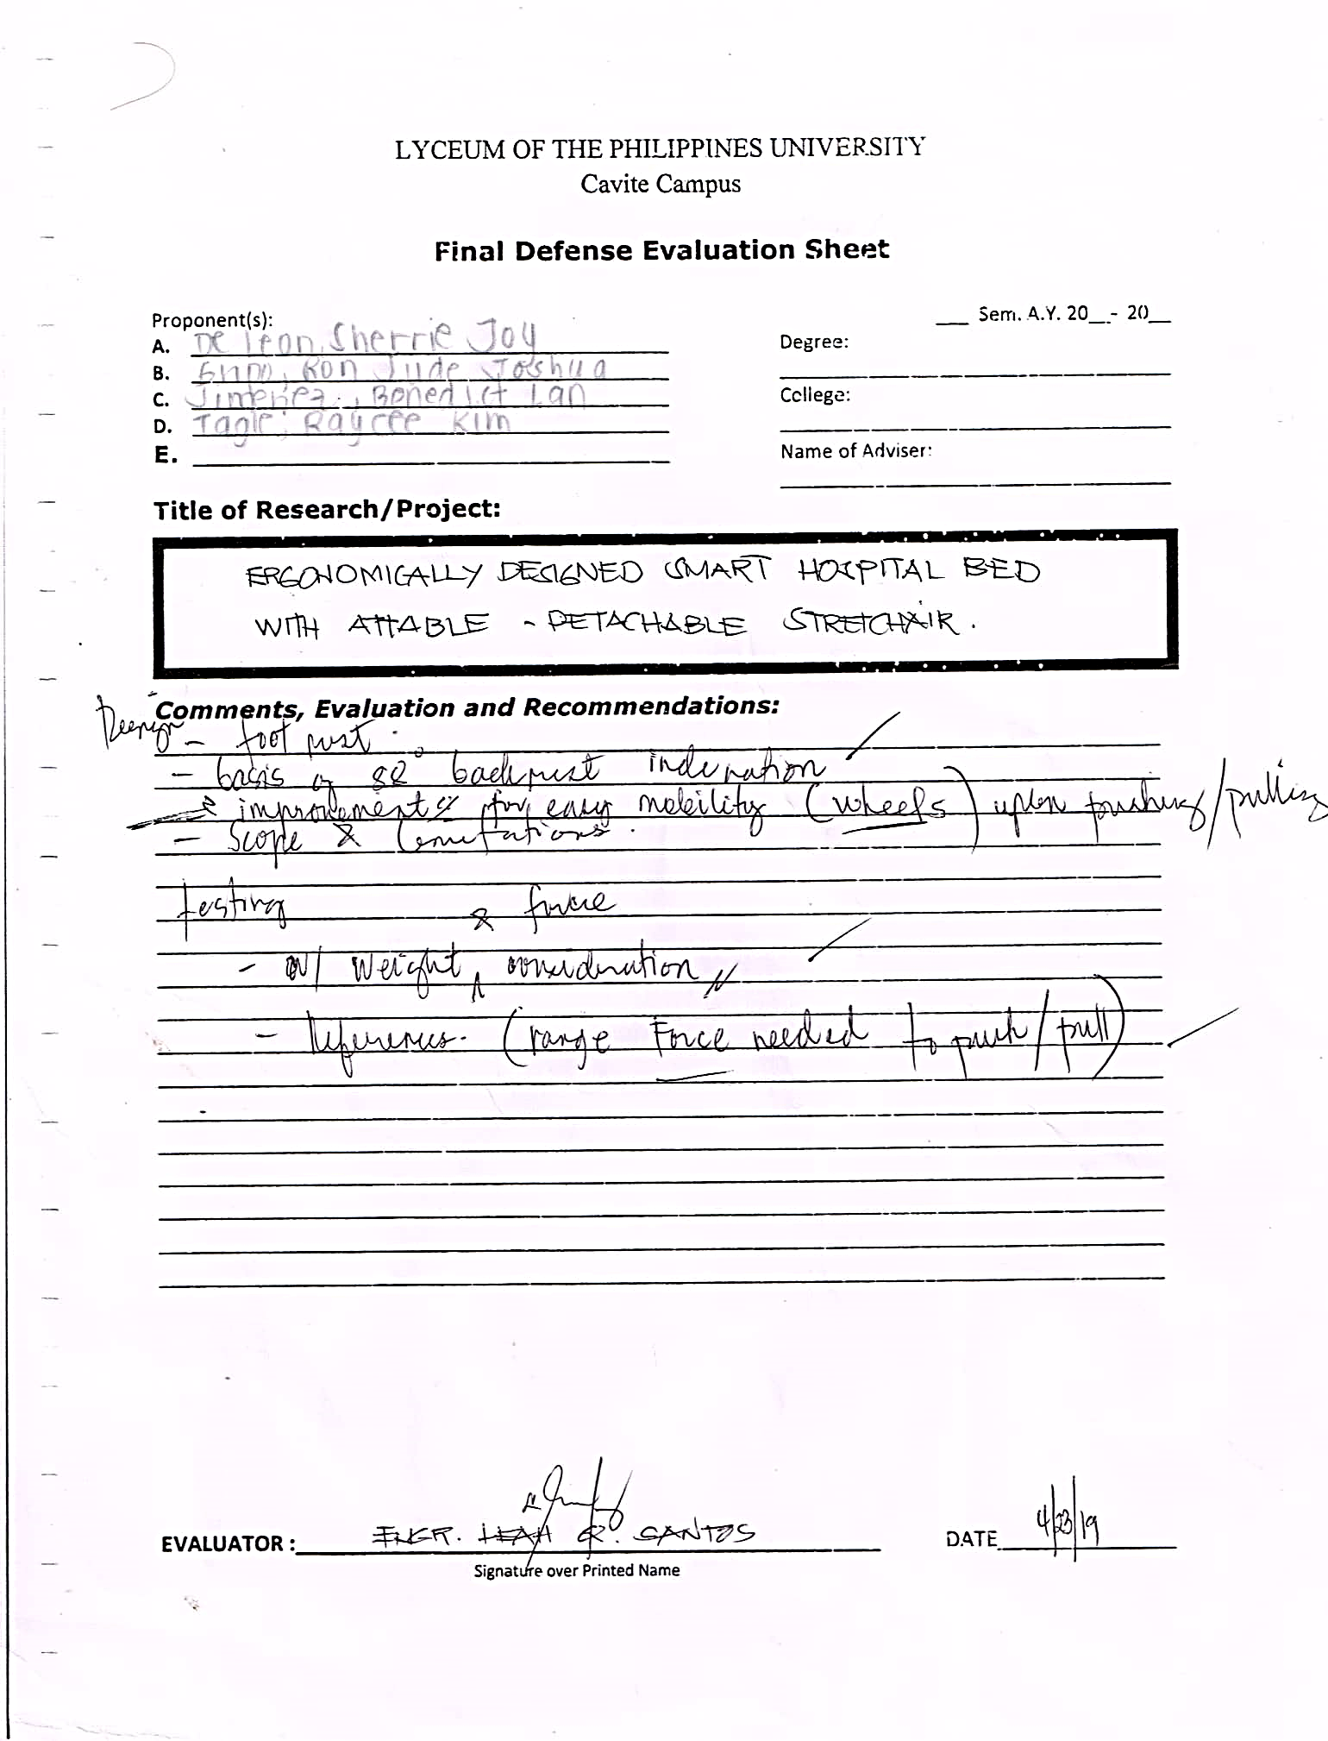

**LIST OF APPENDIX TABLES**

**Appendix #1.** Depreciation

$$DEPRECIATION=\frac{COST-SALVAGE VALUE}{USEFUL LIFE}$$

|  |  |  |  |  |
| --- | --- | --- | --- | --- |
| **Material Used** | **Total Price** | **Useful**  **Life** | **Salvage Value** | **Depreciation** |
| **3 Linear Actuator** | P 16,500 | 5 yrs | P 1,650 | P 2,870 |
| **5 Button** | P 90 | 3 yrs | 0 | P 30 |
| **1 Rocker Switch** | P 55 | 3 yrs | 0 | P 18.33 |
| **1 Arduino Mega** | P 810 | 3 yrs | P 81 | P 243 |
| **1 RFID Reader** | P 890 | 3 yrs | P 89 | P 267 |
| **1 Stepdown Regulator** | P 189 | 3 yrs | 0 | P 63 |
| **2 Magnetic lock** | P 8,000 | 5 yrs | P 800 | P 1,440 |
| **1 Battery 12 –V 26A** | P 2,829 | 2 yrs | P 282.9 | P 1,273 |
| **1 Limit Switch** | P 35 | 5 yrs | 0 | P 7 |
| **1 Stainless Casing** | P 35,000 | 20 yrs | P 3,500 | P 1,575 |
| **Leather cloth** | P 2000 | 5 yrs | P 200 | P 360 |
| **Uratex Foam** | P 2 500 | 7 yrs | P 250 | P 321.42 |

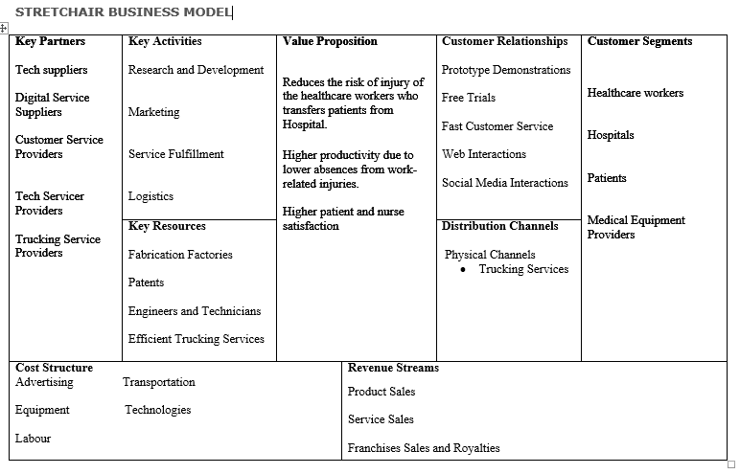**Appendix #2.** Business Model

**LIST OF APPENDIX FIGURES**

**Appendix #1.** Initial Data gathering Request letter

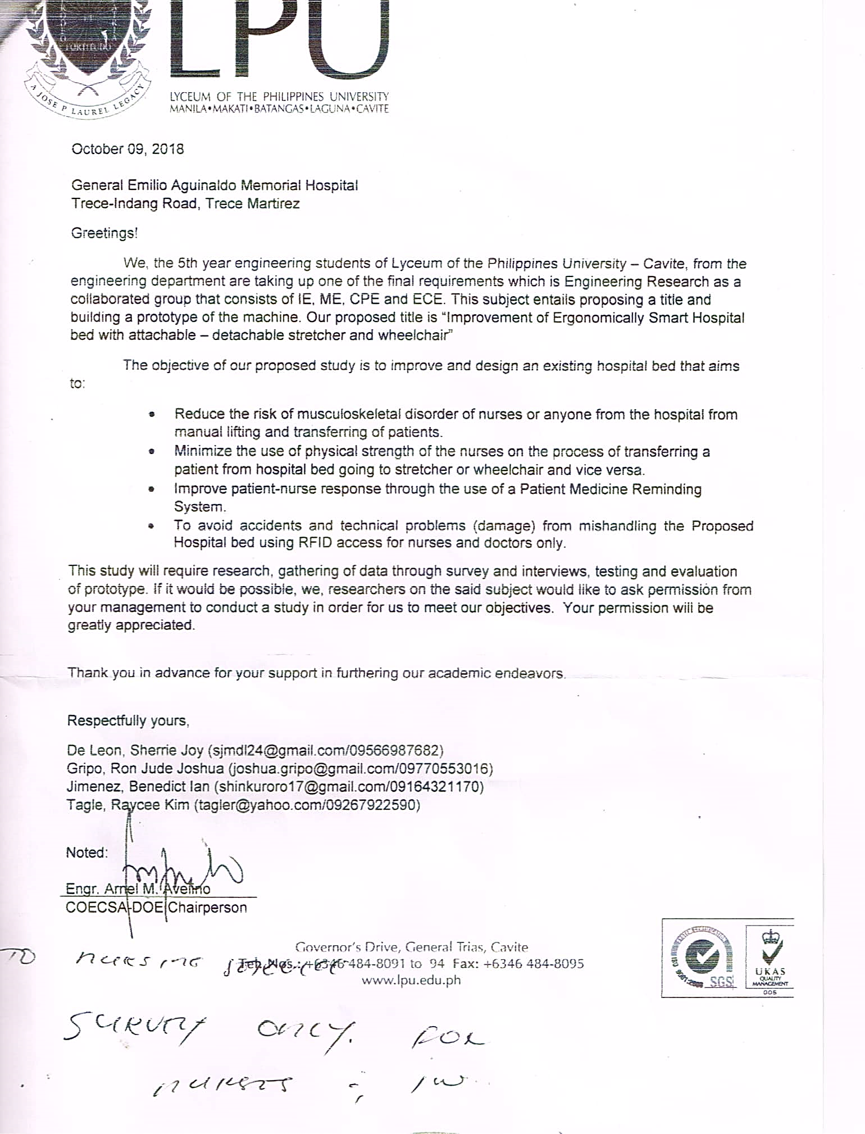

**Appendix #2.** Request Letter Pre – test and Post Test

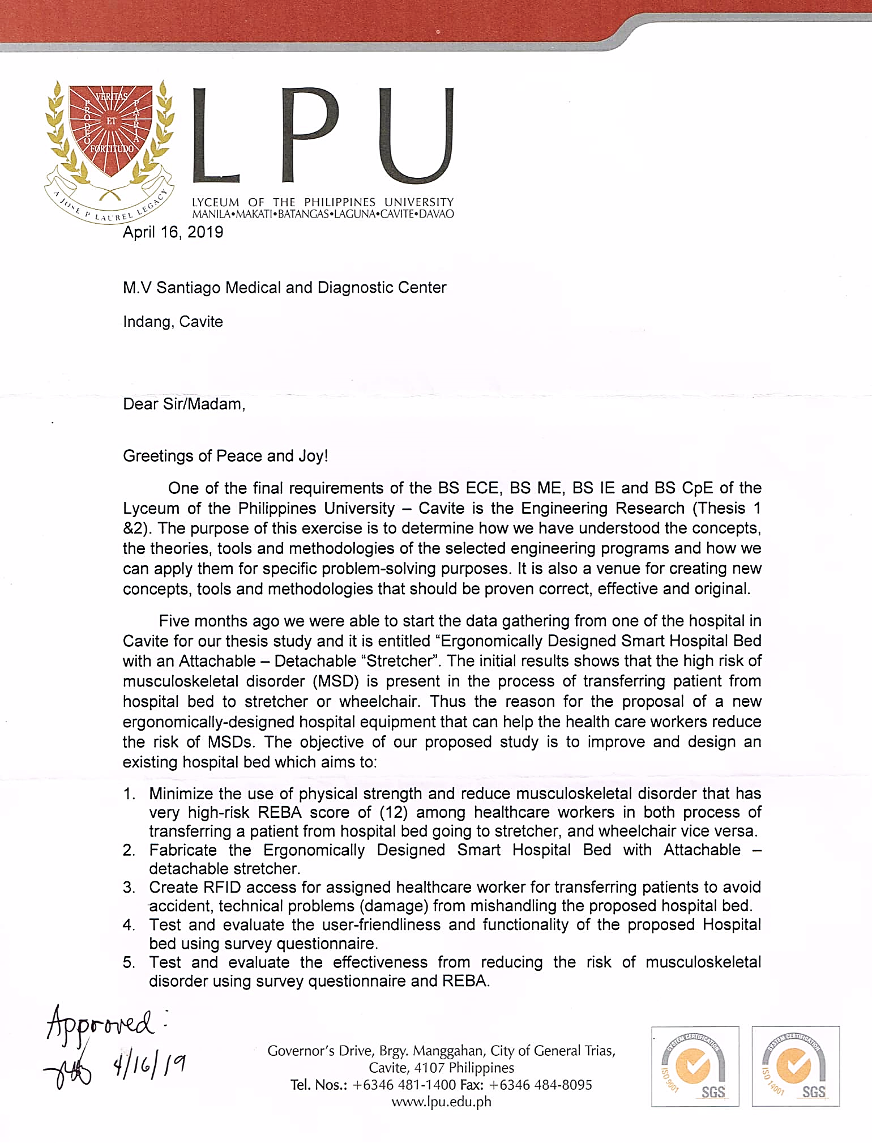

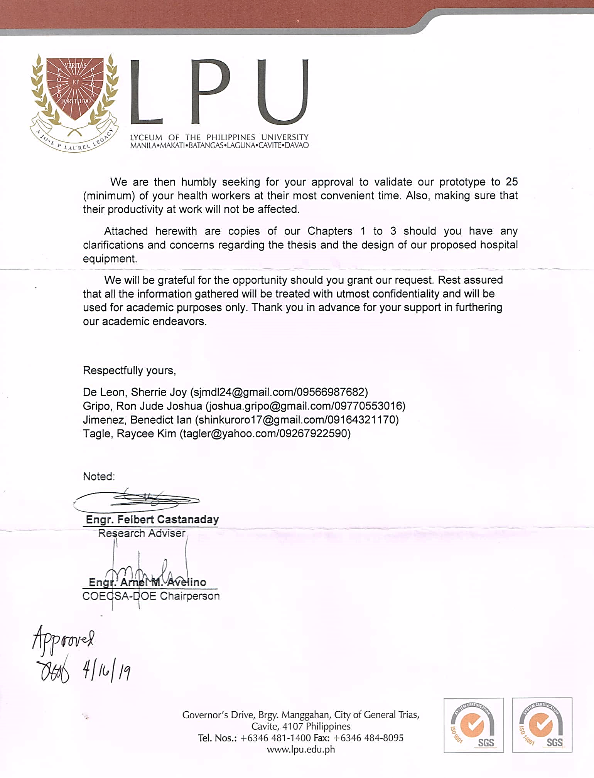

**Appendix #3.** Survey Questionnaire (Pre – Test)



Good day! We, The Engineering students from Lyceum of the Philippines University- Cavite, would like to conduct a survey for our Engineering research study proposal entitled “Ergonomically designed smart hospital bed with attachable – detachable Stretchair”. This survey will only take a few minutes and your response will be greatly appreciated as it can help us gather data for our Thesis. All answers will remain confidential. Responses will not be identified individually as it will be compiled together and analyzed as a group. Thank you for your cooperation and God Bless!

**SURVEY FORM**

**Validated by: Aldren B. Narzoles**

**Direction:** Sagutan ang mga sumusunod sa pamamagitan ng paglalagay ng tsek o sagot sa kahon o blanko.

1. **Nickname**

**­­­­­­­­­­­­**____________________________

1. **Sex**

Male Female

1. **Age**

21 – 25 26 – 30 31 – 35 36 – 40 41 – 45 46 – 50

1. **Ano ang iyong propesyon?**

IWD Nurse

1. **Ilang taon ka nang nag-tatrabaho sa hospital?**

____________________________

1. **Ilang oras kang nagtatrabaho sa loob ng isang araw?**

5 oras 8 oras Higit sa 8 oras

**Ang mga sumusunod na katanungan ay patungkol sa tradisyonal na pag bubuhat at pag lilipat ng nurse sa pasyente mula sa hospital bed patungo sa Stretcher.**

1. **Nagbubuhat/naglilipat ka ba ng pasyente mula higaan papuntang stretcher o vice versa?**

Oo Hinde

1. **Ano ang ginagamit ninyong pamamaraan sa paglipat?**

Mano – Mano Kumot

**Isulat sa patlang kung may iba pang pamamaraan sa paglipat.**  
________________________________

1. **Gaano ka kadalas magbuhat/maglipat ng pasyente sa loob ng isang araw?**

1 beses 2-4 beses 5-7 beses 8-10 beses 10 beses

1. **Anong klase ng pananakit ang inyong nararanasan na sanhi ng pagbubuhat /paglipat ng pasyente?**

Pangangalay Pamamaga Pamamandhid Pangingirot

1. **May nararamdaman ba kayong sakit/pangangalay na sanhi ng pagbubuhat/paglilipat ng pasyente?**

Meron Wala

1. **Kapag kayo ay nagbubuhat/nagliilpat ng pasyente, gaano kadalas mo nararamdaman ang pananakit?**

Madalang MInsan Madalas Palagi

1. **Sa inyong karanasan bilang healthcare worker, kuntento kanaba sa iyong paraan ng paglipat/pagbubuhat ng pasyente?**

Oo Hindi

1. **Kung ikaw ay nakakaramdam ng pananakit/pangangakay habang nagbubuhat/naglilipat ng pasyente mula sa hospital bed patungo sa Stretcher, anong parte ng katawan mo**

**ang naapektuhan at iranggo ang sakit na nararamdaman.**0 - *Walang sakit* 3 – *Masakit*1 - *Di gaano kasakit* 4 - *Nakakaabalang sakit*2 - *Kaunting sakit* 5 – *Sobrang sakit*

|  |  |  |  |  |  |  |
| --- | --- | --- | --- | --- | --- | --- |
| **Parte ng katawan** | **0** | **1** | **2** | **3** | **4** | **5** |
| Neck (Leeg) |  |  |  |  |  |  |
| Shoulders (Balikat) |  |  |  |  |  |  |
| Upper Back (Taas na parte ng Likod) |  |  |  |  |  |  |
| Elbow (Siko) |  |  |  |  |  |  |
| Lower Back (Ibabang parte ng likod) |  |  |  |  |  |  |
| Arm wrist/ Hand (Pulsuhan/Kamay) |  |  |  |  |  |  |
| Thigh (Hita) |  |  |  |  |  |  |
| Knee (Tuhod) |  |  |  |  |  |  |
| Calf or Leg ( Guya o Binti) |  |  |  |  |  |  |
| Feet/ Ankle (Paa/Bukong- bukong) |  |  |  |  |  |  |
| Finger (Daliri) |  |  |  |  |  |  |

**Ang mga sumusunod na katanungan ay patungkol sa tradisyonal na pag bubuhat at pag lilipat ng nurse sa pasyente mula sa hospital bed patungo sa Wheelchair.**

1. **Nagbubuhat/naglilipat ka ba ng pasyente mula higaan papuntang wheelchair o vice versa?**

Oo Hinde

1. **Ano ang ginagamit ninyong pamamaraan sa paglipat?**

Mano – Mano Kumot

**Isulat sa patlang kung may iba pang pamamaraan sa paglipat.**  
________________________________

1. **Gaano ka kadalas magbuhat/maglipat ng pasyente sa loob ng isang araw?**

1 beses 2-4 beses 5-7 beses 8-10 beses 10 beses

1. **Anong klase ng pananakit ang inyong nararanasan na sanhi ng pagbubuhat /paglipat ng pasyente?**

Pangangalay Pamamaga Pamamandhid Pangingirot

1. **May nararamdaman ba kayong sakit/pangangalay na sanhi ng pagbubuhat/paglilipat ng pasyente?**

Meron Wala

1. **Kapag kayo ay nagbubuhat/nagliilpat ng pasyente, gaano kadalas mo nararamdaman ang pananakit?**

Madalang MInsan Madalas Palagi

1. **Sa inyong karanasan bilang healthcare worker, kuntento kanaba sa iyong paraan ng paglipat/pagbubuhat ng pasyente?**

Oo Hindi

1. **Kung ikaw ay nakakaramdam ng pananakit/pangangakay habang nagbubuhat/naglilipat ng pasyente mula sa hospital bed patungo sa wheelchair, anong parte ng katawan mo  
   ang naapektuhan at iranggo ang sakit na nararamdaman.**0 - *Walang sakit* 3 – *Masakit*1 - *Di gaano kasakit* 4 - *Nakakaabalang sakit*2 - *Kaunting sakit* 5 – *Sobrang sakit*

|  |  |  |  |  |  |  |
| --- | --- | --- | --- | --- | --- | --- |
| **Parte ng katawan** | **0** | **1** | **2** | **3** | **4** | **5** |
| Neck (Leeg) |  |  |  |  |  |  |
| Shoulders (Balikat) |  |  |  |  |  |  |
| Upper Back (Taas na parte ng Likod) |  |  |  |  |  |  |
| Elbow (Siko) |  |  |  |  |  |  |
| Lower Back (Ibabang parte ng likod) |  |  |  |  |  |  |
| Arm wrist/ Hand (Pulsuhan/Kamay) |  |  |  |  |  |  |
| Thigh (Hita) |  |  |  |  |  |  |
| Knee (Tuhod) |  |  |  |  |  |  |
| Calf or Leg ( Guya o Binti) |  |  |  |  |  |  |
| Feet/ Ankle (Paa/Bukong- bukong) |  |  |  |  |  |  |
| Finger (Daliri) |  |  |  |  |  |  |

**Appendix #4. Survey Questionnaire (Post – Test)**

**Ang mga sumusunod na katanungan ay patungkol sa karanasan pagkatapos gamitin ang “Ergonomically designed Smart Hospital bed with attachable – detachable Stretchair”**

***Katanungan patungkol sa karanasan sa pag lilipat ng nurse sa pasyente mula sa hospital bed patungo sa Stretcher mode.***

1. **Anong klase ng pananakit ang inyong nararanasan na sanhi ng pag gamit ng stretcher mode sa paglipat ng pasyente? Kung wala ay ipag-paliban na ang katanungan na to.**

Pangangalay Pamamaga Pamamandhid Pangingirot Wala

1. **May nararamdaman ba kayong sakit/pangangalay**

Meron Wala

1. **Kung ikaw ay nakakaramdam ng pananakit/pangangakay habang naglilipat ng pasyente mula sa hospital bed hanggang stretcher mode, anong parte ng katawan mo ang naapektuhan at iranggo ang sakit na nararamdaman.**

0 - *Walang sakit* 3 – *Masakit*1 - *Di gaano kasakit* 4 - *Nakakaabalang sakit*2 - *Kaunting sakit* 5 – *Sobrang sakit*

|  |  |  |  |  |  |  |
| --- | --- | --- | --- | --- | --- | --- |
| **Parte ng katawan** | **0** | **1** | **2** | **3** | **4** | **5** |
| Neck (Leeg) |  |  |  |  |  |  |
| Shoulders (Balikat) |  |  |  |  |  |  |
| Upper Back (Taas na parte ng Likod) |  |  |  |  |  |  |
| Elbow (Siko) |  |  |  |  |  |  |
| Lower Back (Ibabang parte ng likod) |  |  |  |  |  |  |
| Arm wrist/ Hand (Pulsuhan/Kamay) |  |  |  |  |  |  |
| Thigh (Hita) |  |  |  |  |  |  |
| Knee (Tuhod) |  |  |  |  |  |  |
| Calf or Leg ( Guya o Binti) |  |  |  |  |  |  |
| Feet/ Ankle (Paa/Bukong- bukong) |  |  |  |  |  |  |
| Finger (Daliri) |  |  |  |  |  |  |

***Katanungan patungkol sa karanasan sa pag lilipat ng nurse sa pasyente mula sa hospital bed patungo sa Wheelchair mode***

1. **Anong klase ng pananakit ang inyong nararanasan na sanhi ng pag gamit ng wheelchair mode sa paglipat ng pasyente? Kung wala ay ipag-paliban na ang katanungan na to.**

Pangangalay Pamamaga Pamamandhid Pangingirot Wala

1. **May nararamdaman ba kayong sakit/pangangalay**

Meron Wala

1. **Kung ikaw ay nakakaramdam ng pananakit/pangangakay habang naglilipat ng pasyente mula sa hospital bed hanggang wheelchair mode, anong parte ng katawan mo ang naapektuhan at iranggo ang sakit na nararamdaman.**

0 - *Walang sakit* 3 – *Masakit*1 - *Di gaano kasakit* 4 - *Nakakaabalang sakit*2 - *Kaunting sakit* 5 – *Sobrang sakit*

|  |  |  |  |  |  |  |
| --- | --- | --- | --- | --- | --- | --- |
| **Parte ng katawan** | **0** | **1** | **2** | **3** | **4** | **5** |
| Neck (Leeg) |  |  |  |  |  |  |
| Shoulders (Balikat) |  |  |  |  |  |  |
| Upper Back (Taas na parte ng Likod) |  |  |  |  |  |  |
| Elbow (Siko) |  |  |  |  |  |  |
| Lower Back (Ibabang parte ng likod) |  |  |  |  |  |  |
| Arm wrist/ Hand (Pulsuhan/Kamay) |  |  |  |  |  |  |
| Thigh (Hita) |  |  |  |  |  |  |
| Knee (Tuhod) |  |  |  |  |  |  |
| Calf or Leg ( Guya o Binti) |  |  |  |  |  |  |
| Feet/ Ankle (Paa/Bukong- bukong) |  |  |  |  |  |  |
| Finger (Daliri) |  |  |  |  |  |  |

**Appendix #5.** User’s Friendliness Survey Questionnaire

**User-Friendliness Test**

Put a check in the box that has the best answer regarding User’s friendliness and accuracy of the proposed prototype after using it.

|  |  |  |  |  |  |  |  |
| --- | --- | --- | --- | --- | --- | --- | --- |
|  | Item  No. | Item Description | Strongly Agree | Agree | Slightly Agree | Disagree | Strongly Disagree |
| (5) | (4) | (3) | (2) | (1) |
| User-friendliness | 1 | The user can easily get in and get out from the system. |  |  |  |  |  |
| 2 | The system is easy to  learn |  |  |  |  |  |
| 3 | The system is easy to use |  |  |  |  |  |
| 4 | The interface is pleasant to look at |  |  |  |  |  |
| 5 | The figures/buttons were clearly identified |  |  |  |  |  |
| 6 | The system user interface clearly tells its function |  |  |  |  |  |
| Accuracy | 7 | The system executes its functions effectively |  |  |  |  |  |
| 8 | The system is error free |  |  |  |  |  |
| 9 | The system performs the command given by the user |  |  |  |  |  |

**Appendix #6.** Fabricating the Equipment

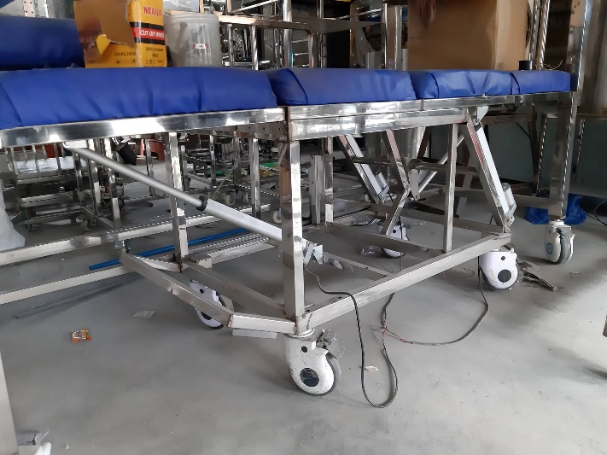

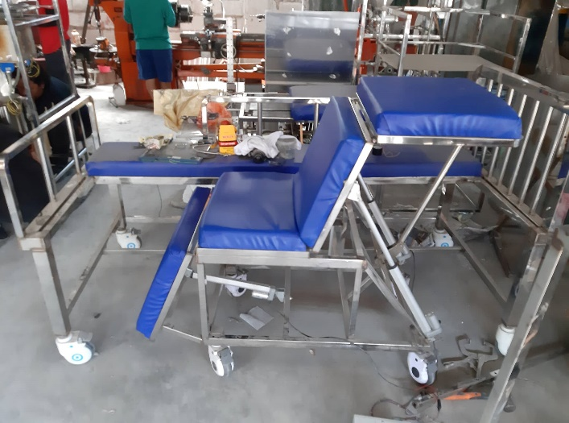

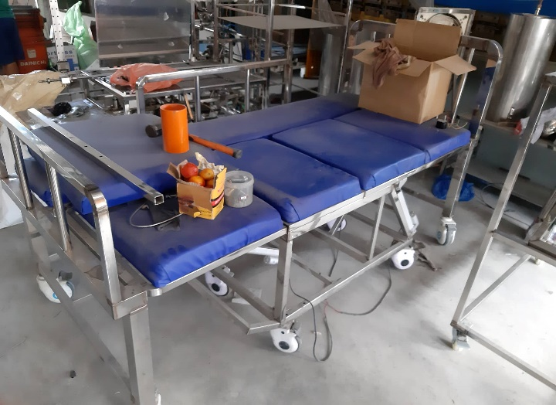

**Appendix #7.** Testing of the project

Software development and testing of Stretchair’s Load capacity

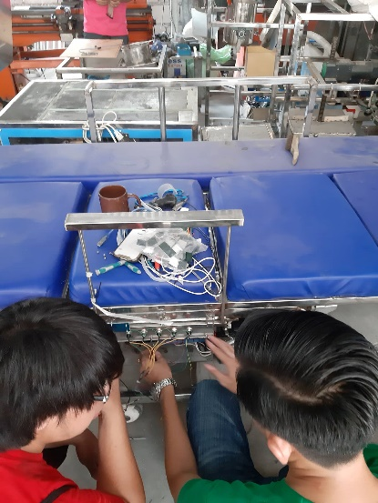 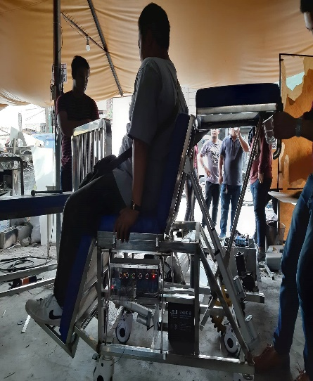 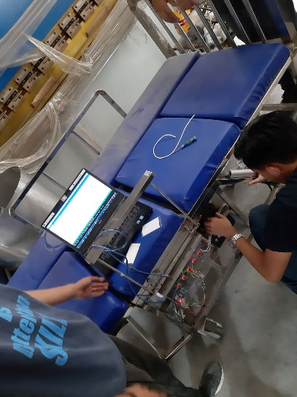

Actual testing of the project in a Medical Center

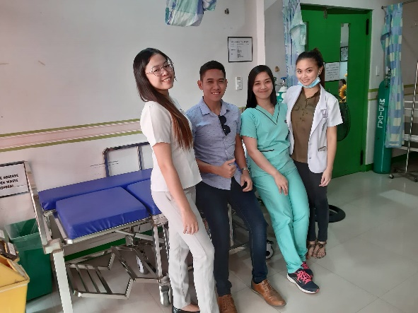 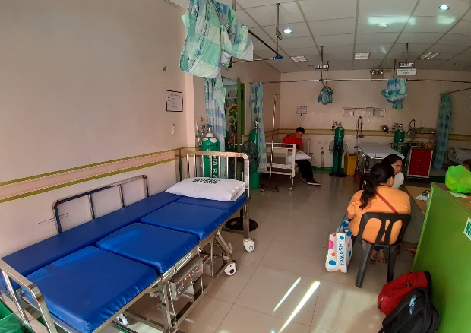

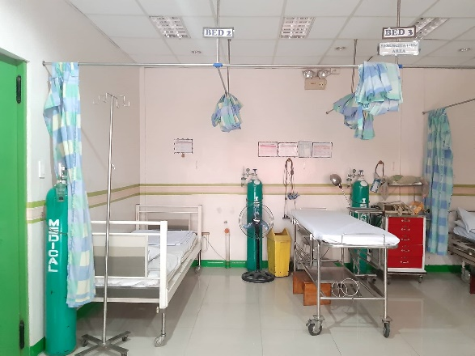 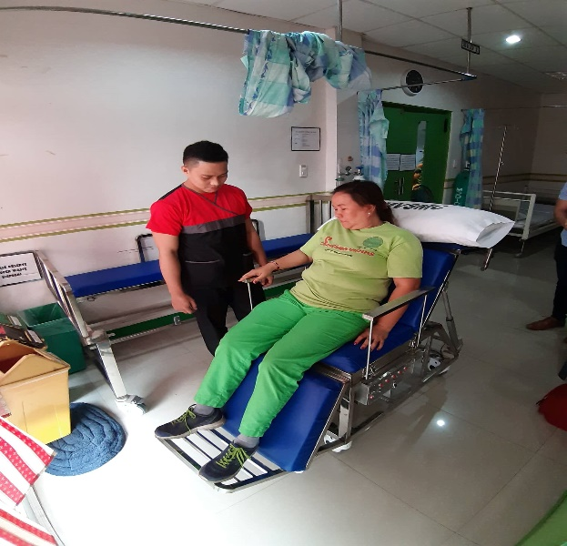

**Appendix #8.** Final Defense



